
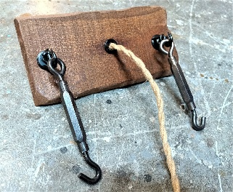
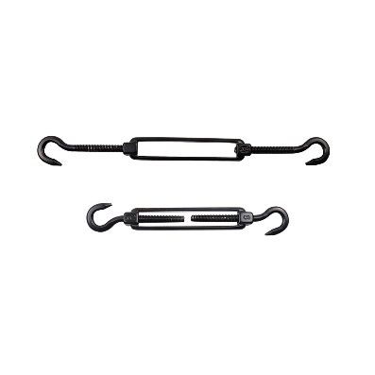
Thank you for your order. I take a lot of time and care to make these, and I hope you enjoy it! Please note: working with electricity can be dangerous and have the risk of shock or even death. I recommend you have a licensed electrician hook it up if you are not familiar with electrical work. I am not an electrician and am only offering this information on installation as a layman. I take no responsibility for any accidents. Use only LED type bulbs to reduce heat.
Ceiling Mount Board (Mount on ceiling using the eye bolts and toggles)
Turnbuckles (Connect to eye bolts and chain, used to make level.)
Eye bolts(To hang chains from Ceiling

Tie Downs (Hook chains to thes on side of lamp with chain connectors)
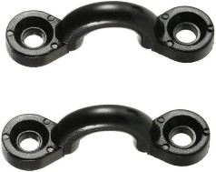
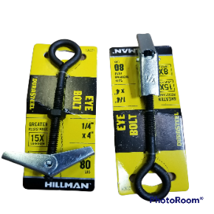
Installation Directions for Your Candle Chandelier
Hold the mounting board on the ceiling to line it up and then mark the two predrilled holes on your ceiling by passing a small nail through to mark the ceiling hole.
Insert the black eye bolts through the predrilled holes on the ceiling mount plate. Screw on the end of each bolt a butterfly toggle as shown. Push the toggles and eyebolt into the ceiling hole. Pull the black eye bolts down as you tighten them to the toggle.
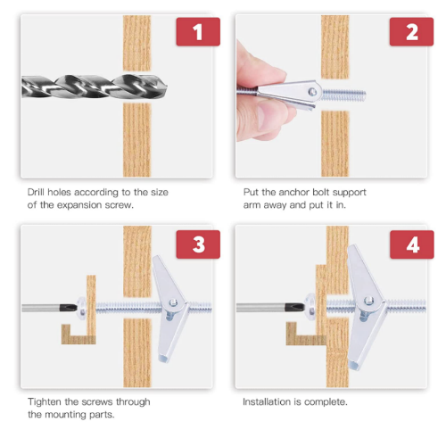
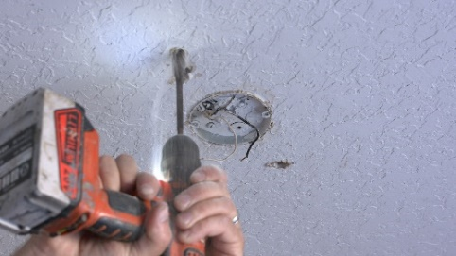
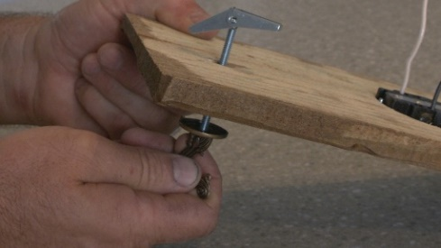

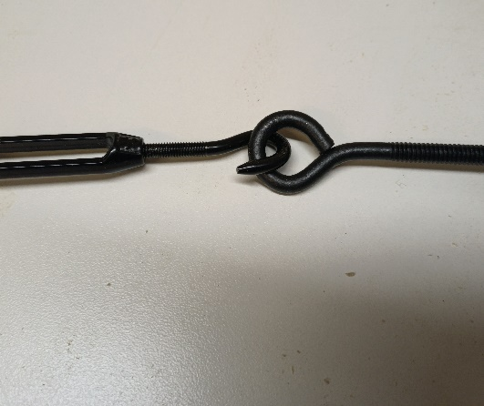

Connect the turnbuckles to each eye hook.

Adjust the length of the two ropes to your desired distance you want the chandelier to hang from the ceiling. Connect the ends of each rope to the black tie downs mounted on the ends. Loop the rope through the turnbuckle end. The other ends of the turnbuckles will hang onto the eyebolts. Use the turnbuckles to adjust for levelness.

Electrical Connection:
Turn off the fuse for the light receptacle you are connecting to. Make sure the existing light no longer turns on.
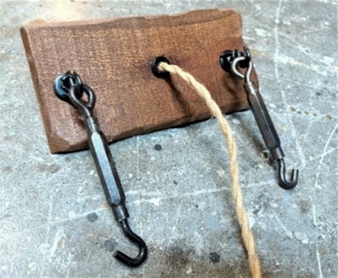
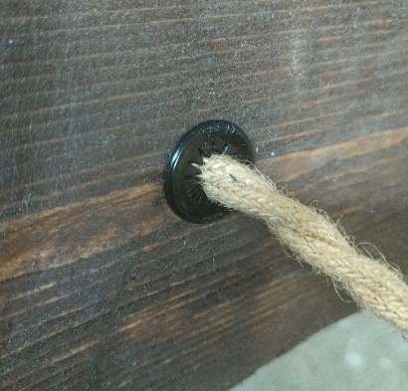
Run the black cloth covered electrical wire through the hole on the ceiling mount board and connect to the existing wires with two wire nuts. Secure the ceiling mount to the ceiling over the light receptacle.

Feel free to call with any questions: 561-847-0077
Jeff Bernier

