APPLICATION FORM

We register your application on a first come first served basis secured by your $500.00 nonrefundable booking fee.

Please print and mail the completed application plus deposit to the following address:

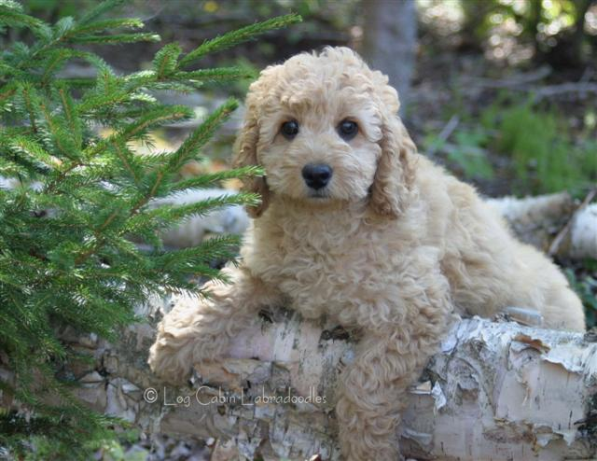
Log Cabin Labradoodles
PO Box 650
Dover-Foxcroft, ME 04426
(207) 270-0067
Name

Address

Phone Cell
E-mail

Desired litter list:

Your answers to the following questions help me select a puppy that compliments your family and lifestyle. Please circle your answers.

1. Do any family members suffer from dog related allergies? Y N

2. Preferred Size: Miniature Medium

3. Preferred Gender: Female Male Flexible

4. Preferred Coat: Fleece Curly Fleece Wavy Straight

5. Preferred Color: Chalk Cream Black
Chocolate/Cafe` Apricot Cream
Apricot Red(rare) Gold Part-i

6. Which best describes your lifestyle? Quiet Somewhat Active Active

7. Is your yard fenced? Y N
If you circled no, how do you intend to keep your puppy safe outdoors?

8. What other animals share your home?

9. If you have children at home, what are their ages?

10. Please feel free to add any additional comments to help us place the prefect puppy in your arms.

All Log Cabin puppies come with a 2 year guarantee against genetic diseases. They receive age appropriate vaccinations and deworming. We microchip every puppy. We are available to help you through out your puppy's life and will accept his return if he ever needs re-homing. Log Cabin reserves the right of first pick of the litter for breeding purposes.

Puppy Price: $2,950.00 (price does not include shipping)

SIGNATURE: date________________

