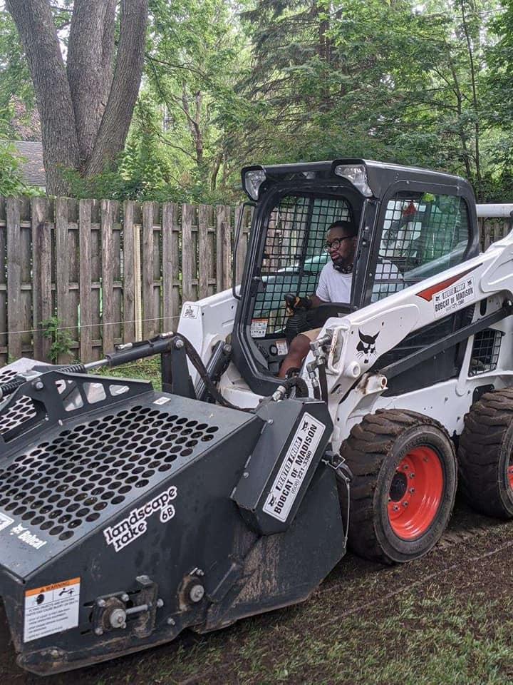  MY HOURS  Monday-Friday  7:30AM-8:00PM  Saturday-Sunday  7:30AM-8:00PM | About Me  Hi, my name is Tony Freiberg founder of Freiberg’s Hardscaping in Madison WI & Dane County & surrounding areas. I am running my business because I like being creative in the hardscape and landscape industry and want to be different from my competition. I want to focus on the details and the design & accomplish a service to admire. What I hope to inspire in your lives is the finish project you come home to a project that you would enjoy for a lifetime. I have opened my company after graduating high school on June 10th 2008 and been in business for 15 years. | FREIBERG’S HARDSCAPING A SERVICE TO ADMIRE SINCE 2008  - Fully Insured bonded & Licensed With The City Of Madison (608)-509-2772 Madison WI
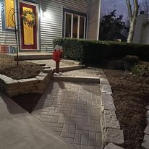  CONTACT ME  TONY FREIBERG, FOUNDER  CELL  (608)-509-2772  Email  freibergshardscaping@gmail.com  WEBSITE  www.freibergshardscaping.net  ADDRESS; HOME BUSINESS | MY SERVICES  WALKWAYS & SIDEWALKS WITH PAVERS  PATIOS  DRY CREEKS  GRADING & LEVELING YARDS & BOBCAT WORK  RETAINING WALL DESIGN & BUILD  RETAINING WALLS INSTALLING  OUTDOOR KITCHENS  PONDS & WATERFALLS DESIGN & BUILD  FIRE PITS  LOW-VOLTAGE LIGHTING  NEW CONSTRUCTION LANDSCAPE  NEW CONSTRUCTION  INSTALLING LANDSCAPE  LANDSCAPE RENEWAL  LANDSCAPE DESIGN & BUILD  HARDSCAPE DESIGN & BUILD  BRICK PAVER DRIVEWAYS  STONE SLAB STEPS  OUTDOOR STONE SEATING  DRAINAGE & FIXING & INSTALLING DRAINAGE PIPES IN THE GROUND  INSTALLING ROCK & GRAVELINSTALLING LANDSCAPE PLASTIC EDGING & STONE EDGING | SERVICES CONT  LAWN MOWING  WEEDWACKING  LEAF BLOWING  DETHACHING  CORE AERATION & LAWN ROLLING  LAWN FERTILIZING  TOP DRESSING  OVERSEEDING  TRANSPLANTING  PLANTING TREES SHRUBS, & PERENNIALS & BULBS  MULCHING RE MULCHING  SIDEWALK EDGING  TREE PRUNNING  HEDGING  MAINTAINING GARDEN BEDS  FALL CLEAN UP  SPRING CLEAN UP  SALTING SANDING SHOVELING & SNOW BLOWING  PRUNING  WEEDING  LAWN INSTALLATION WITH SOD OR GRASS SEED & EROISION CONTROL NET STRAW BLANKET OR STRAW

