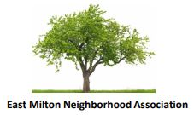 | MEMBERSHIP APPLICATION

Become a member of "Milton's #1 civic organization "

The East Milton Neighborhood Association (EMNA) acts as a unified voice representing the
concerns of all its residents. The organization keeps residents informed of pertinent issues
and events, responds to concerns regarding our neighborhood and seeks ways to improve the overall quality of life. We accomplish this through inclusive membership representation, broad outreach programs and collaboration with government and other community groups.
Please print clearly
Name
Address
Phone
E-mail Address

( ) New member
( ) Current member renewal
( ) I’d like to learn more about neighborhood volunteer opportunities.

Membership Dues are $10 per person. Please make your check payable to EMNA
Mail or drop off check to:

Joe O'Neill, Treasurer
27 Alvin Ave,
Milton, MA 02186

