

Contents of the welcome pack

- The Luna Studio
- About Our New Studio
- Welcome to ATWP
- What’s ahead for 2025 – 2026 season
- Meet the 2025 – 2026 Team
- Class Fees & Class fee information
- Competition Fees
- Costume fees
- New Class Fees
- Dates & events
- The Big events for your Calendar
- New classes to ATWP
Monday
Tuesday
Wednesday
Thursday
Friday
- Class Manager App & Login
- Our forms of communication NEW
- In house shop
- Some exciting new classes
- Final words


About The Luna Studio & ATWP
The Luna Studio is more than just a space — it is the heart of Athena Theatre Works & Productions. Named after our beloved silver Siberian Husky, Luna, the studio carries her spirit of loyalty, grace, and determination. Luna was always by our side — ready for adventure, ready for challenges, and ready to protect. Just like the moon that inspired her name, she was a constant light in our lives.
Our Story
Athena Theatre Works & Productions began as a dream shared between Athena and her husband Jake. Our journey started overseas in Germany, where Jake was serving in the British Army (REME) and Athena was building her career in performing arts. From Germany, our passion for performance travelled with us to Canada, where we expanded our experience, grew our skills, and began shaping the inclusive and creative teaching methods we still use today.
Returning to the UK, we founded ATWP with a mission: to create a space where performing arts could thrive for everyone, regardless of background, ability, or age. Since opening in 2019, we’ve built a reputation for excellence, inclusivity, and opportunity — all while keeping our values close to heart.
The Luna Studio Today
Our newest chapter is The Luna Studio — a place where dreams are realised. Inside, you’ll find:
- Specialised dance flooring for safe training.
- Full mirrored walls to perfect technique.
- Piano & music room for vocal and instrumental work.
- SEND studio for accessible, inclusive learning.
- Costume room for our ever-growing wardrobe.
- Student lounge & waiting area to relax between classes.
- State-of-the-art speakers, tech, and in-house microphones for crystal-clear performances.
- Kitchen & garden where we will grow our own vegetables and fruits — because a healthy mind and body fuel great art.

Welcome Back to ATWP – 2025–2026 Dance Season
Dear ATWP Families,
What an incredible year we’ve had — and what an exciting one we have ahead!
Looking back over the past season, I couldn’t be prouder of what our dancers, teams, and families have achieved together. From attending the National Entertainment Awards as guests, to returning and winning the Golden Buzzer in January — securing our place to perform at the O2 this November — the energy, commitment, and talent within ATWP has been nothing short of inspiring. Our competition results, both locally and nationally, were outstanding, and our IDTA examination achievements — from Primary through to Senior level — were a true testament to the hard work and dedication of every student.
But more important than the trophies and certificates is the personal growth we’ve witnessed. Dancers have tackled challenging new choreography, pushed through changes, built resilience, and achieved not only their dance goals but personal ones too. The confidence, friendships, and community spirit in our studio are what truly set ATWP apart.
A heartfelt thank you goes to our parents — for supporting your own children and for lifting up every dancer in our school. To our incredible dance dads and dance mums who brought energy, spirit, and joy to competitions and events — you are a huge part of what makes ATWP the performing arts family we are.
A New Chapter – Our New Studio
From September, we are thrilled to be moving into our brand-new permanent home at Kids of Wool right next door to where we have been training. This dedicated space will give us:
- More room for classes and specialist training
- Dedicated storage for costumes and equipment
- A private outdoor garden area for creative warm-ups and rehearsals
- Full dance flooring, barres, mirrors, and an upgraded training environment
This move opens the door for exciting new classes alongside our existing timetable:
- Hoop & Silks – Introductory and ongoing aerial arts training
- Adult Ballet – For beginners or those returning to the barre
- Stretch & Tone / Wellness – Gentle conditioning and flexibility training
- Creative Workshops & Drop-Ins – For both children and adults throughout the year
All our current classes, competition teams, and academies will continue as usual, with minimal changes to the core timetable — our focus remains on strong technique, creativity, confidence, and discipline in a positive, professional environment.

What’s Ahead for 2025–2026
Get ready — because this is our biggest year yet! Inside your welcome pack, you’ll find the full calendar from September 2025 to July 2026, but here are just some of the highlights:
- O2 Performance – November 2025
- Liverpool Christmas Opening Performance
- Open Days & Community Events
- IDTA & ISTD Examinations – Ballet, Modern, Tap & more
- Easter School – Intensive holiday training
- Competitions – Regional and national events
- GCSE Dance Exams
- Level 3 & 4 Diploma Exams
- Performers Certificates – Recognising commitment and achievement
- Graduates Programme Launch – For advanced dancers
- Temple & Competitive Department Showcase – End of year celebration
- Preparing for Las Vegas 2026 – International performance opportunity

Our Promise
ATWP remains committed to being a fun, happy, and inclusive school. We cater for dancers who want to train for international recognition, social connection, pure passion, or professional pathways — and there is truly a place for everyone here. We will continue to listen to families, adapt where needed, and make sure every dancer feels supported and valued. If you ever wish to discuss your child’s training or progress, my door is always open.
Thank you for trusting us to teach, guide, and inspire your dancer. I am so proud of what we’ve achieved so far, and even more excited for the journey ahead.
Here’s to another unforgettable year.
Let’s go, Team ATWP!
Kind regards,
Athena Burns
Principal – Athena Theatre Works & Productions

ATWP Teachers & team


Athena Burns
Founder & Principal of ATWP, Athena teaches all students in every subject from ages 2 to 19 years. With a wealth of industry experience and a passion for inclusive performing arts, she leads all core classes and oversees the training of every ATWP student. Miss Athena is highly decorated with a professional teaching qualification to Licentiate Level in all subjects, and most recently a qualified Circus Instructor. Miss Athena holds a Master of Arts with Middlesex University and QTLS.

Miss Gracie
Level 3 Teaching in Education and IDTA Teacher Training in all core subjects, majoring in Classical Ballet. Gracie brings precision, discipline, and a love of technique to the studio, supporting dancers across multiple genres. Gracie is currently an Apprentice at ATWP and working towards her Degree in Psychology and Teaching qualifications both UK state school and Professional dance education with the International Dance Teachers Association. Miss Gracie is also ATWP Studio administrator.



Miss Ash
Hip Hop Specialist, leading our Mini Crew and Intermediate Hip Hop teams. Known for her high-energy style and creative choreography, Ash inspires confidence and performance quality in every dancer. Ash has been a studio of ATWP for several years working with all disciplines . She has moved to our Temple Production team and has competed in national events representing the Southwest. Miss Ash will be completing her teaching qualifications in 2026 as part of our new Graduate program

ATWP Teaching Assistants & Team members

Miss Elleigh Smith Miss Ellie-Rose Micklewright Miss Molly Davis






Miss Katie Gairdner Miss Zara Payne-Falkner Maddison Burns

Backstage & Chaperone Team
Designated backstage team member and registered chaperone for ATWP events, ensuring our dancers are safe, supported, and ready to shine.


Mrs Abigail Gairdner Mrs Anna Davis

ATWP FEES & PAYMENT INFORMATION – 2025–2026
Dear Parents / Guardians,
As we begin an exciting new season at Athena Theatre Works & Productions, we must remind all families of our updated payment policy.
From September 2025, all class fees must be paid by standing order between the 1st and 3rd of each month.
This is essential to ensure we can meet our own venue and running costs, which are now significantly higher with our permanent base. Late fees have caused unnecessary stress over the years, so late payments will no longer be tolerated.

Standing Orders – How They Work
A standing order is a regular payment set up with your bank for a fixed amount, sent automatically to ATWP each month.
- Payments are fixed and regular (monthly or weekly if agreed)
- You control the standing order through your bank or banking app
- You can set it to end after a specific date or number of payments

Fee Structure
- Monthly fees are divided into Monthly equal payments, so you always know the amount due. September – August each year.
- Additional costs (uniform, workshops, competitions, trips) will be billed separately via your Dance Class Manager account.
- Missed Payments – An admin charge of £5.00 per week will be applied until payment is received.
- If fees remain unpaid for more than 10 days, your child will be unable to attend classes until the balance is cleared.

Payment Methods
Preferred Method – Standing Order
Athena Theatre Works & Productions Ltd
Sort Code: 30-90-90
Account Number: 41636368
Payment Reference: Student’s Full Name (First, Middle & Surname)
Other Methods:
- Cash – Pay in person at the studio
- Card Machine – You may pay in person at the studio via card machine
- BACS – Direct bank transfer to the above account
- Class Manager App – Invoices can be placed in your app upon request. Please note a 3.8% fee will be added to cover processing charges for this service.

Scholarships & Pricing Updates
I would like to inform all parents that all scholarships and tuition aid will end from September 2026 and will be reworked. While we have always tried to share fees across the school year or run a bunched programme to help families, these arrangements will be phased out. If you have any concerns, please contact Principal Athena directly. We will therefor hold Scholarships Day , which students will be invited to audition for certain scholarships each year, these will take place May 2026.
Since opening in 2019, we have never increased our fees. However, like many small businesses, we must now reflect rising costs and charge appropriately for our services. We are giving all our valued members a further year at our current rates.
Please note:
- Any new class you join from now on (that you have not already registered for) will be charged at the new rate.
- If you would like your child to join any of our new programmes offering a lower rate for current dancers, please email the studio before 31st August 2025.

Specific Class Increases
- Temple Team – Currently £5 per month; increasing to £10 per month
- Drama with the Parthenon Performers – Increasing to £5 per class. This will no longer be pay-as-you-go; it will be billed monthly over 11 months.
- Voice Classes – Will also move to monthly billing over 11 months.

Thank you for your cooperation and for helping us keep ATWP running smoothly. These changes ensure we can continue to provide the very best training, facilities, and opportunities for our dancers.

Competition Fees & Payment Plan – 2025–2026
ATWP’s competition season is one of the highlights of our year, and careful planning ensures all dancers are prepared and ready to shine on stage. Please read the following information carefully so you are aware of all deadlines and costs.

Competition Dates
- May & June 2026 – Main competition season
- Competition dancers showcase July 2026

Fee Deadlines
All competition entry fees must be completed by March 2026.

Payment Options
You may choose to:
- Pay in Full – One payment due March 31st, 2026
- Monthly Instalments – Split evenly over 4 Months
January 1st 2026
February 1st 2026
March 1st 2026
April 1st 2026

Costume Fees for Competition Dancers
Please note that there is no showcase for non- competitive dancers during 2026 season.
To help keep costs manageable, we will be reusing and reworking many costumes from this year. The following costume fees will apply:
- Soloists/ duets / trio / Temple Team Members – £100 total
- Dancers in only two group dances – £70 total

Payment Options
You may choose to:
- Pay in Full – One payment due November 2025
- Monthly Instalments – Split evenly over 8 months (October 2025 – May 2026)

New Class Fees at ATWP
Our fees are calculated over equal monthly payments across the full dance season and are due on the 1st–3rd of each month.
- 30-minute class – £16 per month
- 45-minute class – £23 per month
- 60-minute class – £26 per month
- 75-minute class – £34 per month
Some specialist sessions may have different rates, which are listed in our timetable. Fees are payable via standing order or card payment at the studio. You may also choose to pay through Class Manager; however, a small 3.8% processing fee will be added.
Missed or late payments will incur a £5 per week admin charge, and dancers will be unable to attend classes if fees are more than 10 days overdue.

Payment Methods
Preferred Method – Standing Order
Athena Theatre Works & Productions Ltd
Sort Code: 30-90-90
Account Number: 41636368
Payment Reference: Student’s Full Name (First, Middle & Surname)

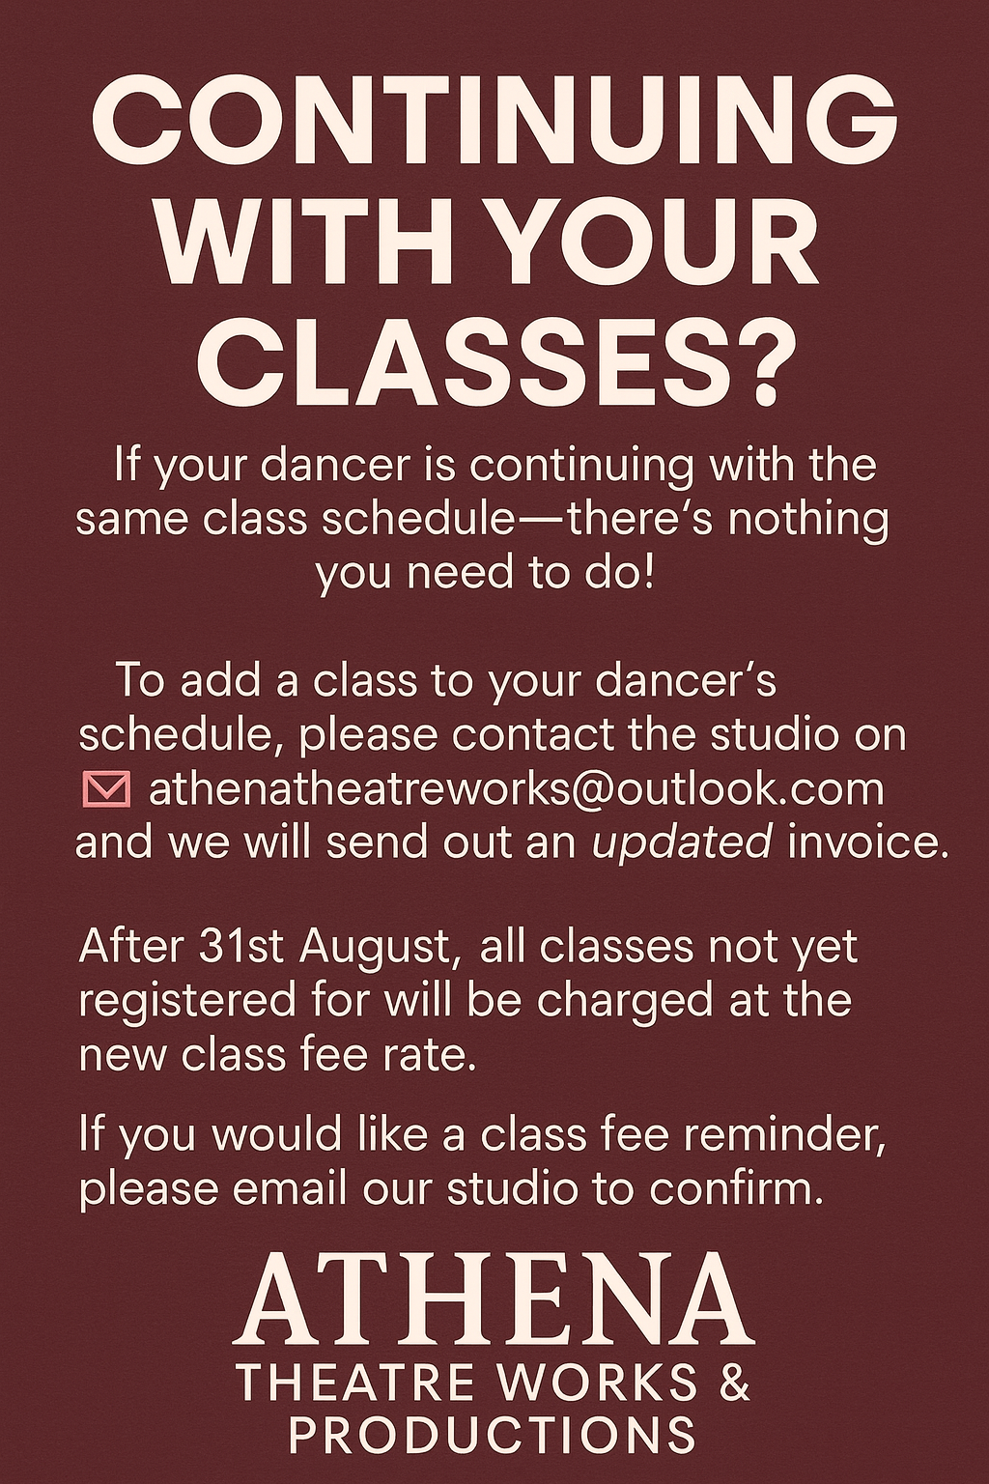

Sunday classes Academy Program Ages 2year – 11 years

The Luna Studio
Class | Age | Time
Primary Dance | 2-3 | 9:00-9:45
Tiny Tumblers | 2-3 | 9:45-10:15
SENDance | 5-10 | 10:15-10:45
Pre/junior Musical Theatre | 4-7 | 10:15-11:00
Class 1 + 2 Tap + Jazz | 4-7 | 11:00-12:00
Acro 1+2 stretch + tone | 4-7 | 12:15-13:00
Inter musical theatre | 8-11 | 12:15-13:00
Mini and junior crew – hip hop | 4-7 | 13:00-13:45
Class 3+4 Tap + jazz | 8-11 | 13:00-14:00
commercial | 8-11 | 14:00-14:45
Company A | 5-7 | 14:00-15:00
Temple Jr and inter | 7-11 | 15:00-15:45
Acrobatics stretch and tone | 8-11 | 15:45-16:30
Inter competitive teams | 8-11 | 16:30-17:30

Senior Saturday classes Ages 12+
The Luna Studio
Class | Age | Time
Classical ballet A | Ability | 08:30-09:15
Classical ballet B | Ability | 09:15-10:00
Modern + contemporary | 12+ | 10:00-10:45
Acrobatics stretch and tone | 12+ | 10:45-11:30
Musical theatre | 12+ | 11:30-12:30
Senior Jazz + tap | 12+ | 13:00-14:15
Commercial | 12+ | 14:15-15:00
Competitive team | Ability | 15:00-16:00
Senior Temple team | Ability | 16:00-17:30
The Graduate Program | Invitation only | 17:30 – 18:00

Monday classes
The Luna Studio
Class | Age | Time
PPA school provision | 4-11 | 09:00-12:00
Community arts after school | 4-11 | 15:30-17:30
Drama production | 6+ | 17:30-18:30
LAMDA | 10-25 | 18:30-19:15
PCERT LAMDA | 16-25 | 19:15-20:00

Tuesday Classes
The Luna Studio
Class | Age | Time
Little beats | 1-3 | 09:15-10:00
Barre + Ballet over 50s | 50+ | 10:30-11:30
Jr voice company | 6+ | 16:45-17:15
Inter + senior voice company | 11+ | 17:15-17:45
GCSE dance | 14+ | 17:45-19:00

Wednesday Classes
The Luna Studio
Class | Age | Time
Stretch + tone wellness | 18+ | 09:15-10:00
Mini cirque, hoop + silks | 4-8 | 16:45-17:45
Junior cirque, hoop + silks | 8-12 | 17:45-18:45
Adult Acro, stretch and tone | 18+ | 18:45-19:30

Thursday Classes
The Luna Studio
Class | Age | Time
PPA school provision | 4-11 | 09:00-12:00
Community arts after school | 4-11 | 15:30-17:30
AB adult dance | 18+ | 18:00-19:00

Friday classes
The Luna Studio
Class | Age | Time
PPA school provision | 4-11 | 09:00-12:00
Preparatory Ballet | 4-6 | 16:45-17:30
Primary Ballet | 6-7 | 16:45-17:30
Primary Modern | 6-7 | 17:30-18:30
Grade 1 + 2 Ballet | 8-11 | 17:30-18:30
Grade 1 + 2 Modern | 8-11 | 18:30-19:15
Pre-pointe | 11+ | 19:15-19:45

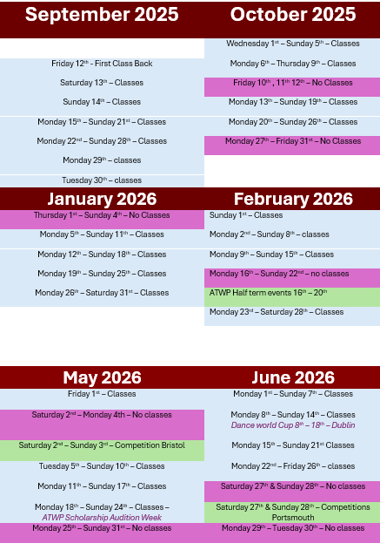
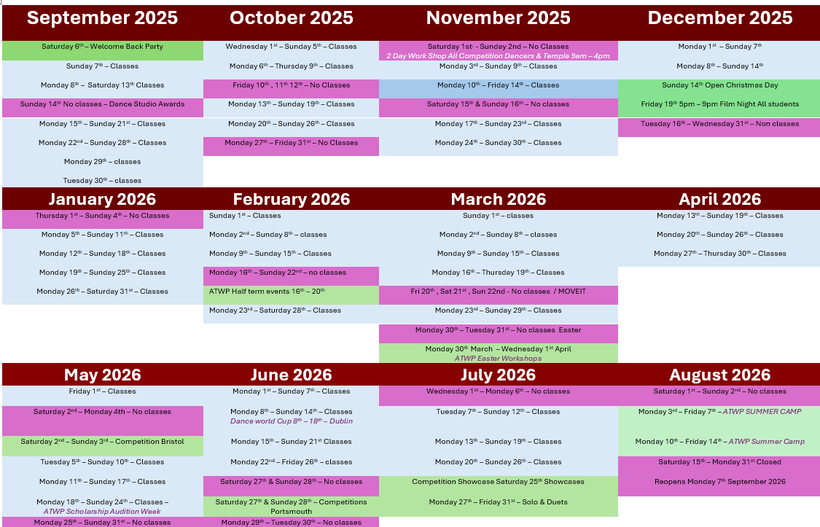
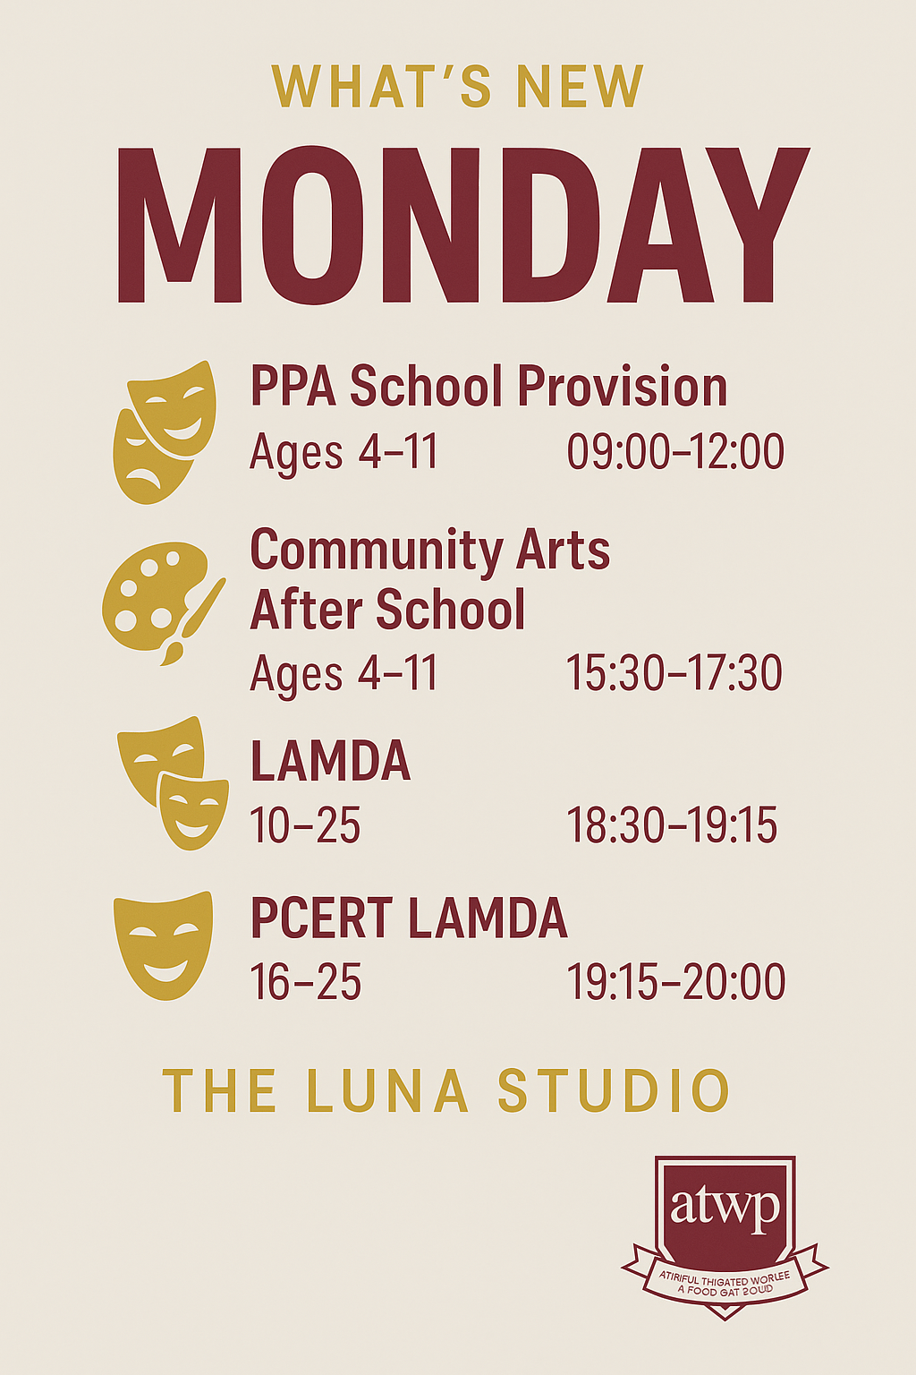

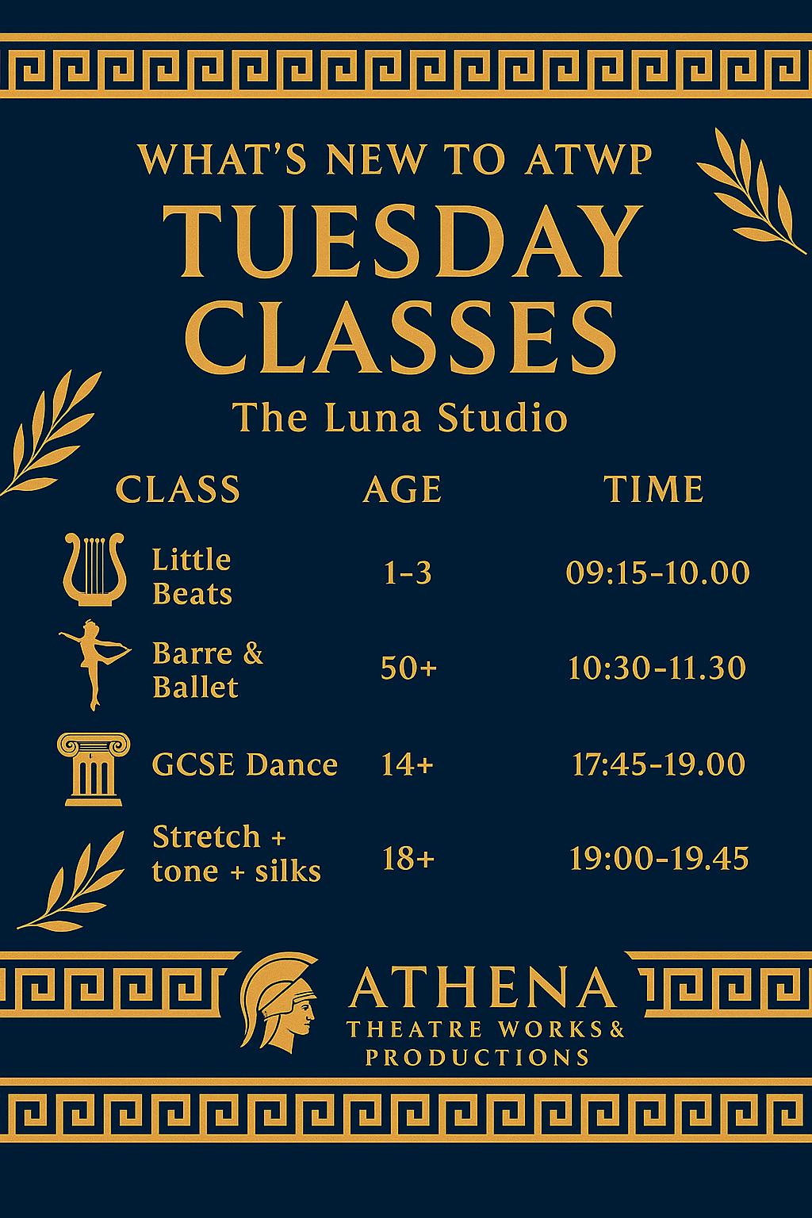
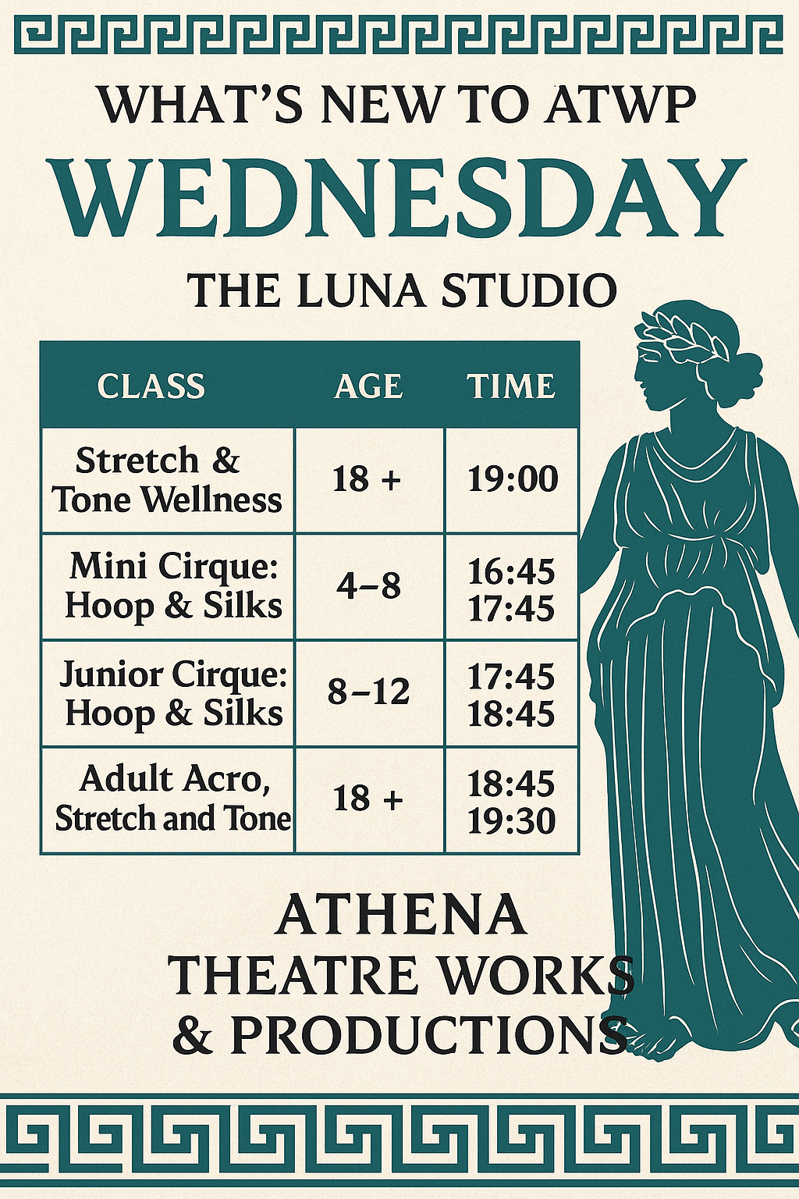
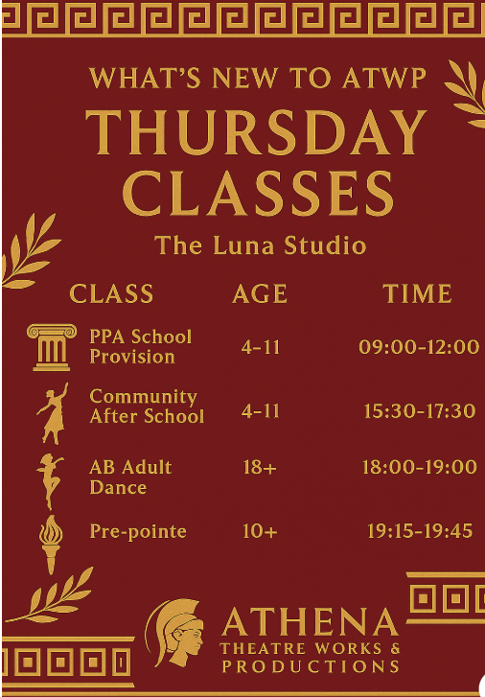
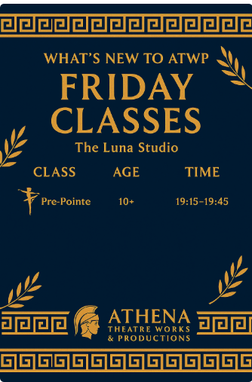

Class Manager Information Page
ATWP uses the app Class Manager – an online portal for easily managing your child’s classes.
To access Class Manager, simply:
- Download the app and follow the link on a welcome email provided once your child’s details are registered.
- Enter your registered email and password.
- If you are a new user, follow the registration process to create an account.
With Class Manager, you can:
- View Your Child’s Timetable and stay up to date with class schedules.
- Check the Calendar and see upcoming events, holidays, and important dates.
- Access Important Information. You will be able to find key details about classes, policies, and updates.
- Sign Up for Trial Classes. You can easily register for trial sessions to explore new classes.
Payment Options:
- We currently accept BACS (Bank Automated Clearing System) payments.
- All class fees are made via standing order , from April 2026 this will move to direct debit .
Please ensure payments are made to the correct details provided in your account. If you have any questions regarding payments, feel free to contact us.
Our BACS details are:
Sort Code 30-90-90
Account Number 41636368

CONTACTING ATWP & THE TEAM
📢 Important Update – Studio Communications
Please note that 07932 669091 is no longer in use.
From now on, all communications, class enquiries, orders, and updates must be sent to our new and only email address:
📧 athenatheatreworks@outlook.com
Our studio will soon have a new phone number and dedicated handset, which will be shared on our website in August once the updated site goes live in the next few days.
To protect our staff’s privacy and ensure we can respond efficiently, personal phone numbers will no longer be used for studio communications. Once the new number is released, please use it to WhatsApp or text us when needed.
Office Hours
📩 Emails: Monday–Friday, 9:00am–3:00pm
📱 Studio Phone: During class times only
Book a Free Taster Class
Visit 🌐 www.athenatheatreproductions.com to register or email
We appreciate you’re understanding and support in keeping communications streamlined so our team can focus on delivering the best possible experience for our students.

✨ Coming October 2026 – ATWP In-House Studio Attire ✨
We’re excited to announce that from October 2026, Athena Theatre Works & Productions will officially stock all your dancewear and performance essentials in-house!
No more searching online — you’ll be able to get everything you need directly from the studio.
What’s in stock?
- Official ATWP logo & printed items – hoodies, t-shirts, jackets, bags, and more!
- Temple Team Attire – full range of performance wear for our competitive & production teams.
- Dance Shoes – jazz trainers, ballet shoes, tap shoes, and more.
- Studio Dancewear – leotards, leggings, tights, warm-ups, and accessories.
Why buy in-house?
- Guaranteed correct uniform for classes, exams & performances.
- High-quality, tried & tested by our dancers.
- Support your studio & wear your team colours with pride.
📍 Shop in studio – try on before you buy
🛒 Order online anytime: www.athenatheatreproductions.com/shop note your order number and simply email us. Or come in and try on and pay via card.


