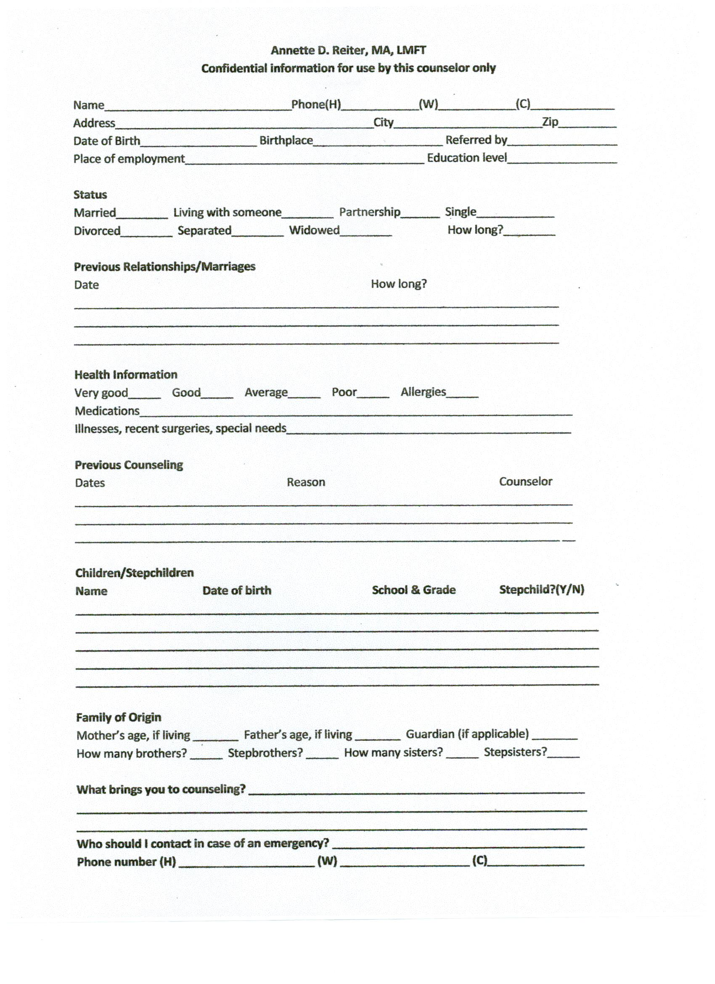
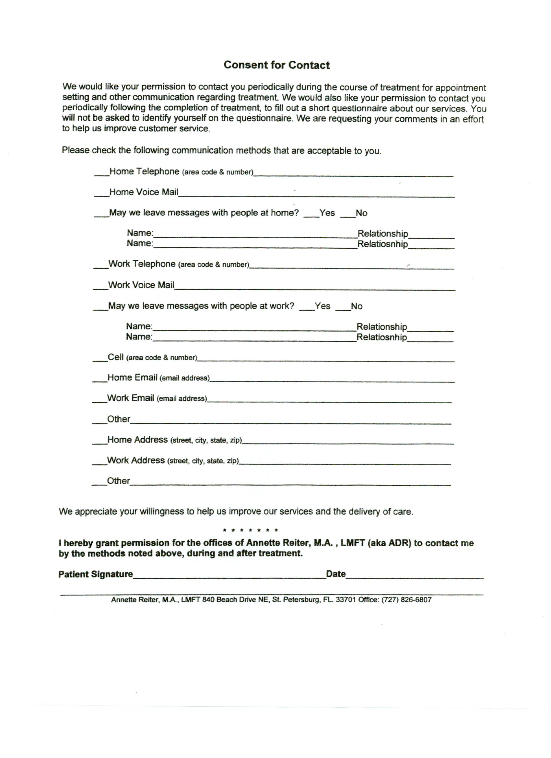
Annette Reiter, MA, LMFT (#1896)
727-826-6807 (landline)
annetter840beach@gmail.com

CLIENT’S RIGHTS AND INFORMED CONSENT
Acknowledgement of Receipt of HIPPA Privacy Notice

Each client will be treated with respect and dignity.
Each client will participate in establishing the goals for counseling.
Each client’s records will remain confidential. No information regarding you or your participation in counseling will be disclosed with the following exceptions:
- A request is made by you and you have read and signed a “Release of Information” form.
- You express the intent to harm yourself or another person.
- You inform me of child and/or elder abuse.
- Information is required for the purpose of insurance claims reimbursement.
A fee will be established with you on or before the intake session. The fee is payable after the session. If you set an appointment for a future date and find that you must cancel, you will not be charged for the session if you provide 24 hours notice by email or voice mail. _____Initial

ADR has explained A) the ways that my identifying information is protected, B) the times when information about me may be released without my specific permission, and C) my rights related to my medical information.
I hereby agree to protect the confidentiality and privacy of other patients at all times. I will not discuss any information concerning other patients with individuals, organizations, agencies or any person not directly employed by ADR.
I, ____________________________________have received and read the “Client’s Rights” and “HIPPA Privacy Notice” form, and I give my consent to participate in counseling with Annette D. Reiter. If applicable, I authorize her and her contracted services to file insurance claims and to receive payment for assessment and counseling services provided to me.
Fee $_______________________________(payment due date of service)
Signed ____________________________________ Print ____________________________
Date ______________________ Witness _________________________________________
This acknowledgement will be retained in your clinical record.

