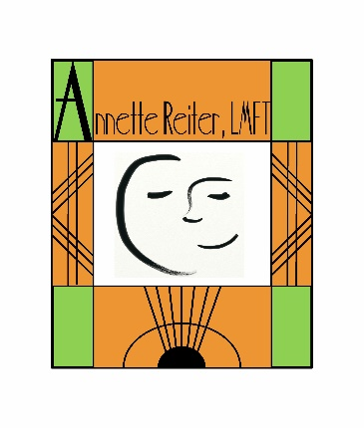
Agreement between Annette Reiter, Inc. & GS 120™ Clients
Annette Reiter, Inc. agrees to interview and assess the client to arrive at an individualized profile in keeping with his/her interests, aptitudes, personality and values.

Annette Reiter, Inc. agrees to generate a GS 120™ with a list of potential careers in keeping with the client’s profile and teach him/her how to begin to explore those careers.

The GS 120™ will provide a Summative Report of the assessment results for the client following the self-exploration process.

The GS 120™ does not include personal counseling or therapy for clients. However, counseling and/or therapy may be scheduled separately through Annette Reiter, Inc. private practice.

There will be no refunds once the GS 120™ testing process has begun.
This agreement was reviewed and signed on _________________________________________
Date
___________________________________ ___________________________________
Client Name Email
___________________________________ ___________________________________
Phone Number ___________________________________
Mailing Address
___________________________________
Client Signature

_________________________ ______________________________
Parent’s Signature (if Client is under 18 years of age) Annette Reiter, Inc.

