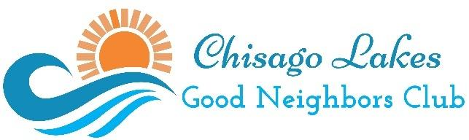 | Adopt a Senior Program  Senior Form

This program is part of the Chisago Lakes Good Neighbors Club and focuses on connecting volunteer members with seniors, and emphasizes the concept of friendship, social interaction, and offering an occasional helping hand. This program is made possible through the Chisago Lakes Area Community Foundation Big Idea Grant.

Applicant:
First Name Last Name
Street Address
City State Zip
Please provide the following contact information and check your preferred method of contact.
Cell Phone
Home Phone
Email
Text Message to Cell Phone Number

Relative or Contact Person:
First Name Last Name
Street Address
City State Zip
Relationship to applicant:
Please provide the following contact information and check your preferred method of contact.
Cell Phone
Home Phone
Work Phone
Email
Text Message to Cell Phone Number

More on back!
Areas of interest that may help connect you to a volunteer:

Religious Stewardship  Sports  Gardening  Card Games  Board Games  Cooking/Baking  Hunting/Fishing  Movies  TV Shows | Game Shows  Books/Reading  Crossword Puzzles  Jigsaw Puzzles  Crafts  Sewing  Walking/Exercise  Music  Other

For your safety and the safety for all our volunteers, volunteers have agreed to the following conditions. Please contact an Adopt a Senior Committee Member if you feel any of these conditions are not being met.
- Volunteers are members of the Chisago Lakes Good Neighbors Club and over the age of 18 or under the direct supervision of a responsible adult at all times.
- Confidentiality - Volunteers will not disclose any personal information pertaining to older adults, members, volunteers, or donors.
- Discrimination Policy - Volunteers will treat all older adult members, other volunteers, and donors with dignity and respect. Further, they will not discriminate on any basis.
- Harassment policy – Volunteers agree to not engage in intimidating, hostile, inappropriate or offensive behavior toward members, volunteers, or donors. Such behaviors include derogatory or degrading comments, unwanted touch, or illegal activity, etc. If they witness or experience such behavior, they will immediately report the concern to an Adopt a Senior Committee Member.
- Medical Advice - Volunteers will not give medical advice to an elder friend. If a volunteer has any concerns regarding an older adult’s medications or medical care they will alert the person listed as their relative or contact person on their application form.
- Financial Advice – Volunteers will not provide financial, banking, or tax advice; act as a representative payee or conservator; serve as a trustee or personal representative for the estate of an older adult.
- Repudiation of Gifts and Professional Services - Volunteers may not accept individual cash gifts or non-financial gifts from our older adults (with the exception of small token gifts totaling $25 or less in any given year), or perform any type of assistance to the older adult for pay. Loaning money to or borrowing money from an older adult is also strictly prohibited.
- Waiver and Release of Liability - In consideration of the risk of injury while volunteering and as consideration for the right to volunteer, volunteers knowingly and voluntarily enter into this waiver and release of liability. Volunteers waive all rights, claims, or causes of action arising from their volunteering. Volunteers release and discharge Chisago Lakes Good Neighbors Club for any injury, or emotional loss incurred as a result of volunteering, including traveling related volunteering.
- Background Check – Volunteers understand that to help ensure the safety of the people the Chisago Lakes Good Neighbor Club serves; volunteers for the Adopt a Senior Program are required to pass a background check. Volunteers will not be placed until a background check is performed and passed by the Adopt a Senior Committee.

Senior Signature Date:
Return completed form via email: To: clgoodneighborsclub@gmail.com
Subject: Adopt a Senior

