Date: ___________+
Hillbilly Degree
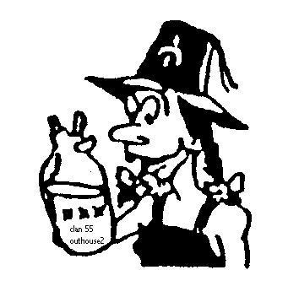
THE GRAND AND GLORIOUS ORDER OF THE HILLBILLY
DEGREE
Clan and Outhouse #_________________________
___________________________ Shrine Center
Petition for membership
Check one! E. Mail of Clan: ________________________________
____ (Men) I certify that I’m a member in good standing of a Blue Lodge, the SHRINE OF NORTH AMERICA, and I’m willing to participate in the initiation.
___ (Men) I’m a member of clan#______ and apply for associate membership in Clan#55 Outhouses#2
____ (Ladies) I certify my sponsor is a member in good standing of a blue lodge, the Shrine of North America, and I’m a willing participate in the initiation!
H.B Card #__________ (Men) Signature _________________________
Unit#___________ Initiated_______________ Approved___________
(Men) Name (print): _________________________ (Ladies) _______________________
P.O Box or Address__________________________ (Ladies) Signature: ____________________
City: _____________________ State: _______ Zip____________ Ph# ___________________
Fee: _____________ Recommended by: ___________________________
Clan Snail Mail Address and Contact persons Info:________________________________________________________________________________

