Imperial Hillbilly Clan
4568 Piketon Rd.
Lucasville, Ohio
45648
www.internationalshrinehillbillies.com

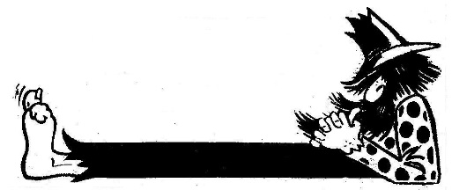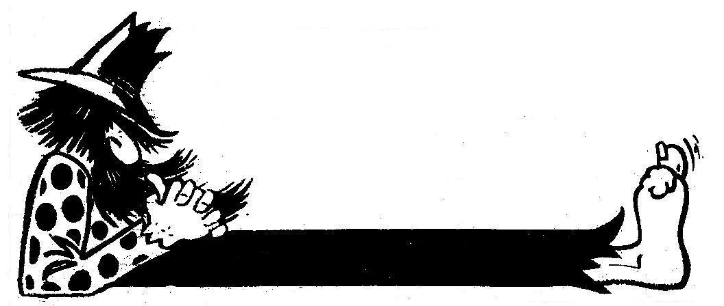

____________________________________________________________________________________________________________
International Queen Contest
Imperial Convention

Rules of selection!

All contestants must register and have their membership cards checked for proof that they are a valid hillbilly gal. This registration will be done by members of host clan. ALL CONTESTANTS CLAN AFFILATION shall NOT be made known to anyone! ONLY valid card carrying gals shall be allowed to run! NO HOST CLAN MEMBERS ARE ELLIGABLE!

At the beginning: ALL PAST INTERNATIONAL QUEENS PRESENT – Should be introduced up front!

Contestants should be asked questions pertaining to what they would do to best represent ALL Hillbilly Clans in North America. ETC. They should then be led around the area for inspection of theme dress by Present International Queen!

Judges WILL BE SELECTED BY HOST CLAN ONLY! 4-6 (Not all from host)

Queen contest will be held on Friday night of convention!

Convention Host Shall provide the following: Crown – Sash for winner! (Sash should have year elected!)

After winner is announced, all past international queens shall pose with the winner for pictures!

Judging Guidelines

Point System: 1-10 (1 lowest)

Originality: 1. Cleanliness 2. Staying with theme

Deduct points for following

Vulgarity
Dirty costume
Toilet paper exposed from back or front
Lewd behavior
Bare exposure – top or bottom

ATTENDITION: We are selecting a Queen to represent the entire International Hillbilly Organization! They above all must conduct themselves with the highest level of respect to others at all times! Remember we in the end work for kids!

Fun: YES Filth: NO

__________________________________________________________________________________________________________
Proud Supporters of the Hillbilly Shriners
__________________________________________________________________________________________________________

