New to the Toledo Area!!

We are now offering Pneumatic Mulch Installation Services.

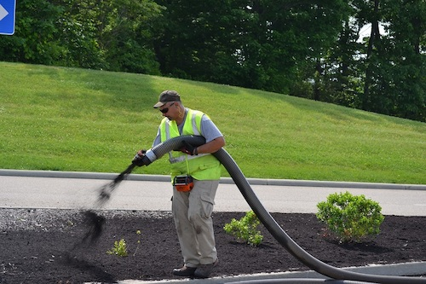

Renewed Outdoors, LLC is a locally owned and operated company based out of Perrysburg, Ohio. We manufacture environmentally friendly products from locally sourced and recycled yard waste. We have used our products in both large and small installation projects. As we continue to grow, we look for efficient ways to produce and install organic recycled mulches and composted products of the highest quality. Along with providing the cleanest installation procedures, we are extremely quick and efficient with all installations. Installing mulch, topdressing with compost, installation of erosion control and wattles, and Green Roof projects are all projects we can handle!

**Now offering the following mulches for installation with just one truck!**

* **Natural Hardwood- 2X or 3X**
* **Dyed Black, Brown and Red Hardwood**
* **Playground Mulch (Certified available)**
* **Woodchips- for erosion control**

**No additional man power or heavy equipment needed. Blown-in services have little to no damage to your property.**

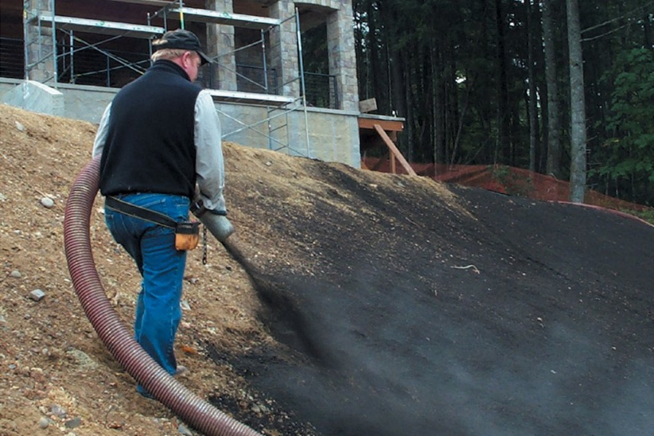

We are highly efficient with installing a variety of products for Home Owner Associations, Commercial Companies, Public Parks, Public Utilities and Services, Municipalities, Schools, Daycare Centers and many other industries.

We will also work with other landscape contractors to efficiently install larger quantities of products in a timely manner, with minimal labor requirements, giving the contractor a large profit margin with no labor!

**Terraseeding is also available!**

**(A compost material blended with grass seed equals a fast germination for a lush, green lawn)**

**Choose between compost only, a compost-soil blend or a custom requested media.**

Alongside with Mulch installation services, we can also provide pneumatic installation of compost, some bulk rock products, varying soil media blends to serve purposes such as lawn installation and renovations, athletic field renovations and top-dressing, garden and Green Roof products. We can complete sediment control services with silt sock filters, install Bio-swale and similar retention soil media, complete riverbank erosion control and reclamation projects along with other similar sustainability and environmentally friendly projects! We can effectively apply products up to 600’ from the truck, allowing the most efficient and cost-effective method to install materials on time sensitive projects.

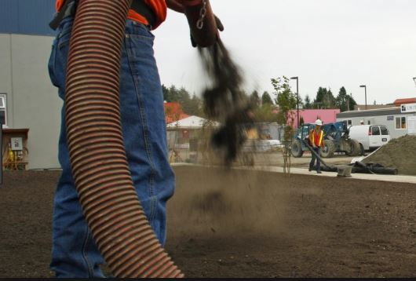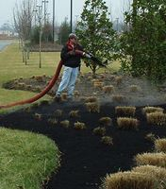

All of our materials are sourced as locally as possible and we manufacture most of our own organic mulch and compost products in-house. This allows us to control our quality to provide premium materials for the proper installation within your project!

