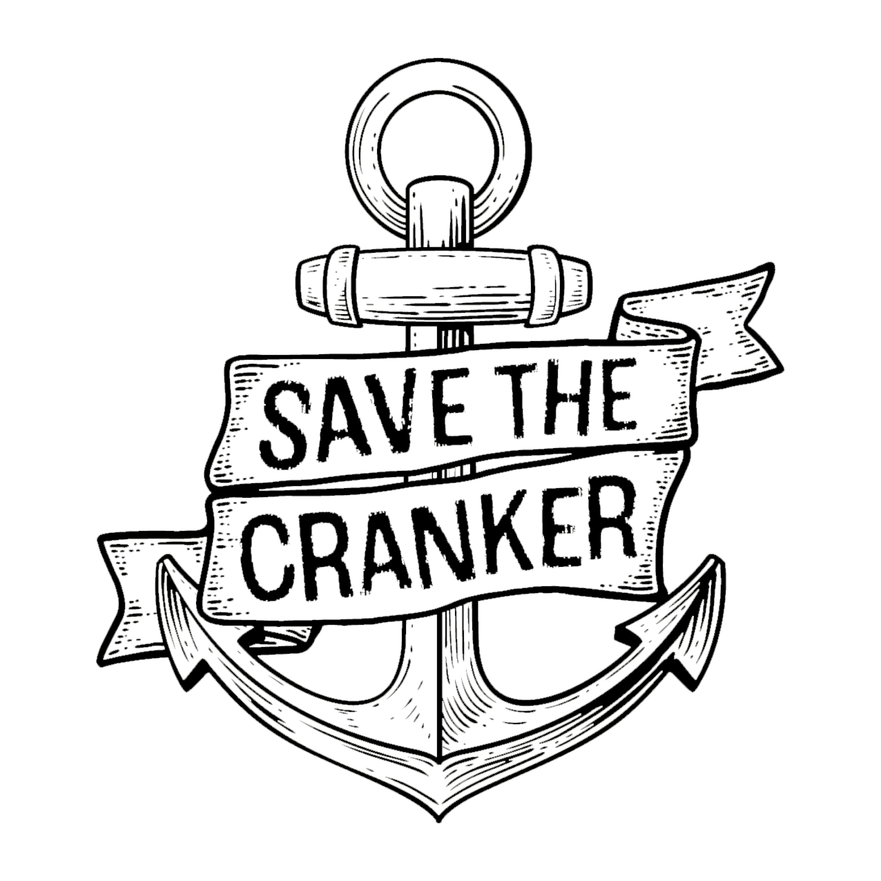
Talent Release Form

Name of Person Completing the Form:Click or tap here to enter text. (referred to as I)
E-Mail: Click or tap here to enter text.
Brief description of visuals/audio recorded:Click or tap here to enter text.
Date:Click or tap to enter a date.
Location:Click or tap here to enter text.

    - I understand that my image, likeness, voice, testimonial, name and/or any other representation of me will be recorded or captured at the session undertaken for the Save The Cranker Campaign as described above (Images).

    - I consent to the Save The Cranker Campaign (and anyone acting within its authority) using, reproducing or editing the Images:
      - for commercial and educational purposes;
      - to promote the campaign and its interests; and
      - to enable any product in which the Images appear to be licensed, distributed, exhibited or sold (including for a commercial return), (Image Rights).

    - The Images may appear, or be referenced in, any medium, including written publications, audio, video or other media which may exist in the future.

    - In exercising the Image Rights, the Save The Cranker Campaign will not intentionally disparage, denigrate or damage my name or reputation.

    - I acknowledge that I will not:
      - acquire any rights over any product in which the Images are used, or any monetary proceeds which are derived from their sale, licensing, distribution or other use; and
      - be paid for acting as a participant in the session or providing the above consents.

    - I release the Save The Cranker Campaign (and anyone acting with its authority) from any claims relating to the above consents.

Name of Person Completing Form:Click or tap here to enter text.

Date: Click or tap to enter a date.

The signatory must email savethecranker@gmail.com with this completed form.

If the person signing is aged under 18, a parent or legal guardian must sign below.
I am the parent or legal guardian of the above person and I also give my consent to the terms of this form.

Name of Parent or Guardian:Click or tap here to enter text.

Date: Click or tap to enter a date.

The parent or legal guardian must email savethecranker@gmail.com with this completed form.

Completing this form in plain text and emailing it to savethecranker@gmail.com constitutes your talent release.

Save The Cranker Campaign

http://savethecranker.com.au/

April 2024

