**12 Musical Meditations To Channel Your Inner Yogi**

October 29, 2019

Focus your energy and calm your mind by adding these relaxing melodies to your next yoga session.



**1.**[**"Only Time" By Enya**](https://open.spotify.com/track/6FLwmdmW77N1Pxb1aWsZmO)

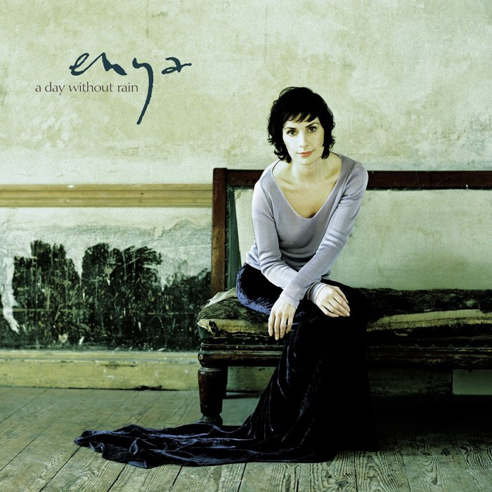

**2.**[**"Ong Namo" By Mirabai Ceiba**](https://open.spotify.com/track/1NeBKF6ydn9jIiBD0kEeR8)



**3.**[**"Chapter Of The Forest" By Trevor Hall**](https://open.spotify.com/track/3eDYjWD8Axyj50BPtxq2R7)



**4.**[**"Way Down We Go" By Kaleo**](https://open.spotify.com/track/0y1QJc3SJVPKJ1OvFmFqe6)



**5.**[**"Guru Ram Das Raakho Saranaa-Ee (Sanctuary)" By Snatam Kaur**](https://open.spotify.com/track/5axGtQ9y39sOhxpR1zd9DE)



**6.**[**"Way Down Low" By Brenda McMorrow**](https://open.spotify.com/track/3cgkjZVW7DuY5SdyJCrzxl)



**7.**[**"Sunshine" By Matisyahu**](https://open.spotify.com/track/1ma4sCjoVMptvilcgJDPGc)



**8.**[**"Bountiful, Blissful, Beautiful" By Bachan Kaur**](https://open.spotify.com/track/0lYjXaxme8dOQzrikcJgnA)



**9.**[**"Lon-Dubh (Blackbird)" By Julie Fowlis**](https://open.spotify.com/track/0oeNHGiNyo5FkoKAUwWHTf)



**10.**[**"The Voice" By Celtic Woman**](https://open.spotify.com/track/2E3y6X63fbZCYJGELwRAWQ)



**11.**[**"Om Sarve" By Tina Malia**](https://open.spotify.com/track/323wg8AkiQYJ2JThcKgeri)



**12.**[**"La Ilaha Il Allah" By HuDost**](https://open.spotify.com/track/2arY7jdOw1GPx2Z0htsNrG)

