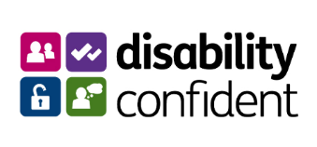

Guaranteed Interview Scheme
If you require this form in an alternative format, please let us know

The Birmingham 2022 Commonwealth Games Organising Committee Ltd is committed to the employment and career development of disabled people.

We guarantee to interview anyone with a disability whose application meets the minimum criteria for the post. By ‘minimum criteria’ we mean that you must provide us with evidence in your application which demonstrates that you generally meet the level of skills and experience defined as essential within the person specification for the position.

The Equality Act 2010 defines someone as a disabled person if a) they have a physical or mental impairment; and b) the impairment has a substantial and long-term adverse effect on their ability to carry out one or more normal day to day activities.
Do you wish to claim an interview under the Guaranteed Interview Scheme?

Yes

No

Will you require assistance if invited to interview / assessment?

Yes

No

If yes, please provide details here any specific requirements or equipment you may need:

Name:
Date:

If applying under this scheme, please complete this form and return it with your CV and covering letter to recruitment@birmingham2022.com

