1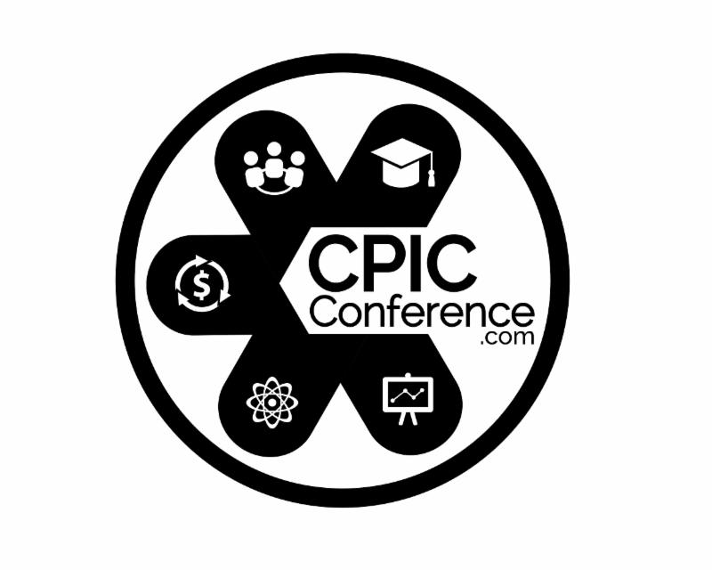  

Introduction to Technology Business Management (TBM) Training for Federal IT Compliance - 1 Day Seminar

The Agnostic Introduction to Technology Business Management (TBM) for Federal IT Compliance (1 Day). This one-day overview and introductory course allows the attendee to be eligible for eight (8) Continuous Learning Points (CLPs) for continuing professional education towards a variety of certifications and practices. Technology Business Management means different things to different people... it can be:
- A proprietary software solution implemented by consulting firms with a council that may or may not truly represent the variety of commercial off-the-shelf (COTS) options and vendors (yet),
- A framework for assigning costs to information technology in certain "cost towers" that does NOT have to be vendor-specific,
- An approach that has been successfully implemented in the private sector but faces real cultural and financial obstacles in the federal market,
- A best practice that fits into the Technical Reference Model (TRM) component of a compliant federated architecture approach; enabling clearer insight into how resources are expended in service-driven technologies that more accurately can depict how the fed spends money beyond operations, maintenance, development, modernization or enhancements.

Our instructors will provide an "agnostic" overview to assist attendees with how to understand the intent, the compliance-driven mandate from the Office of Management & Budget (OMB). We will review what has been incorporated into mandatory financial and project/ program/ portfolio/ investment reporting during 2017 (for Budget year 2019) as well as a review of what is prognosticated to be rolled out in terms of reporting for 2018 (budget years 2020 and 2021).
As we continue to refine the requirements and emerging information, we will continue to post updates to course agenda, information and content.
Instructor(s):
Shawn Battle, CPP-I
Janelle Moore, MSIM, CPP, CPP-I, GRC-IT, CGEIT

Page 1 of 2

Introduction to Technology Business Management (TBM) Training for Federal IT Compliance - 1 Day Seminar

When
Thursday December 6, 2018
8:30 - 5:00 PM EST

Where
Regus
Carlyle Crescent
1940 Duke Street, Suite 200
Alexandria
Driving Directions

Contact
Assistant
CPIC Forum
Christine Davenport-Everett
Federal CPIC Forum & Zen Federal, LLC
877-469-7690 x5
assistant@cpicforum.org

REGISTER NOW

Page 2 of 2
  JANELLE B. MOORE,  Instructor BIO |   Janelle Moore is the CEO of Zen Federal LLC and Executive  Director of the Federal CPIC Forum. 20+ years of C-level  experience leading and growing business particularly in  health and IT fields supporting a variety of agencies to include  the Department of Veterans Affairs and Centers for  Disease Control. Mrs. Moore is an expert at facilitating  adult education, coaching, counseling and mentoring as  well as leading change in diverse environments. Strategic  thinking, innovation, networking and building  enduring relationships are core strengths.  Solutions-driven. Resourceful. Each client receives  dedication, performance and customized support.  Mrs. Moore has been featured in “CEO Today Magazine,”  and was awarded the prestigious CEO award for  Management Consulting in May of 2018. You can  access Janelle’s Profile in “CEO Today Magazine”  at: CEO Today
CREDENTIALS:
CGEIT Certified (ISACA) (2009- present)
CIO Certificate/ Masters, National Defense University
Information Assurance Certificate/ Masters, National Defense University (NSA 4011)
CIO Certificate, GSA
Capital Planning Professional Certification - CPP
Certified Capital Planning Instructor- CPP-I
Fellow, Industry Advisory Council - Association for the Council of Technologies (IAC-ACT) Partners Program - 2002.

PUBLICATIONS
Capital Planning and Investment Control Guidebook
Wounded Warrior Handbook ("The Red Book") 1st and 2nd Editions
Military Marriage Survival Guide
Special Needs Families in the Military: A Resource Guide
Life After The Military: A Handbook for Transitioning Military and related technologies.

EXPERIENCE
2006-Present, Director, Federal CPIC Forum
2002- Present, Chief Executive Officer (CEO), Zen Federal LLC
2000 - 2002 Senior Associate, Booz Allen Hamilton
1999-2001 Director of Federal Marketing, Market*Access International
1997-1999 Marketing Program Manager & Contracts Manager, Federal Data Corporation (Northrop Grumman IT)

EDUCATION
Mrs. Moore has three Masters in CIO studies and proceeding towards a
Doctorate work in CPIC/Information Management
2005-2007 Syracuse University, Master of Science, Information Management
2002-2005 National Defense University, Masters. Information Resources Management College:
CIO Certificate
2002-2005 National Defense University, Masters, Information Resources Management:
Information Assurance
1991-1994 East Carolina University, Bachelor of Arts, Philosophy/Business Administration

HONORS & AWARDS
CEO award for Management Consulting in May of 2018
Fed100 Nominee, 2015-2016
Fed100 Awards Cooper Godlove
CPIC Award of Excellence, Outstanding Educational Partner
Cooper-Godlove CPIC Awards of Excellence, Award for Excellence in Service Cooper-Godlove
CPIC Award of Excellence, CPIC Industry PaceSetter

  Shawn E. Battle  Instructor BIO | Shawn Battle is a highly accomplished Program Manager with specialized expertise in diverse areas of Information Systems, Technology Innovation,  and Business Transformation. Adept at developing and implementing  enterprise level programs to support cross-functional and collaborative information assets that improve productivity and minimize risk. Skilled in creating custom applications, adapting emerging technology within organizations, and surpassing business objectives. Superior Leadership  talents relating to organizational development, portfolio management,  budget formulation and execution, and project improvement. Mr. Battle  is a Federal CPIC Forum advisor and presently serving in the  capacity of co-chair of the CPIC Forum's Certification & Education Special  Interest Group (SIG), is a CPP-I certified instructor and has joined the  TBM Council among other qualifications and credentials.
CAREER HIGHLIGHTS
Successfully managed a $1 billion IT Portfolio with 200+ investments, through evaluation, selection, and budget formulation • Developed a proof of concept and presented it to the Executive Office of the President and members of Congress • Created an integrated governance structure that provided line-of-sight coordination between Architecture, Capital Planning, Program Management, and Organizational Objectives • Led aggressive turnaround management initiatives involving multiple runaway projects, which included realigning resources, budgets, time-lines, and expectations while delivering the program and exceeding expectations • Spearheaded the development and implementation of multiple disaster recovery, continuity of operations, and data center consolidation programs within budget and prior to planned completion dates

EDUCATION & CREDENTIALS
Masters Certificate, Chief Information Officer/Executive Competencies – Federal CIO University Master of Science, Technology Management – George Mason University Bachelor of Science, Information Systems, Minor in Business – George Mason University; Graduated Cum Laude

AREAS OF EXPERTISE FOR MR. BATTLE
Strategic Planning & Resource Management:
- Enterprise and Solutions Architecture
- Business Process Mapping/Modeling
- Organizational Knowledge Management
- IT Transitioning and Road-mapping
Portfolio Management & Budgeting:
- Capital Planning and Asset Control
- Financial Resource Allocation
- Cost Benefit-Alternatives Analysis
- Business Case Development
IT Governance & Program Management:
- COBIT and ITIL Implementation
- Organizational Change Control
- Risk Management (NIST Framework)
- Information and Decision Analytics
In addition, Mr. Battle has 15 years+ experience in Life Cycle Solutions & Professional Services to the Federal Government Sector

