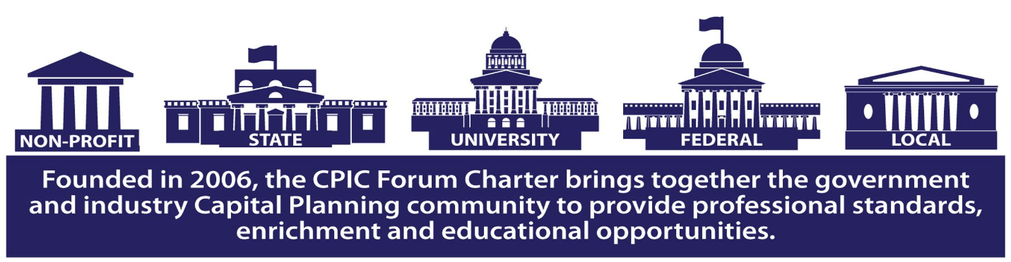

**Capital Planning & Investment Control (CPIC)**

**CPIC: 4 Day Course (Boot Camp)**

Four Days & 36 Continuing Professional Learning Credits Offered  
Recommended for those pursuing Capital Planning Professional (CPP) certification or those looking for a deeper level of exposure to the CPIC Life Cycle Methodology, how CPIC ties to Project/ Investment/ Program/ Portfolio Management, in-depth exposure to required artifacts, and deeper dives into the content required to present a compliant business case justification for ongoing or new investments.

This course is offered once annually each November in Clearwater, Florida and is available for acquisition as a private course offering.

Candidates to Analysts Initiative (C2AI) candidates may upgrade to this course to complete course requirement. This 4-day intensive course covers the comprehensive nature of CPIC-in-practice, guidance, and specifics relating to required artifacts and how to do them; augmented with guest speakers and media presentations. The course includes:

* CPIC Exam-recommended reading list
* CPIC Body of Knowledge (BOK)
* Capital Planning Professional Exam access for one exam completion



*Page 1 of 3*

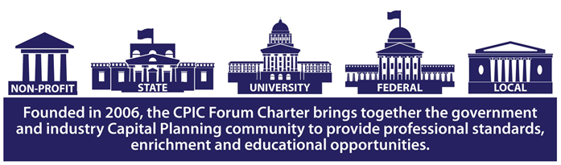

**4 Day Course Outline:**

Throughout the course, the instructor will explain the common compliance challenges for contractor-led work versus government-led work, which efforts may be appropriately designated for contractor support versus “inherently governmental” roles, and how tools may support or enhance reporting efforts at the portfolio, program and project levels. Each course is facilitated by at least one certified Capital Planning Professional Certified Instructor (CPP-I) and counts towards:

* C2AI requirements
* Federal Acquisition Certification (FAC) electives
* The Capital Planning Professional Certification (CPP) application and/or electives
* Can be self-reported with the attendance certificate for other professional, project and program management certification continuing education requirements.

Learn about the on-going budget guidance changes announced annually by the Office of Management & Budget (OMB); The course is updated annually to reflect the most recent changes in guidance. This course introduces the annual, most recent changes to the process and reviews the current versions of Exhibits or Reports. It delves into the reporting requirements which now accompany the budget justification and submittal processes. This course is designed to review the current guidance and requirements, to include monthly reporting requirements to the IT Dashboard. The course is designed to teach attendees the key tenets behind OMB Circulars and the General Accountability Office (GAO) Information Technology Investment Management (ITIM) Guide as requiring the use of CPIC.



*Page 2 of 3*



**Course Outline:**

During this lecture-based and discussion-enriching course, the instructor will discuss which types of projects are defined as “Major” investments and how the Administration has changed the way we are gathering, measuring, reporting and monitoring performance via the IT Dashboard. We will discuss the requirements and compliance issues surrounding the laws driving and enabling Capital Planning, investment control, performance-based contracting, enterprise architecture and portfolio management. Attendees will learn the importance of establishing and reporting credible cost, schedule and performance data for reporting within the context of demonstrating performance in the required reports. Throughout the seminar, the instructor will explain the common compliance challenges for contractor-led work versus government-led work, which efforts may be appropriately designated for contractor support versus “inherently governmental” roles, and how tools may support or enhance reporting efforts at the portfolio, program and project levels. Capital Planning Professional (CPP) Certification seekers: With requisite knowledge, skills and experience, completing this full course, the survey, and a passing exam score could be sufficient credentials to complete a Capital Planning Professional (CPP) Certification. Application fees for the CPP may be included, see your course for particulars. Retake exam fees are not included. Students have up to three months to use the one-time exam access from the date the course is successfully completed.

[**REGISTER FOR OCTOBER 20-24 2019 - DUNEDIN/CLEARWATER, FLORIDA**](http://events.r20.constantcontact.com/register/event?oeidk=a07ef0qzo251aec9077&llr=lzhhlrqab)



*Page 3 of 3*

|  |  |
| --- | --- |
| **JANELLE B. MOORE,**  **Instructor BIO** | Janelle Moore is the CEO of Zen Federal LLC and Executive  Director of the Federal CPIC Forum. 20+ years of C-level  experience leading and growing business particularly in  health and IT fields supporting a variety of agencies to include  the Department of Veterans Affairs and Centers for  Disease Control. Mrs. Moore is an expert at facilitating  adult education, coaching, counseling and mentoring as  well as leading change in diverse environments. Strategic  thinking, innovation, networking and building  enduring relationships are core strengths.  Solutions-driven. Resourceful. Each client receives  dedication, performance and customized support.  Mrs. Moore has been featured in “CEO Today Magazine,”  and was awarded the prestigious CEO award for  Management Consulting in May of 2018. You can  access Janelle’s Profile in “*CEO Today Magazine”*  at: [CEO Today](https://managementconsultingawards.ceotodaymagazine.com/winners-edition/44/) |

CREDENTIALS:

CGEIT Certified (ISACA) (2009- present)

CIO Certificate/ Masters, National Defense University

Information Assurance Certificate/ Masters, National Defense University (NSA 4011)

CIO Certificate, GSA

Capital Planning Professional Certification - CPP

Certified Capital Planning Instructor- CPP-I

Fellow, Industry Advisory Council - Association for the Council of Technologies (IAC-ACT) Partners Program - 2002.

PUBLICATIONS

Capital Planning and Investment Control Guidebook

Wounded Warrior Handbook ("The Red Book") 1st and 2nd Editions

Military Marriage Survival Guide

Special Needs Families in the Military: A Resource Guide

Life After The Military: A Handbook for Transitioning Military and related technologies.

EXPERIENCE

2006-Present, Director, Federal CPIC Forum

2002- Present, Chief Executive Officer (CEO), Zen Federal LLC

2000 - 2002 Senior Associate, Booz Allen Hamilton

1999-2001 Director of Federal Marketing, Market*Access International

1997-1999 Marketing Program Manager & Contracts Manager, Federal Data Corporation (Northrop Grumman IT)

EDUCATION

Mrs. Moore has three Masters in CIO studies and proceeding towards a

Doctorate work in CPIC/Information Management

2005-2007 Syracuse University, Master of Science, Information Management

2002-2005 National Defense University, Masters. Information Resources Management College:

CIO Certificate

2002-2005 National Defense University, Masters, Information Resources Management:

Information Assurance

1991-1994 East Carolina University, Bachelor of Arts, Philosophy/Business Administration

HONORS & AWARDS

CEO award for Management Consulting in May of 2018

Fed100 Nominee, 2015-2016

Fed100 Awards Cooper Godlove

CPIC Award of Excellence, Outstanding Educational Partner

Cooper-Godlove CPIC Awards of Excellence, Award for Excellence in Service Cooper-Godlove

CPIC Award of Excellence, CPIC Industry PaceSetter

|  |  |
| --- | --- |
| **Shawn E. Battle**  **Instructor BIO** | Shawn Battle is a highly accomplished Program Manager with specialized expertise in diverse areas of Information Systems, Technology Innovation,  and Business Transformation. Adept at developing and implementing  enterprise level programs to support cross-functional and collaborative information assets that improve productivity and minimize risk. Skilled in creating custom applications, adapting emerging technology within organizations, and surpassing business objectives. Superior Leadership  talents relating to organizational development, portfolio management,  budget formulation and execution, and project improvement. Mr. Battle  is a Federal CPIC Forum advisor and presently serving in the  capacity of co-chair of the CPIC Forum's Certification & Education Special  Interest Group (SIG), is a CPP-I certified instructor and has joined the  TBM Council among other qualifications and credentials. |

CAREER HIGHLIGHTS

Successfully managed a $1 billion IT Portfolio with 200+ investments, through evaluation, selection, and budget formulation • Developed a proof of concept and presented it to the Executive Office of the President and members of Congress • Created an integrated governance structure that provided line-of-sight coordination between Architecture, Capital Planning, Program Management, and Organizational Objectives • Led aggressive turnaround management initiatives involving multiple runaway projects, which included realigning resources, budgets, time-lines, and expectations while delivering the program and exceeding expectations • Spearheaded the development and implementation of multiple disaster recovery, continuity of operations, and data center consolidation programs within budget and prior to planned completion dates

EDUCATION & CREDENTIALS

Masters Certificate, Chief Information Officer/Executive Competencies – Federal CIO University Master of Science, Technology Management – George Mason University Bachelor of Science, Information Systems, Minor in Business – George Mason University; Graduated Cum Laude

AREAS OF EXPERTISE FOR MR. BATTLE

Strategic Planning & Resource Management:

* Enterprise and Solutions Architecture
* Business Process Mapping/Modeling
* Organizational Knowledge Management
* IT Transitioning and Road-mapping

Portfolio Management & Budgeting:

* Capital Planning and Asset Control
* Financial Resource Allocation
* Cost Benefit-Alternatives Analysis
* Business Case Development

IT Governance & Program Management:

* COBIT and ITIL Implementation
* Organizational Change Control
* Risk Management (NIST Framework)
* Information and Decision Analytics

In addition, Mr. Battle has 15 years+ experience in Life Cycle Solutions & Professional Services to the Federal Government Sector