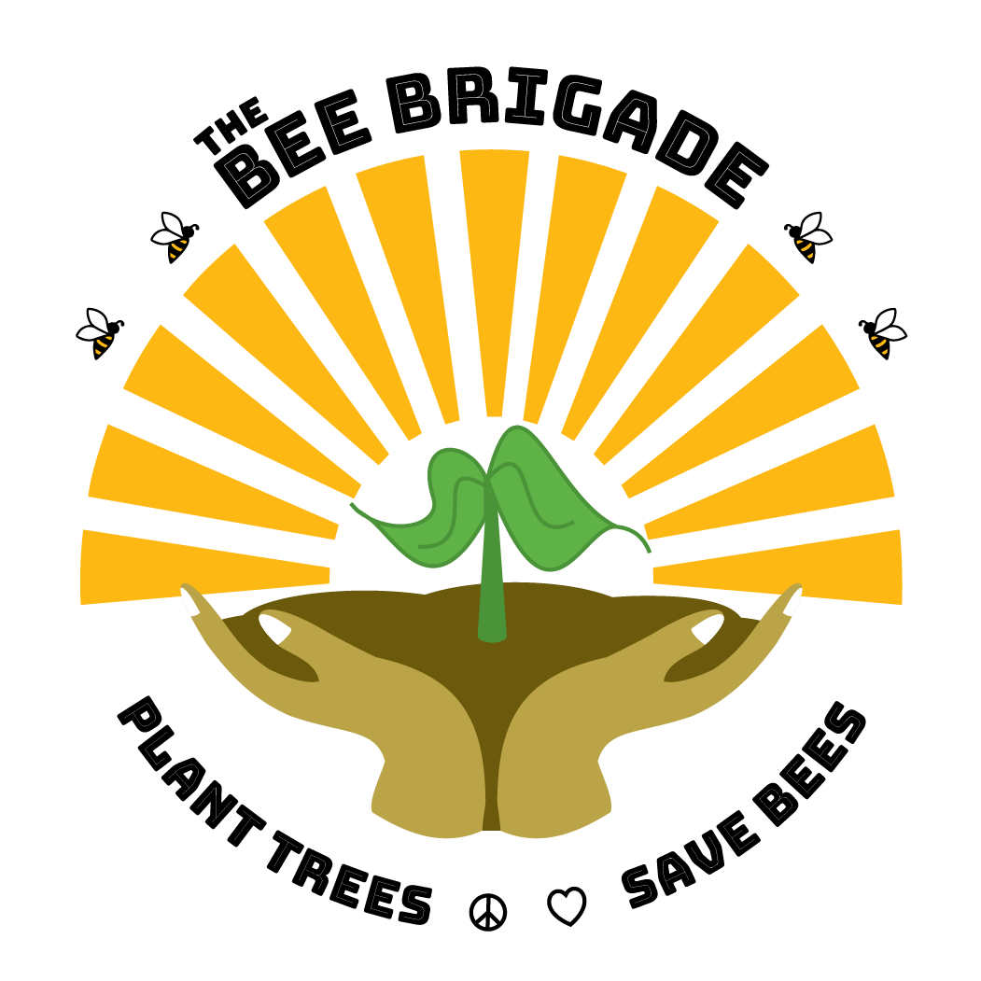

**Future Beekeepers of America**

**-Saving the Bees through Farm to School Program-**

**About The Bee Brigade**

The Bee Brigade is a federally recognized 501c3 Charitable Organization and California Public Benefit Corporation based out of San Diego, California. Focused on integrating and educating the general public about bees, how they are used in agriculture, and their importance in our environment. Other programs include pathways to land ownership for underserved community members, beekeeping school, and various ways to allow the underserved community access to this knowledge.

**Bee Brigade Mission**

The Mission of the Bee Brigade is to connect nature and human life through bee education at perpetual bee sanctuaries that serve as a hub for hands on learning about beekeeping, the agriculture industry, and ways to protect this part of our environment.

**Program Description**

The Future Beekeepers of America- Saving the Bees through Farm to School Programs- will be a partnership between The Bee Brigade (501c3) and Vista Unified School District. The Vista Unified School District serves 10,000+ students with over 65% of a student population receiving free reduced lunch. Through the funds received from the grant, The Bee Brigade will introduce students to agricultural beekeeping, pollinator sustainability, and the health and nutritional benefits of honey. With the Bee Brigade Mobile Classroom, we will provide an experiential learning opportunity, that will increase students’ exposure to the beekeeping industry. The goal of this program is to 1. Educate the youth about the importance of bees & sustainability, 2. Offer a new trade and set of skills for children of underserved populations to learn, 3. Empower and educate the youth on how to create their own beekeeping or agricultural related careers, and 4. Encourage the youth to play a vital roll in the harmony of animals and humans on the planet.

**Program Elements**

1. Mobile Classroom
2. Beekeeping Agricultural Training
3. Experiential Nutritional Learning
4. Farm to School Program- Coursework and Training Materials

**Program Measures of Success & Sustainability**

We will measure our success of the program through: student sign-ups and participation (with a goal of a minimum of 10% of each student body), program implementation at all 8 campuses, Future Beekeepers organizations and clubs being initiated at schools, and in classroom evaluation forms when partnered directly with a teacher. One major goal of the program is for it to be convenient and cost free for schools, so that they can continue to sign up annually and we can eventually capture more schools in the district.

**Schools to Partner with**

|  |  |  |
| --- | --- | --- |
| **SCHOOL NAME** | **ENROLLEMENT** | **FREE REDUCED LUNCH POPULATION** |
| MADISON MIDDLE SCHOOL | 1044 | 752 |
| RANCHO MINERVA MIDDLE SCHOOL | 630 | 585 |
| ROOSEVELT MIDDLE SCHOOL | 903 | 689 |
| VISTA INNOVATION & DESIGN ACADEMY (MS) | 808 | 480 |
| VISTA MAGNET MIDDLE SCHOOL OF TECHNOLOGY, SCIENCE & MATH | 844 | 601 |
| VISTA HIGH SCHOOL | 2240 | 1758 |
| RANCHO BUENA VISTA HIGH SCHOOL | 1987 | 1335 |
| MISSION VISTA HIGH SCHOOL | 1660 | 667 |
| **TOTAL PROGRAM ENROLLMENT** | **10116** | **6868** |

**Budget Narrative- $99,480.00**

1. **Personnel - $16,920.00**
   1. Director- $7,000.00
      1. The Director will spend 10% of their annual time on this project. Annual salary is $70,000 x 10%= $7,000
   2. Project Manager - $7,000.00
      1. The Project Manager will spend 10% of their annual time on this project. Annual salary is $70,000 x 10%= $7,000
   3. Mobile Team- $9,600.00
      1. The Mobile Team will be comprised of 2 employees both making minimum wage of $15.50/hr. There will be a total of 64 visits a year x 5 hours per visit= 320 hours per employee- per year. 320 hours x 2 employees x $15.50 minimum wage= $9,960.00
2. **Travel - $2,560.00**
   1. Vehicle Gasoline- $2,560.00
      1. $40.00 is the average cost of trip x 64 annual trips= $2,560.00
3. **Equipment- $30,000.00**
   1. Mobile Trailer- $10,000
      1. A mobile trailer will be used to transport “The Bee Brigade Mobile Classroom” to each school campus. The trailer will help carry supplies and provide experiential learning opportunities. A trailer will require $10,000.00.
   2. Agricultural Truck (Used)- $20,000.00
      1. In order to tow the trailer to each location, a purchase of a used agricultural vehicle will be necessary. This vehicle will allow our mobile team to reach each destination and provide the farm to school programs. A used vehicle purchase will require $20,000.00.
4. **Supplies- $50,000.00**
   1. Classroom Handouts - $6,000.00
      1. The Bee Brigade will pass out agricultural training handouts and worksheets during school programs. The cost of evaluations is also included in this handout fee, which is a total of $6,000.00 for the 12-month period.
   2. Classroom Teaching Display Materials- $12,000.00
      1. Display Materials will be needed for the inside of the Mobile Classroom Trailer, as well as for inside classrooms for presentation use. There will need to be ample materials, so that the Bee Brigade can possibly leave some educational materials with the 8 different campuses we visit. A total of $12,000.00 is required to purchase the needed displays.
   3. Bee Suits- $12,000.00
      1. In order to provide an experiential learning experience, The Bee Brigade will purchase Bee Suits and bring them to campuses. Students will get the opportunity to suit up like a real-life beekeeper, while diving deeper into the knowledge of agriculture and farm life. Average beekeeping suit price is $120 x 100 suits= $12,000.00.
   4. Beekeeping Equipment- $10,000.00
      1. In order to provide an experiential learning experience and agricultural training, The Bee Brigade will purchase beekeeping equipment to bring to campuses. Students will get the opportunity to learn about the tools needed to thrive in this agricultural field. We will be able to demonstrate vital beekeeping skills and training with the purchase of $10,000.00 worth of equipment.
   5. Honey Processing Supplies- $10,000.00
      1. In order to help a majority of underserved youth get access to healthier food products, as well as develop the skills needed to produce their own food in the future, The Bee Brigade will teach honey processing at each campus. This will require a $10,000.00 purchase of honey processing supplies, which includes individual jars for students to take home.
5. **Match Contributions from The Bee Brigade- $35,000.00**
   1. Honey for Consumption & Tastings – $20,000.00
      1. 1 oz of raw honey is roughly $2.00 x 10,000 students= $20,000.00
   2. Agricultural Crop Maintenance- Beekeeping- $15,000.00
      1. 1 Year-round beekeeper will maintain the hives needed to complete this program. The Bee Brigade will be contributing this portion of our beekeeping services, without grant funds. A beekeeper cost $60,000.00 annually, and they will be using 15% of their time for this program. $60,000 x %15= $15,000.00.