Article 9: Landscape Regulations

Section 9.01: Purpose
The purpose of this Article is to establish the minimum standards for the provision, installation, and maintenance of landscape plantings that are necessary to preserve and enhance the aesthetic beauty of the City, and to ensure the health, safety, and general welfare of its residents. More specifically, the intent of these regulations is to provide for adequate buffering between incompatible land uses; protect, preserve, and enhance the aesthetic appeal and scenic beauty of the City; reduce noise and air pollution; reduce storm water run-off; filter and reduce glare from artificial light sources; and provide shaded areas along streets and in parking lots.

Section 9.02: Affected Property
- New Developments: All new developments, buildings, structures, and parking areas shall comply with the minimum landscape requirements set forth herein provided however, developments that provide four (4) or less parking spaces shall be exempt from the landscape requirements for parking areas.

- Renovation to Existing Development: If total renovations to an existing development within a five (5) year period enlarge the total footprint twenty-five (25) percent or more, then the parking area for such development shall be required to comply with the minimum requirements set forth herein to the fullest extent technically feasible as determined by the permit-issuing authority.

Section 9.03: Percentage of Property to be Landscaped
Each development shall devote a minimum of twelve (12%) percent of its total area to landscaping, which may include existing, or transplanted trees, shrubs, hedges, and lawns. Paved areas, gravel areas, and retention ponds shall not be calculated as part of the minimum twelve (12%) percent. This requirement shall not be applicable to developments located in the B-2 district.

Section 9.04: Street Frontage Landscaping Requirements
Parking areas located adjacent to public rights-of-way shall provide a landscape strip between the parking area and the right-of-way.

- If the parking area does not exceed 100,000 square feet in area, then such landscape strip shall be a minimum of ten (10) feet in width and shall contain a minimum of one (1) shade tree and eight (8) shrubs per forty (40) linear feet of street frontage (See Figure 1). Such required shrubs shall be a species with a minimum mature height of three (3) feet.

Figure 1
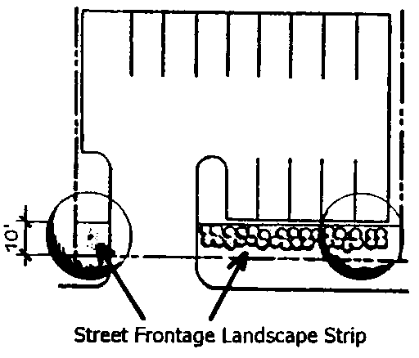

- If the parking area exceeds 100,000 square feet in area, then such landscape strip shall comply with one (1) or a combination of the following options:

  - Such landscape strip shall be a minimum of twenty (20) feet in width and shall contain a berm with a minimum height of two and one half (2.5) feet above the finished elevation of the parking area. Such berm shall have a maximum slope of one foot of rise to three feet run (1:3) and a minimum crown width of three (3) feet. In addition to the required berm, one (1) shade tree and eight (8) shrubs per forty (40) linear feet of street frontage shall be required (See Figure 2).

Figure 2
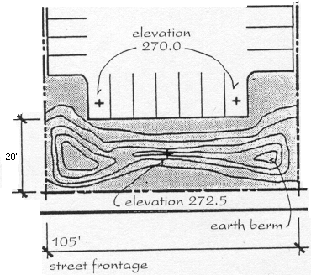

  - Such landscape strip shall be a minimum of twenty-five (25) feet in width and consist of undisturbed woodland or forest (See Figure 3).

Figure 3
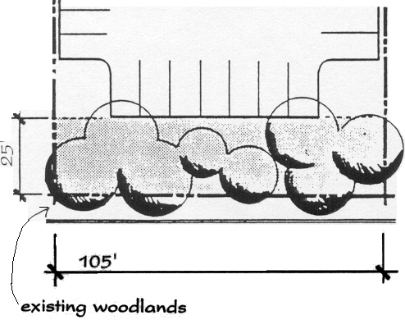

Section 9.05: Peripheral Landscaping Requirements
A landscape border a minimum of five (5) feet in width shall encompass the periphery of parking areas not located adjacent to public rights-of-way. Such landscape border shall be required between any parking area and any property line, yard, required yard, or buildings. Such landscape border may be interrupted for ingress and egress to buildings and adjoining lots. The landscape border shall contain a minimum of one (1) shade tree or one (1) ornamental tree, and eight (8) shrubs per forty (40) linear feet of perimeter (See Figure 4).

Figure 4
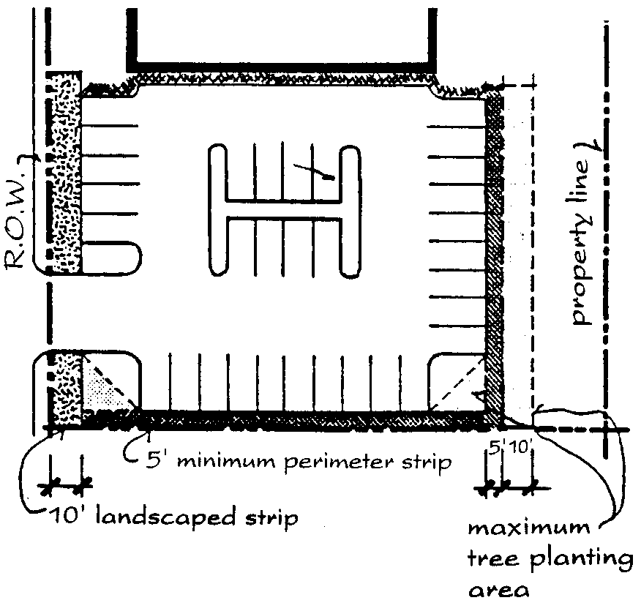

Section 9.06: Landscape Requirements for the Interior of Parking Areas
- The interior of parking areas shall contain landscape islands and peninsulas located in such a manner as to divide and break up large expanses of paving; guide and delineate an orderly traffic flow pattern; promote pedestrian and vehicular safety; and preserve existing trees and vegetation.

- A maximum of twelve (12) consecutive parking spaces in a row shall be permitted without a landscape island or peninsula.

- Each end of each row of parking spaces shall require a landscape island unless the end of such row of parking spaces is adjacent to a landscape strip or border as required in Sections 9.04 and 9.05 (See Figure 5).

Figure 5
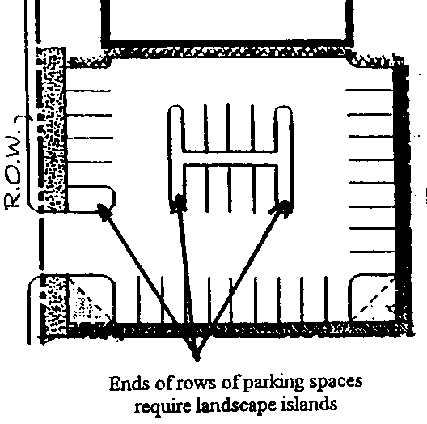

- The minimum width for a landscape island or peninsula that is parallel to a parking space shall be nine (9) feet, and the minimum length for the same shall be eighteen (18) feet. Each landscape island or peninsula shall contain a minimum of one (1) shade tree (See Figure 6).

Figure 6
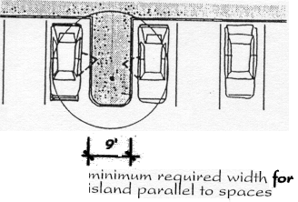

- No more than four (4) double rows of parking spaces shall exist without a landscape island extending the entire length of one double row of parking. Such landscape island shall be a minimum of nine (9) feet in width and shall contain one (1) shade tree per forty (40) linear feet of length (See Figure 7).

Figure 7
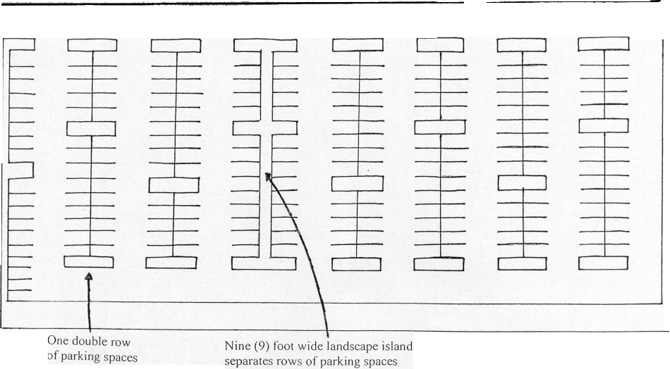

- The permit-issuing authority may require the channelization of ingress and egress points to parking areas in order to facilitate and ensure the safe and efficient movement of vehicular traffic into, from, and through such parking area. Channelization may be accomplished by limiting parking spaces along primary ingress and egress points, and or the use of landscape islands, raised concrete islands, or other structures that will guide and delineate traffic flow.

Section 9.07: Landscape Buffers
- Requirements for landscape buffers shall be based on the zoning of the adjacent parcels and not the current land use. The type of buffer required for each zoning classification is outlined in Table 9-A.

- No building or portions of buildings, except buildings required in conjunction with public utility services, shall be permitted in a required buffer.

- Subject property boundaries adjacent to delineated wetlands (as determined by the US Army Corp of Engineers) or delineated floodways (as determined by FEMA) shall be exempt from any landscape buffer requirements set forth herein.

- Nonresidential uses proposed in residential zoning districts shall require a minimum type A buffer along all property lines adjacent to existing residential uses or undeveloped properties.

- Single-family detached development shall be exempt from any buffer requirements set forth herein unless specifically required by the permit-issuing authority during the subdivision approval process.

- The Board of Adjustment and Appeals shall have the authority to waive or reduce a required buffer upon a finding that the proposed use of the subject property will not adversely impact the adjoining property if the buffer requirement is waived or reduced.

Table 9-A: Landscape Buffer Requirements
 | Adjacent Property
Subject Property |  | R-20 | R-12 | R-9 | R-8 | R-7 | R-7A | O-I | B-1 | B-2 | B-3 | I-1 | I-2 | O-S
Subject Property | R-20 | - | - | - | - | - | - | - | - | - | - | - | - | -
Subject Property | R-12 | - | - | - | - | - | - | - | - | - | - | - | - | -
Subject Property | R-9 | - | - | - | - | - | - | - | - | - | - | - | - | -
Subject Property | R-8 | - | - | - | - | - | - | - | - | - | - | - | - | -
Subject Property | R-7 | - | - | - | - | - | - | - | - | - | - | - | - | -
Subject Property | R-7A | - | - | - | - | - | - | - | - | - | - | - | - | -
Subject Property | O-I | A | A | A | A | A | A | - | - | - | - | - | - | -
Subject Property | B-1 | A | A | A | A | A | A | - | - | - | - | - | - | -
Subject Property | B-2 | A | A | A | A | A | A | - | - | - | - | - | - | -
Subject Property | B-3 | B | B | B | B | B | B | A | - | - | - | - | - | -
Subject Property | I-1 | C | D | D | D | C | - | B | B | B | A | - | - | -
Subject Property | I-2 | C | D | D | D | C | - | B | B | B | A | - | - | -
Subject Property | O-S | - | - | - | - | - | - | - | - | - | - | - | - | -

Section 9.08: Buffer Types
The buffer requirements set forth in Table 9-A shall be the minimum buffer requirements permitted. The following buffer types are listed in descending order of degree of density. (Buffer A is the least dense and Buffer E is the most dense.) In order to allow variation and flexibility in buffer requirements, buffer types listed here-under that exceed the degree of density of the buffer type required in Table 9-A shall be permitted.

- Type A: ten (10) foot wide buffer containing:
  - One (1) shade tree per 35 linear feet;
  - Seven (7) tall, evergreen shrubs per 35 linear feet.

- Type B: ten (10) foot wide buffer containing:
  - One (1) shade tree per 35 linear feet;
  - Seven (7) tall, evergreen shrubs per 35 linear feet;
  - One (1) solid fence or masonry wall (earth tone in color), six (6) feet in height extending the entire length of the common property boundary where such buffer is required.

- Type C: 25 (twenty-five) foot wide buffer containing:
  - One (1) shade tree per 25 linear feet;
  - One (1) evergreen tree per 25 linear feet;
  - Seven (7) tall, evergreen shrubs per 25 linear feet.

- Type D: 25 (twenty-five) foot wide buffer containing;
  - One (1) shade tree per 25 linear feet;
  - One (1) evergreen tree per 25 linear feet;
  - Seven (7) tall, evergreen shrubs per 25 linear feet;
  - One (1) solid fence or masonry wall (earth tone in color), six (6) feet in height extending the entire length of the common property boundary where such buffer is required.

- Type E: 30 (thirty) foot wide buffer containing:
  - One (1) shade tree per 25 linear feet;
  - One (1) evergreen tree per 25 linear feet;
  - Seven (7) tall, evergreen shrubs per 25 linear feet;
  - Six (6) foot high berm with a minimum six (6) foot wide crown extending the entire length of the common property boundary where such buffer is required.

Section 9.09: Landscape Material Specifications
- All plant materials shall be healthy, living plants. The use of artificial plants to satisfy requirements set forth herein shall be prohibited.

- All plant materials used to satisfy requirements set forth herein shall be suitable for the climatic characteristics of Rockingham. The recommended plant list in Section 9.14 lists species of plants that are suitable for the climate of Rockingham.

- Equal spacing of plant material installed to satisfy requirements set forth herein shall not be required. Plant materials may be grouped and clustered in order to present a more natural appearance; provided however, material installed to comply with buffer requirements set forth herein shall be placed in a manner to form a continuous buffer.

- Existing trees, regardless of classification may be counted toward requirements for shade trees or ornamental trees as set forth herein provided such trees are a minimum of three (3) inches in caliper, in good health, and located in the approximate area as required herein.

- Ornamental trees may be substituted on a 1:1 ratio for shade trees where tree installation is required in close proximity to overhead utility services.

- Shade trees shall be defined as any deciduous or leaf bearing tree that reaches a mature height in excess of forty (40) feet. Shade trees shall be a minimum of two (2) inches in caliper or eight (8) feet in height at the time of installation.

- Evergreen trees shall be defined as any tree that maintains foliage on a year round basis. Evergreen trees shall be a minimum of one and one half (1.5) inches in caliper or six (6) feet in height at the time of installation.

- Ornamental trees shall be defined as any deciduous or evergreen tree that has a particular ornamental characteristic and tends to have a mature height less than that of a shade tree. The ornamental characteristic of such trees may include a distinctive shape, color, flower, or limb configuration. Ornamental trees shall be a minimum of one and one half (1.5) inches in caliper or six (6) feet in height at the time of installation.

- Shrubs shall be a minimum of three (3) gallons in size at the time of installation. Where these regulations specifically require the installation of ‘tall, evergreen shrubs’, such shrubs shall be a minimum of three (3) gallons in size and three (3) feet in height at the time of installation; shall reach a minimum mature height of six (6) feet; and shall be a species of shrub that does not loose all its leaves at one time.

- Groundcover shall consist of grass, turf, sod, ivy, bedding plants, or low, spreading vines. Pebbles, wood chips, bark, mulch, straw, and similar materials shall be used to delineate planting beds, but in no instance shall such materials be used for the purpose of sidewalks, parking areas, or driveways. Areas dedicated for lawns shall be cleared of debris, graded level, and covered with sod, turf, or grass seed.

Section 9.10: Landscape Plan Preparation
All landscape plans shall be drawn to scale and prepared in a professional manner. The Code Enforcement Officer shall reserve the right to refuse acceptance of landscape plans that have not been prepared in a professional manner. All landscape plans shall comply with the requirements set forth herein. Landscaping shall not be haphazardly placed in order to fill left over space, but rather to accomplish the intent of these regulations as set forth in Section 9.01).

Section 9.11: Landscape Plan Submittal Requirements
- Two (2) copies of the proposed landscape plan shall accompany all applications for building permits. In situations where a site meets the minimum requirements set forth herein or a proposed development is not subject to requirements set forth herein, the Code Enforcement Officer may waive the requirement for the submittal of a landscape plan.

- The landscape plan shall illustrate the following information:

- Location and labels for all proposed plant materials;

- Location and labels of existing vegetation to be saved or remain undisturbed;

- Methods and details for the protection of existing vegetation;

- Location and specifications for proposed fences, walls, or berms;

- Plant list or schedule with the botanical and or common name, quantity, spacing, and size of all proposed materials at the time of installation;

- Location of all existing and proposed structures, paved areas, landscape islands, and sidewalks;

- If an irrigation system is proposed that is equipped with automatic timers and is connected to the City of Rockingham public water system, then such system shall be equipped with automatic rain and soil moister sensors that are activated to prevent the operation of those irrigation systems while rain is falling and / or when soil moisture is adequate. Any irrigation system connected to the City of Rockingham public water system shall require the installation of a double backflow protection device.

Section 9.12: Financial Guarantees
The City of Rockingham recognizes that vegetation used in landscaping or screening should be planted at certain times of the year to ensure the best chance of survival. In order to ensure compliance with requirements set forth herein, and to reduce the potential expense of replacing landscaping or screening materials which were installed in an untimely or improper fashion, in lieu of requiring the completion and installation of any and all landscape improvements prior to the issuance of a certificate of zoning compliance, the Code Enforcement Officer may enter into a written agreement with the developer whereby the developer shall agree to complete all required landscape improvements. Once said agreement is signed by both parties and the security required herein is provided, the certificate of zoning compliance may be issued if all other requirements of these regulations are met. To secure this agreement, the developer shall provide as approved by the Code Enforcement Officer either one, or a combination of the following guarantees equal to 1.25 times the entire cost of the improvements secured. Any expense associated with cost verification by the Code Enforcement Officer shall be paid entirely by the developer.

- Surety Performance Bond: The developer shall obtain a performance bond from a surety bonding company authorized to do business in the state of North Carolina. The bond shall be payable to the City of Rockingham. The duration of the bond shall be until such time as the City approves the improvements.

- Cash or Equivalent Security: The developer shall deposit cash, an irrevocable letter of credit or other instrument readily convertible into cash at face value, either with the City or in escrow with a financial institution designated as an official depository of the City. The use of any instrument other than cash shall be subject to the approval of the Code Enforcement Officer. If cash or other instrument is deposited in escrow with a financial institution as provided herein, then the developer shall file with the City an agreement between the financial institution and himself guaranteeing the following:

  - That said escrow amount will be held in trust until released by the City and may not be used or pledged by the developer in any other transaction during the term of the escrow; and

  - That in case of a failure on the part of the developer to complete said improvements, the financial institution shall upon notification of the City to the financial institution of an estimate of the amount needed to complete the improvements, immediately pay the City the funds estimated to complete the improvements, up to the full balance of the escrow account, or deliver to the City any other instruments fully endorsed or otherwise made payable in full to the City.

- Default: Upon default, meaning failure on the part of the developer to complete the required improvements in the time allowed by this Ordinance or as spelled out in the performance bond or escrow agreement, then the surety, or financial institution holding the escrow account shall if requested by the City, pay all or any portion of the bond or escrow fund to the City up to the amount needed to complete the improvements based on an estimate by the City. Upon payment, the City, in its discretion, may expend such portion of said funds, as it deems necessary to complete all or any portion of the required improvements. The City shall return to the developer any funds not spent in completing the improvements.

- Release of Guarantee Security: The Code Enforcement Officer may release part of any security posted as the improvements are completed and approved by the City. Such funds may be released within ten (10) days after the corresponding improvements have been so approved.

Section 9.13: Landscape Material Installation and Maintenance
- All landscaping material shall be installed in accordance with accepted planting procedures prior to the issuance of a Certificate of Occupancy or a financial guarantee posted in accordance with Section 9.12.

- The owner, occupant, tenant, or agent shall be jointly and severally responsible for the maintenance of all landscaping. Landscaping shall be maintained in a good condition so as to present a healthy, neat, and orderly appearance. Proper maintenance shall include watering, weeding, mowing, mulching, fertilizing, and pruning. Any dead or damaged landscaping material shall be promptly replaced with materials of an approved size and type.

- Trees planted and retained to fulfill the requirements of this ordinance shall be permitted to attain their normal, mature size. Trees shall be pruned only as necessary to promote healthy growth and prevent hazardous conditions.

Section 9.14: Recommended Plant List
The following list contains some plant species that are native to the Rockingham area or are known to be suitable for the climate of the Rockingham area. Applicants seeking landscape approval shall not be required to select materials from the following list, but shall be encouraged to select plant species that are known to be suitable for the climate of the Rockingham area.

- Shade Trees

  - American beech
  - Bald Cypress
  - Black gum
  - Elm
  - Hickory
  - Japanese zelkova
  - Laurel oak
  - Live oak
  - Pecan
  - Pin oak
  - Poplar
  - Red maple
  - Red oak
  - River birch
  - Southern magnolia
  - Southern sugar maple
  - Sweet Gum
  - Sycamore
  - Water Oak
  - White Oak
  - Willow Oak

- Ornamental Trees

  - American holly
  - Carolina silver bell
  - Crabapple
  - Crape myrtle
  - Eastern redbud
  - Flowering apricot
  - Flowering dogwood
  - Japanese Maple
  - Red Cedar
  - Saucer magnolia
  - Southern magnolia
  - Star magnolia
  - Wax myrtle
  - Yaupon holly

- Evergreen Trees (for buffers)

  - Carolina cherry laurel
  - Canadian hemlock
  - Eastern red cedar
  - Douglas fir
  - Leyland cypress
  - White cedar

- Shrubs and Hedges

  - Abelia
  - Azalea
  - Barberry
  - Boxwood
  - Camelia
  - Dwarf yaupon holly
  - Gardenia
  - Hydrangea
  - Indian Hawthorn
  - Juniper
  - Nandina
  - Rosemary
  - Wax myrtle
  - Redtips
  - Privet

- Groundcover

  - Carolina jasmine
  - Centipede grass
  - Common periwinkle
  - Confederate jasmine
  - Creeping fig
  - Creeping gardenia
  - Creeping juniper
  - Daylily
  - English Ivy
  - Fescue grass
  - Honeysuckle
  - Lantana
  - Liriope
  - Vebena
  - Winter Creeper
  - Wisteria
  - Zoysia grass

