Article 11: Sign Regulations

Article 11: Sign Regulations

Section 11.01: Purpose
The regulation of the location, size, placement, and certain other features of signs is necessary to enable the public to locate goods, services, and facilities without difficulty and confusion; to encourage and enhance the general attractiveness of the community; and to protect property values therein. Accordingly, the intent of this Article is to establish regulations governing the display of signs that shall:

- Promote and protect the public health, safety, comfort, morals, convenience and aesthetics of the community;

- Enhance the local economy by promoting the reasonable, orderly, and effective display of signs, and thereby encourage increased communication with the public;

- Restrict signs and lights which overload the public’s capacity to receive information or which increase the probability of traffic congestion and accidents by distracting attention or obstructing vision;

- Reduce conflict among signs and lights and between public and private environmental information systems; and

- Promote signs that are compatible with their surroundings, are appropriate to the type of activity to which they pertain, and are expressive of the identity of proprietors and other persons displaying signs.

Section 11.02: Prohibited Signs
The following sign types are hereby expressly prohibited from erection, construction, alteration, or use, except as otherwise specifically permitted in this Ordinance:

- Roof signs, provided however roof surfaces constructed at an angle of seventy-five degrees (75) or greater shall be considered wall space for the purpose of determining the location of wall signs.

- Any vehicle sign where the sign projects beyond the manufacturer’s profile of the vehicle and is displayed in public view under such circumstances as to indicate that the primary purpose of such display is to attract the attention of the public rather than to serve the business of the owner thereof in the manner which is customary for such vehicle.

- Any sign that emits a sound, odor, or visible matter such as smoke or vapor.

- Any sign that is portable or not securely attached to a building or to the ground except as provided in Section 11.05 “Temporary Signs”.

- Any sign that obstructs free ingress to or egress from a door, window, fire escape or other exit way, or any sign or advertising display attached to a fire escape.

- Any sign or sign structure other than freestanding, where any portion of which extends above the parapet, building roofline, or canopy against which the sign is located.

- Any sign erected in a street or highway right-of-way except for signs of a governmental body used to convey legal notices, identify public property, convey public information, and direct or regulate pedestrian and vehicular traffic.

Article 11: Sign Regulations

- Any sign or sign structure that is abandoned, dilapidated, or poses a safety hazard.

- Any sign which exhibits statements, words or pictures of obscene, pornographic or immoral subjects.

- Signs of any material including, but not limited to paper, paint, cardboard, plastic, wood, and metal which are painted on or attached to trees, lamp post, parking meter posts, hydrants, traffic signs, stairways, refuse containers, utility poles, rocks or other natural features, provided however, yard sale signs displayed for one (1) day only shall be permissible.

- Any sign that obstructs the view of motor vehicle operators entering a public roadway from any driveway, street or alley. All signs shall comply with the sight visibility triangle requirements set forth in Section 5.08.

- Swinging signs either projecting or freestanding that exceed eight (8) square feet in gross surface area per sign face.

- Any sign, or sign structure with a three-dimensional shape of a human, animal, tire, paint can, toilet, or other product or item.

- Any sign that interferes with above ground or underground utilities or any sign that obstructs any natural or artificial drainage systems.

- Any sign which involves motion or rotation of any part of the sign structure or sign face and/or utilizes intermittent flashing lights, animation, automatically changing copy, or electronic messaging except as provided in Section 11.15 (D).

- Any sign illumination system that contains or utilizes any beacon, spot, search or stroboscopic light, glaring light, or reflector, which is visible from any public right-of-way or adjacent property, or any such lights that are operated outside, under any circumstances, except by authorized public agencies.

- Signs using the words “stop”, “danger” or any other word, phrase, symbol, or character in a manner that misleads, confuses, or distracts a vehicle driver.

- Any sign that displays lights resembling by color, design or other characteristics those customarily associated with danger, traffic control devices, or used by police, fire, ambulance, and other emergency vehicles or for navigation.

- Any sign erected, altered, displayed, or changed without a permit from the City of Rockingham Planning and Inspections Department except as otherwise specifically provided herein.

- Any other type or kind of sign which does not comply with the terms, conditions, and provisions contained in this Ordinance.

Section 11.03: Permit Procedures
- Unless otherwise provided for in this Ordinance, no sign or sign structure, regardless of its cost of construction, shall be erected, replaced, relocated, constructed, changed, or altered until such sign has been approved by the Code Enforcement Officer and a sign permit has been issued by the Planning and Inspections Department.

Article 11: Sign Regulations

- Application for a sign permit to erect, alter, or relocate a sign shall be made to the Planning and Inspections Department upon a form provided by the Code Enforcement Officer and shall include the following information:

  - Name, address, telephone number, and signature of the owner of the premises (and occupant if different).

  - Name, address, telephone number, and signature of sign contractor, if any.

  - The approximate value of the sign to be installed, including the installation cost.

  - Two copies of a sketch or blue print of the proposed signage drawn to scale, showing elevations of the sign as proposed on the building façade, awning, or canopy. In the case of a freestanding sign, a sketch plan of the property drawn to scale illustrating the proposed location of the sign.

  - Specifications and scaled drawings showing the materials, design, dimensions, structural supports, and electrical components of the proposed sign.

  - Any other information, specifications, photographs, or the like deemed necessary by the Code Enforcement Officer in order to assure compliance with requirements set forth in this Ordinance.

- Upon compliance with the requirements set forth herein and any applicable Building Code requirements, the Code Enforcement Officer shall approve the application for a sign permit and authorize the issuance of a sign permit. A sign permit shall be issued by the Planning and Inspections Department after the payment of any applicable permit fees.

- Failure to obtain a final satisfactory inspection within the permit period shall render the permit invalid and the applicant shall be required to reapply for a permit or remove the sign and sign structure.

- The Planning and Inspections Department may make or require any inspections of any construction work to ascertain compliance with the provisions of this Ordinance and other laws that are in force, and to ascertain that the sign is erected or displayed as indicated in the approved sign permit.

Section 11.04: Signs Exempt from Permit Procedures
The following signs and sign alterations shall be hereby exempted from the standard permit procedures provided such signs comply with all other applicable sections of this Ordinance. Signs exempt from permit procedures shall not be included in determining the allowable number or size of signs per premises.

- Accessory Signs on Vehicles and Trailers: Signs affixed to vehicles and trailers where the sign is incidental and accessory to the primary use of the vehicle or trailer.

- Public Services and Information Signs: Public service signs may be displayed that identify public services or conveniences, such as restrooms, telephone, state vehicle inspection, credit cards accepted, hours of operation, vacancies, trading stamps given, trade association affiliations, octane ratings, self-service, and type of fuel provided that such signs shall not exceed twelve
(12) square feet in sign area and are attached to a permitted freestanding sign or mounted flush against a building or structure.

Article 11: Sign Regulations

- Flags: Flags, emblems, and insignia of political, professional, religious, educational, or corporate organizations providing that such flags, emblems, and insignia shall not be displayed for commercial purposes nor in such a manner as to act as attention-seizing devices. This section shall not prohibit the use of decorative flags that may or may not contain the name or logo of a corporate organization.

- Governmental Signs: Governmental signs for control of traffic and other regulatory purposes, street signs, warning signs, railroad crossing signs, and signs of public service companies indicating danger and aids service or safety.

- Memorial Signs: Memorial plaques or tablets, grave markers, names of buildings, statutory, or other remembrances of persons or events, which are non-commercial in nature.

- Name and Address Plates: Signs, not exceeding six (6) square feet in gross surface area per sign face and an aggregate gross surface area of twelve (12) square feet, indicating the name of the occupant, the address of the premises, and identification of any legal business or operation which may exist at the premises.

- No Trespassing, No Dumping, No Parking, Towing, and Other Similar Signs: No trespassing, no dumping, no parking, towing, and other similar signs not exceeding two (2) square feet in gross surface area per sign face and an aggregate gross surface area of four (4) square feet in residential districts. Such signs shall not exceed six (6) square feet in gross surface area per sign face and an aggregate gross surface area of twelve (12) square feet in non-residential districts.

- Public Signs: Signs required by governmental bodies or specifically authorized for a public purpose by any law, statute, or ordinance. Such public signs may be of any type, number, area, height, location, or illumination as required by law, statute, or ordinance.

- Off-premise Directional Signs: Civic organizations, educational facilities, and religious institutions shall be permitted to utilize off-premise directional signs provided such signs shall not exceed a gross surface area of six (6) square feet per sign face and an aggregate gross surface area of twelve (12) square feet. Such signs shall not exceed five (5) feet in height and shall not be illuminated. Such signs shall not be located in any public right-of-way. The number of off- premise directional signs shall not exceed three (3) per organization or institution.

- Institutional Signs: Educational facilities, governmental facilities, religious institutions, and charitable organizations shall be permitted one (1) freestanding sign per street frontage identifying the name of the entity and any other desired message. Such sign shall not exceed a gross surface area of twenty-four (24) square feet per sign face and an aggregate gross surface area of forty-eight (48) square feet.

- Vending Machine Signs: Permanent, non-flashing signs on vending machines, gasoline pumps, ice containers, or other similar machines indicating only the contents of such devices, the pricing of the contents contained within, directional or instructional information as to use, and other similar information provided such signs shall be mounted flush against and shall not project beyond the profile of any such machines or devices.

- Interior Window Signs: Window signs attached to the interior side of a window or glass door or mounted as such to be visible from the exterior.

- Athletic Facility Signs: Signs attached to scoreboards, fences and other similar appurtenances at athletic facilities not intended to be viewed from public rights-of-way or adjacent properties.

Article 11: Sign Regulations

- Changeable Copy Signs and Marquees: The changing of letters or numbers on signs designed for changeable lettering or numbering provided the signs were legally erected and maintained for such purposes.

- Cabinet Sign Faces: The replacement of sign faces in an existing sign cabinet provided no structural or electrical alterations are performed.

Section 11.05: Temporary Signs
Temporary signs shall be erected and maintained in accordance with the following provisions:

- General Requirements for all Temporary Sign Categories

  - Temporary special event signs shall require the issuance of a temporary sign permit by the Planning and Inspections Department. All other temporary sign categories shall be exempt permit procedures.

  - No temporary sign shall be illuminated.

- Temporary Special Event Signs: Temporary special event signs for sales, grand openings, holidays, fundraisers, charity events, or other special activities shall be subject to the following requirements:

  - Temporary special event signs shall include portable signs and banners.

  - One (1) temporary special event sign shall be permitted per premises provided however, in unified developments one (1) such sign shall be permitted per one hundred (100) linear feet of street frontage. Such signs shall not be placed in public rights-of-way.

  - Such signs shall not exceed a gross surface area of thirty-two (32) square feet per sign face and an aggregate gross surface area of sixty-four (64) square feet.

  - Such signs shall be displayed for a maximum of twelve (12) weeks during any one-year period with the year beginning on the date of issuance of the required permit. The Code Enforcement Officer shall maintain a log sheet for the purpose of tracking when one of the twelve allotted weeks is used. The permit holder shall be responsible for notifying the Code Enforcement Officer twenty-four (24) hours in advance when one (1) of the twelve (12) weeks is to be used.

  - Non-profit organizations shall be required to obtain permits for temporary special event signs, but the permit fee shall be waived.

- Temporary Construction Signs: Temporary construction signs identifying the parties involved in the construction to occur or occurring on the premises on which such sign is placed shall be subject to the following requirements:

  - In residential districts such signs shall not exceed thirty-two (32) square feet in gross surface area per sign face and the aggregate gross surface area shall not exceed sixty- four (64) square feet. In nonresidential districts such signs shall not exceed sixty-four
    - square feet in gross surface area per sign face and the aggregate gross surface area shall not exceed one hundred twenty-eight (128) square feet.

Article 11: Sign Regulations

  - Temporary construction signs may be erected and maintained for a period not to exceed thirty (30) days prior to the commencement of construction and shall be removed within seven (7) days of the termination of construction of the project or development.

- Temporary Real Estate Signs: Temporary real estate signs advertising the sale, lease, rent or pending auction of the premises upon which such sign is located shall be subject to the following requirements:

  - In residential districts such signs shall not exceed twelve (12) square feet in gross surface area per sign face and the aggregate gross surface area shall not exceed twenty- four (24) square feet. In nonresidential districts, such signs shall not exceed sixty-four
    - square feet in gross surface area per sign face and the aggregate gross surface area shall not exceed one hundred twenty-eight (128) square feet.

  - Such signs shall be located only upon the premises for sale, lease or rent and only one
(1) such sign shall be permitted per zoning lot.

  - Such signs shall be removed within seven (7) days of the sale or lease of the premises upon which the sign is located or the completion of the auction.

  - Real estate directional signs identifying an “open house” “auction” or other similar event shall be permitted to be located off-premise only on the days of such event. Such sign shall not exceed a gross surface area of six (6) square feet per sign and an aggregate gross surface area of twelve (12) square feet. Such signs shall not be located in a public right-of-way.

- Temporary Subdivision Signs: Temporary subdivision signs announcing the sale of lots in a new subdivision development shall be subject to the following requirements:

  - One (1) temporary subdivision sign shall be permitted per entrance to the subdivision.

  - Such sign shall not exceed a gross surface area per sign face of sixty-four (64) square feet and an aggregate gross surface area of one hundred twenty-eight (128) square feet.

  - Such sign shall be located on property that is a part of the subdivision and shall be removed once fifty (50%) percent of the lots are sold.

Section 11.06 Construction Specifications
- All signs shall be designed to meet all applicable requirements of the North Carolina State Building Code.

- All signs, except those permitted on a temporary basis as set forth in this Article, shall be constructed of permanent materials and shall be permanently attached to the ground, a building, or another structure.

- All electrical signs shall be approved by Underwriters Laboratory (UL) as specified in the National Electric Code. An Underwriters Laboratory label shall be required on the outside ballast and on the cabinet that seals the sign structure.

- Flood lights or similar lighting utilized as a part of a sign illumination system shall be hooded or shielded so that the light source is not visible from any public right-of-way or adjacent property.

Article 11: Sign Regulations

Section 11.07: Maintenance
All signs and supports, braces, guys, and anchors thereof shall be kept in good repair, refurbished and repaired from time to time, as necessary, and perpetually maintained in a safe condition, free from deterioration, defective or missing parts, or peeling or faded paint, and able to withstand the wind load for which such sign was originally designed. Any sign not in compliance with this provision is hereby declared to be a prohibited sign.

Section 11.08: Abandoned Signs
- Any sign that advertises or pertains to a business, product, service, event, activity, or purpose which is no longer conducted or that has not been in use for sixty (60) days or which is no longer imminent, or any sign structure that has not displayed any sign copy for a period in excess of one hundred eighty (180) consecutive days shall be deemed to be an abandoned sign. Abandoned signs are hereby declared to be prohibited signs and shall be removed by the entity responsible for such sign upon notification by the Code Enforcement Officer.

- When any sign is relocated, made inoperative, or removed for any reason, except for maintenance, all structural components including the sign face and sign structure, shall be removed or relocated with the sign. All structural components of freestanding signs shall be removed to ground level. The structural components of all other signs, including painted wall signs shall be removed or restored back to the original building configuration.

Section 11.09: Nonconforming Signs
- Any permanent sign lawfully existing or under construction on the effective date of this Ordinance which does not conform to one (1) or more of the provisions of this Ordinance may be continued to be displayed, utilized, and maintained indefinitely as a legal nonconforming sign subject to compliance with the requirements set forth below. No requirement set forth herein shall prevent the City Council from adopting amortization schedules for non-conforming signs.

- Normal maintenance of legal nonconforming signs, including changing of copy, necessary non- structural repairs, and incidental alterations that do not extend or intensify the nonconforming features of such sign shall be permitted. In instances where a “cabinet” nonconforming sign exists with removable faces, such faces may be changed if damaged or if a different sign message is desired.

- No structural alteration, enlargement, extension, or relocation shall be permitted for a legal non- conforming sign unless such alterations, enlargement, extension, or relocation will result in the elimination of the non-conforming features of the sign. For the purposes of this section, the replacement of a sign cabinet on an existing nonconforming sign shall not be considered a structural alteration if the replacement cabinet is the same size as or smaller than the cabinet being replaced.

- If a legal nonconforming sign is damaged or destroyed by any means to the extent that such damage or destruction equals or exceeds fifty (50%) percent of the replacement value of such sign, then such sign shall not be rebuilt or used thereafter unless such sign conforms to all of the provisions of this Ordinance. If a legal nonconforming sign is damaged or destroyed by any means to the extent that such damage or destruction does not exceed fifty (50%) percent of the replacement value of such sign, then such sign may be repaired to its original condition and may continue to be displayed. In situations where this section is applicable, the applicant for a sign permit shall be required to submit a bonafide cost estimate for repairs to the existing sign and a bonafide cost estimate for a replacement sign of similar design.

Article 11: Sign Regulations

Section 11.10: Removal of Signs Erected on Public Property or Rights-of-Way
It shall be unlawful to erect, use or maintain a sign or sign structure on public property or public rights- of-way without approval from the City of Rockingham. The Code Enforcement Officer shall be authorized to remove such signs without any type of notification to the entities responsible for the display of such signs. The cost of retrieval of any sign removed by the City shall be $15.00.

Section 11.11: Permanent Signs Permitted in all Residential Districts
- Nonresidential uses (conforming or nonconforming) shall be permitted one (1) wall sign not to exceed a gross surface area of thirty-two (32) square feet; and one (1) freestanding sign not to exceed a gross surface area of thirty-two (32) square feet per sign face and an aggregate gross surface area of sixty-four (64) square feet. Such freestanding signs shall not exceed eight (8) feet in height and shall be located a minimum of ten (10) feet from any public right-of-way or adjoining property boundary.

- Residential subdivisions shall be permitted one (1) identification sign per entrance. Such signs shall not exceed a gross surface area of forty (40) square feet per sign face and an aggregate gross surface area of eighty (80) square feet. Such signs shall not exceed eight (8) feet in height. Such signs shall not be internally illuminated.

- Apartment, townhouse, and condominium complexes shall be permitted one (1) identification sign per entrance. Such signs shall not exceed a gross surface area of thirty-two (32) square feet per sign face and an aggregate gross surface area of sixty-four (64) square feet. Such signs shall not exceed eight (8) feet in height and shall be located a minimum of ten (10) feet from any public right-of-way or adjoining property boundary. Such signs shall not be internally illuminated.

Section 11.12: Freestanding Signs and Wall Signs Permitted in B-1 and O-I Districts
- Freestanding signs located in the B-1 and O-I districts shall conform to the following requirements:

  - Number of Signs: One (1) freestanding sign per premises shall be permitted provided however developments located on corner lots or through lots shall be permitted one (1) additional freestanding sign. In such instances where an additional freestanding sign is permitted, the minimum distance between freestanding signs located on the same premises shall be one hundred fifty linear feet (150’).

  - Sign Area: The gross surface area shall not exceed fifty (50) square feet per sign face and the aggregate gross surface area shall not exceed one hundred (100) square feet.

  - Sign Height and Width: Signs shall not exceed twenty (20) feet in height nor shall signs exceed ten feet (10’) in width. Any sign which projects over or extends into a driveway or parking area shall be no lower than thirteen feet (13’) above grade at the lowest point. Any sign that projects over or extends into a pedestrian walkway shall be no lower than eight (8) feet above grade at the lowest point.

  - Location: The nearest part of any freestanding sign shall be located a minimum of five feet (5’) from any right-of-way line. No freestanding sign shall extend over any structure or adjoining property boundary. Regardless of lot boundaries, no freestanding sign shall be located within forty feet (40’) of another freestanding sign.

- Wall signs located in the B-1 and O-I districts shall not be regulated in regards to maximum sign area and maximum number. Wall signs shall be securely mounted flush to the building wall. Wall signs shall not project beyond the edge of the wall upon which such sign is mounted.

Article 11: Sign Regulations

Section 11.13: Freestanding Signs and Wall Signs Permitted in the B-2 District
- Freestanding signs located in the B-2 district shall conform to the following requirements:

  - Number of Signs: One (1) freestanding sign per premise shall be permitted provided however developments located on corner lots or through lots shall be permitted one (1) additional freestanding sign. In such instances where an additional freestanding sign is permitted, the minimum distance between freestanding signs located on the same premises shall be one hundred fifty linear feet (150’).

  - Sign Area: The gross surface area shall not exceed forty (40) square feet per sign face and the aggregate gross surface area shall not exceed eighty (80) square feet.

  - Sign Height and Width: Signs shall not exceed fifteen feet (15) in height nor shall signs exceed ten feet (10’) feet in width. No sign shall project over or extend into a driveway or parking area. Any sign that projects over or extends into a pedestrian walkway shall be no lower than eight (8) feet above grade at the lowest point.

  - Location: There shall be no minimum setback for a freestanding sign from a public right- of-way, provided however, no portion of any sign shall encroach into a public right-of- way.

- Wall signs located in the B-2 district shall not be regulated in regards to maximum sign area and maximum number. Wall signs shall be securely mounted flush to the building wall. Wall signs shall not project beyond the edge of the wall upon which such sign is mounted.

Section 11.14: Freestanding Signs and Wall Signs Permitted in the B-3, I-1, and I-2 Districts
- Freestanding signs located in the B-3, I-1 and I-2 districts shall conform to the following requirements:

  - Number of Signs: One (1) freestanding sign per premises shall be permitted provided however developments located on corner lots or through lots shall be permitted one (1) additional freestanding sign. In such instances where an additional freestanding sign is permitted, the minimum distance between freestanding signs located on the same premises shall be one hundred fifty linear feet (150’).

  - Sign Area: The gross surface area shall not exceed two hundred (200) square feet per sign face and the aggregate gross surface area shall not exceed four hundred (400) square feet.

  - Sign Height and Width: Signs shall not exceed thirty-five (35) feet in height nor shall signs exceed twenty feet (20’) in width. Any sign which projects over or extends into a driveway or parking area shall be no lower than thirteen feet (13’) above grade at the lowest point. Any sign that projects over or extends into a pedestrian walkway shall be no lower than eight (8) feet above grade at the lowest point.

  - Location: The nearest part of any freestanding sign shall be located a minimum of five feet (5’) from any right-of-way line. No freestanding sign shall extend over any structure or adjoining property boundary. Regardless of lot boundaries, no freestanding sign shall be located within forty feet (40’) of another freestanding sign.

Article 11: Sign Regulations

- Wall signs located in the B-3, I-1, and I-2 districts shall not be regulated in regards to maximum sign area and maximum number. Wall signs shall be securely mounted flush to the building wall. Wall signs shall not project beyond the edges of the wall upon which such sign is mounted.

Section 11.15: Other Signage Allowances for Nonresidential Districts
- Projecting Signs: One (1) projecting sign shall be permitted in lieu of a freestanding sign. Projecting signs shall not exceed a gross surface area of thirty-two (32) square feet per sign face and an aggregate gross surface area of sixty-four (64) square feet. Such sign shall not project more than eight (8) feet from the building wall. Such sign shall maintain a minimum height of eight (8’) feet above any sidewalk. Projecting signs designed in a manner to allow the sign face to swing shall not exceed a gross surface area of eight (8) square feet per sign face.

- Unified Developments: Unified developments which contain three (3) or more businesses shall be permitted one (1) additional freestanding sign provided such sign is located a minimum of one hundred fifty (150) feet from any other freestanding sign located in the unified development. Such additional freestanding sign shall conform to the requirements for freestanding signs for the zoning district in which the sign is proposed.

- Fuel Pricing Signs: Businesses engaged in the retail sale of motor vehicle fuels shall be permitted an additional fifteen (15) square feet of gross surface area per sign face incorporated into a permitted freestanding sign or attached to a fuel pump canopy support column for the purpose of advertising fuel prices.

- Electronic Message Centers: Electronic message centers (also referred to as automatic changeable copy) sign units shall be permitted either as a wall sign, fixed projecting sign, or incorporated into a permitted freestanding sign. The gross surface area of such sign unit shall not exceed a gross surface area of forty (40) square feet per sign face and an aggregate gross surface area of eighty (80) square feet. In the B-1, B-2, and O-I districts, such sign area shall be in addition to that permitted under other Sections of this Article. No manual changeable copy signs (also referred to a letter boards) shall be allowed as a part of any freestanding sign that contains an electronic message center.

- Changeable Copy Signs (Marquee Signs): Cinemas, theaters, and auditoriums or any other principal use where a theater or auditorium is an accessory use shall be permitted an additional sixty (60) square feet of gross surface area per sign face incorporated into a permitted freestanding sign or permitted wall sign specifically for changeable copy signage.

- Directory Signs: Commercial centers, office parks, and unified developments containing three (3) or more businesses shall be permitted one (1) on-premise directory sign. The gross surface area per sign face shall not exceed eight (8) square feet for each occupant located in the building, complex or development. Directory signs shall not exceed ten (10) feet in height. Directory signs shall contain only the name and address of the businesses located on the premises.

- Entrance / Exit Signs: Signs identifying points of ingress and egress for a specific business location or premise shall be permitted provided such signs shall not exceed a gross surface area six (6) square feet per sign face and an aggregate gross surface area of twelve (12) square feet. The number of such signs per premise shall be limited to one (1) per point of ingress and / or egress. Such signs shall not exceed four (4) feet in height. The sign copy of such signs shall be limited to “entrance” or “exit” and the name or corporate logo of the business or premise.

- Under-canopy Identification Signs: One (1) under-canopy identification sign shall be permitted per business entrance. Such sign shall not exceed a gross surface area of six (6) square feet and an aggregate gross surface area of twelve (12) square feet.

Article 11: Sign Regulations

- Automobile Dealership Secondary Freestanding Signs: Automobile dealerships shall be permitted one (1) additional freestanding sign if used for pre-owned automobiles and / or if two (2) or more automotive product lines (automobile makes) are offered for sale on the premises. Such secondary freestanding sign shall adhere to the requirements for freestanding signs for the zoning district in which the automobile dealership is located. Such secondary freestanding sign shall be located a minimum of one hundred fifty (150’) feet from any other freestanding sign located on the same premise.

- Off-premise Directional Signs: Businesses which have no frontage on major or minor thoroughfares as identified in the “Thoroughfare Plan for the City of Rockingham-Hamlet” and are located within one thousand (1000) feet of an intersection with a major or minor thoroughfare shall be permitted one (1) off-premise identification/directional sign at the nearest intersection with a major or minor thoroughfare. Such sign shall not exceed a gross surface area of thirty (30) square feet per sign face and an aggregate gross surface area of sixty (60) square feet. Such sign shall not exceed twenty (20) feet in height. Such sign shall not be located within forty (40) feet of another freestanding sign or off-premise directional sign. Such signs shall be located a minimum of five (5’) feet from the right-of-way line. The applicant shall be required to submit written consent from the property owner for the placement of such sign. Co- location on the same sign structure shall be permitted at intersections where more than one business intends to utilize the provisions of this subsection, in which case an additional fifteen
(15) square feet of sign area per sign face shall be permitted per additional business.

Section 11.16: Creation of Special Sign Overlay Districts
The City of Rockingham recognizes that some large, comprehensively designed developments may have a need for greater flexibility in regards to signage than the other Sections of this Article can provide. It is therefore the intent of this section to allow for the creation of special sign overlay districts for unified developments or other comprehensively planned developments encompassing one or more contiguous tracts of land which total at least twelve (12) acres in size. The creation of a special sign overlay district shall be considered an amendment to the Unified Development Ordinance and shall follow the procedural requirements for amendments set forth in Article 2. Any special sign overlay district created shall specify the area to be included and the specific sign regulations applicable in the special overlay sign district. Applications for the creation of special sign overlay districts shall be prepared by a design professional and shall be evaluated by the Planning and Zoning Board and City Council in terms of the appropriateness of the proposed graphic sign system to the development’s architecture, site plan, function, land use, traffic patterns, and compatibility with surrounding developments.

Section 11.17: Outdoor Advertising Signs
- Except as set forth in subsection (B) below, outdoor advertising signs (also known as billboards) shall be permitted in the B-3, I-1, and I-2 zoning districts provided all of the following requirements are met:

  - Outdoor advertising signs shall be located on zoning lots not occupied by any other use.

  - The outdoor advertising sign structure shall comply with all building setback requirements for the zoning district in which such structure is proposed.

  - Outdoor advertising signs shall not be located within three hundred (300) linear feet of a residential zoning district nor within five hundred (500) linear feet of another outdoor advertising sign, educational facility, or religious institution.

  - Outdoor advertising signs shall contain a maximum of two sign faces and the sign structure shall be an all steel, monopole design. The sign faces shall be configured back-

Article 11: Sign Regulations

to-back (parallel) or a V-shaped configuration to a maximum of a 12-foot separation on one end of the sign faces. The maximum gross surface area per sign face shall not exceed three hundred (300) square feet.

  - Outdoor advertising signs shall not exceed thirty-five (35) feet in height.

- Outdoor advertising signs shall be specifically prohibited within five hundred feet (500) of the right-of-way lines of the following road segments:

  - US Highway 1 North (Fayetteville Road) from Washington Street to Old Aberdeen Road;

  - US Highway 220 from North Lee Street to Snead Avenue;

  - US Highway 1 South (South Hancock Street) from Franklin Street to Mizpah Road; and

  - US Highway 74 Business from US Highway 1 South (South Hancock Street) to Clemmer Road.

Section 11.18: Richmond Plaza Special Sign Overlay District
All exterior signage located in the Richmond Plaza Shopping Center (hereinafter referred to as “Premises”) including outparcels shall be subject to the standards, allowances, and requirements set forth in this Section. No signs shall be erected or maintained on the exterior of the premises except as permitted herein.

- Store Front Signs: Each Tenant space shall be permitted one (1) wall sign (hereinafter referred to as the "Store Front Sign") on the front of the Premises subject to the following requirements:

  - Major retail stores (or inducement tenants) having at least (6,500) square feet shall be permitted appropriate Store Front Signs with respect to their inducement tenant status.

  - Minor retail and service stores shall be permitted one (1) Store Front Sign on the façade immediately above the front of the store on the canopy facade. Such signs shall be installed within the “sign band area” as generally depicted in Exhibit A and centered vertically and horizontally.

  - The content of the Store Front Sign shall be limited to the name of the business conducted by the Tenant on the Premises, provided however, the use of corporate crests, shields, slogans or insignia may be permitted subject to Property Owner prior written approval of specifications and drawings.

  - The maximum allowable square footage of the Store Front Sign shall not be regulated, provided however compliance with the standards set forth in subsection (2) above shall be maintained as applicable for minor retail and service store tenant spaces.

  - The Store Front Sign shall be either (a) individual internally illuminated plastic-faced letters or logo, or (b) individual illuminated back-lighted letters or logo. No box signs shall be permitted to be used as tenant wall-mounted signage except as otherwise provided herein.

  - All sign transformers, raceways and ballast boxes shall be concealed. Raceway color shall match wall color. The signage return color of can (side casing of the signage letters or logo) shall be black, white, the color of the wall, or match the overall sign color scheme. Manufacturer's names, stamps and decals shall not be exposed.

Article 11: Sign Regulations

  - The forward projection of the Store Front Sign shall not be more than twelve inches (12") from the face of the building. All Store Front Signs shall be mounted with a minimum of one inch (1") spacing between the exterior wall and the back of the signage.

  - Notwithstanding the above, any Tenant occupying an “end-cap” unit shall be permitted to erect an additional Store Front Sign on any exterior wall that is solely apart of its demised Premises. Tenants occupying “outparcel” units shall be permitted to erect one
    - Store Front Signs on all exterior walls.

- Under Canopy Signs: Each tenant space shall be permitted one (1) flush-mounted illuminated "Under the Canopy" sign subject to the following requirements.

  - The Under the Canopy sign shall be centered over the main entrance to the demised Premises and shall not exceed a gross surface area of six (6) square feet and an aggregate gross surface area of twelve (12) square feet.

  - The sign box shall match the prominent color of building façade. Signs shall have white faces with colors and logos matching Tenant’s branding.

  - All sign transformers, raceways and ballast boxes shall be concealed. Manufacturer's names, stamps, and decals shall not be exposed.

- Freestanding Signs: Richmond Plaza Shopping Center shall be permitted freestanding signs subject to the following requirements and allowances:

  - The Premises shall be permitted two (2) pylon signs as illustrated in Exhibit B. Such pylon signs shall be located in the approximate locations as illustrated in Exhibit C and shall maintain a minimum five-foot (5’) setback from the right-of-way, provided however, the existing pylon sign at the main entrance on E. Broad Avenue may remain in its current location. The pylon signs shall be permitted with the overall square footage of sign area as calculated by the dimensions in Exhibit B. Any future repairs, refurbishments, or redevelopment of the pylon signs shall be entitled to be done so at an equal or reduced square footage of sign area as indicated in Exhibit B.

  - One (1) monument sign shall be permitted as illustrated in Exhibit D. Such monument sign shall be located in the approximate location as illustrated in Exhibit C, subject to approval by NCDOT. The monument sign shall be permitted with the overall square footage of sign area as calculated by the dimensions in Exhibit D. Any future repairs, refurbishment or redevelopment of the monument sign shall be entitled to be done so at an equal or reduced square footage of signage area as depicted in Exhibit D.

  - Tenant 23 as identified on the Site Map (Exhibit C) shall be permitted one (1) freestanding sign subject to the requirements for the B-3 zone as set forth in Section
11.14. Tenants 24, 27 and 28 shall be permitted each one (1) freestanding sign subject to the requirements for the B-3 zone as set forth in Section 11.14 except such signs shall not exceed 125 square feet in sign area and a maximum height of twenty (20) feet. Units 25 and 26 shall be permitted one (1) freestanding sign structure on which to collocate signs subject to the requirements for the B-3 zone as set forth in Section 11.14 except such sign shall not exceed 125 square feet in sign area and a maximum height of twenty (20) feet. Any future division of these tenant spaces shall require collocation of

Article 11: Sign Regulations

signs on the sign structures herein allowed. No freestanding sign permitted pursuant to this subsection shall be located within forty (40) feet of another freestanding sign, pylon sign, or monument sign. Freestanding signs permitted pursuant to this subsection shall be located in a position so as to not unreasonably interfere with the visibility of the two pylon signs permitted in subsection (1) above as agreed upon by the Property Owner.

- No exposed neon or incandescent bulbs or flashing, blinking, rotating or moving signs or makers shall be permitted. Any interior storefront window or door signs that are visible externally shall be approved by Property Owner.

- No signs shall be permitted at or on the rear of the Premises except that a small identification sign showing only the name of the Tenant shall be lettered on the exterior of the delivery door.

- No signs or banners shall be painted on or attached to the exterior of the masonry, doors, windows, parapet, or any other surfaces of the Premises (including the interior of all window, door and glass fronts) of the Premises without Property Owner consent. Roof signs shall be prohibited.

- All signs and related components shall be kept in good repair, refurbished and repaired as necessary, and perpetually maintained in a safe condition, free from deterioration, defective or missing parts, or peeling or faded paint.

- All signs shall be professionally designed, manufactured and erected. All signs shall be approved by Underwriter's Laboratory (U.L.). No sign shall be erected until written specifications and drawings of such sign are first approved in writing by Property Owner and proper permits obtained from the City of Rockingham Inspections Department. Such specifications and drawings shall be submitted to Property Owner in duplicate and shall show the size, construction, materials, colors, script, name of the sign manufacturer, and proposed location of such sign on the building façade. Such information and documentation shall also be submitted to the City of Rockingham Inspections Department along with the written approval of such sign by the Property Owner.

- The permit-issuing authority, with written approval of the Property Owner, shall have the authority to deviate from the standards set forth herein for wall signage to accommodate the special or unique needs of a tenant, provided however, no signs shall be approved that are inconsistent with other provisions of Article 11.

- All signs existing on the date of adoption of the Richmond Plaza Special Sign Overlay District that do not comply with one or more requirements set forth herein shall be allowed to remain as legal nonconforming signs and shall be subject to the applicable provisions of Section 11.09 unless otherwise specified herein.
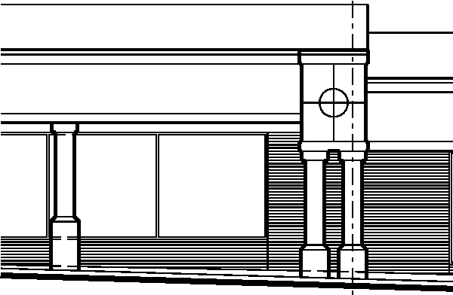
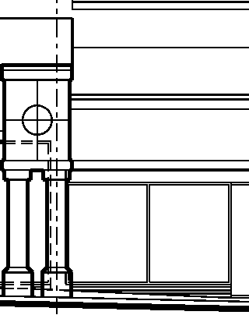

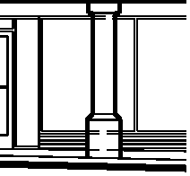
I I I I I I I I I I I I I I I I I I I I I I I I I I I I I I I I I I I I I I I I I I I I I I I I I I I I I I I I I I I I I I I I I I I I I I I I I I I I I I I I I I I I I I I

TENANT SIGNAGE
_...,c,
rn
A | EXHIBIT A | Small Shops Sign Band  Richmond Plaza, Rockingham, North Carolina | -1-1----1- - -  Architecture  Michael L Dyer  11342 Colonial Country Lane Charlotte, NC 28277 .  (704) 560-1347 mdyersr@gma1l .com
Scale: 3/32" = 1'-0" | EXHIBIT A
May 4, 2015 | EXHIBIT A

I
I I
I
I
I I
I
I I I I
[_ _ _ _ _ _ _ _ _ _ _ _ _ _ _ _ _ _ _ _ _ _ _ _ _ _





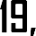






















































Exhibit B

--·-·--·---·--·--·-·------·7
I
.'
belkl llenney /

- - Available 1,750 sf

- Available 1,750 sf 3 - Todd's Computers 4 - Fuji Restaurant
5 - Fragrance Outl 6 - Foot Locker / 7 - Ted's Nails,,
8 - Availabl ,.7, ""311111-.c1N

9 - Available
10 - Available 1, 11 - Forever More
- - Available 7,749 sf

- Shoe Show
- - Hibbett Sports
- - Lucero's Shop
- - Gifts For All Seasons
- - Available 6,500 sf
- - Available 3,960 sf
- - GNC

- Stylorama
- - Merle Norman 22 - Freedom Fitness 23 - Firestone

- Verizon Wireless
- - Proposed Duncan Doughnut
26 - Available 2,000 sf ------.......:..-.
- - Proposed Outparcel 4,000 - 6,000 sf

- Little Caesars


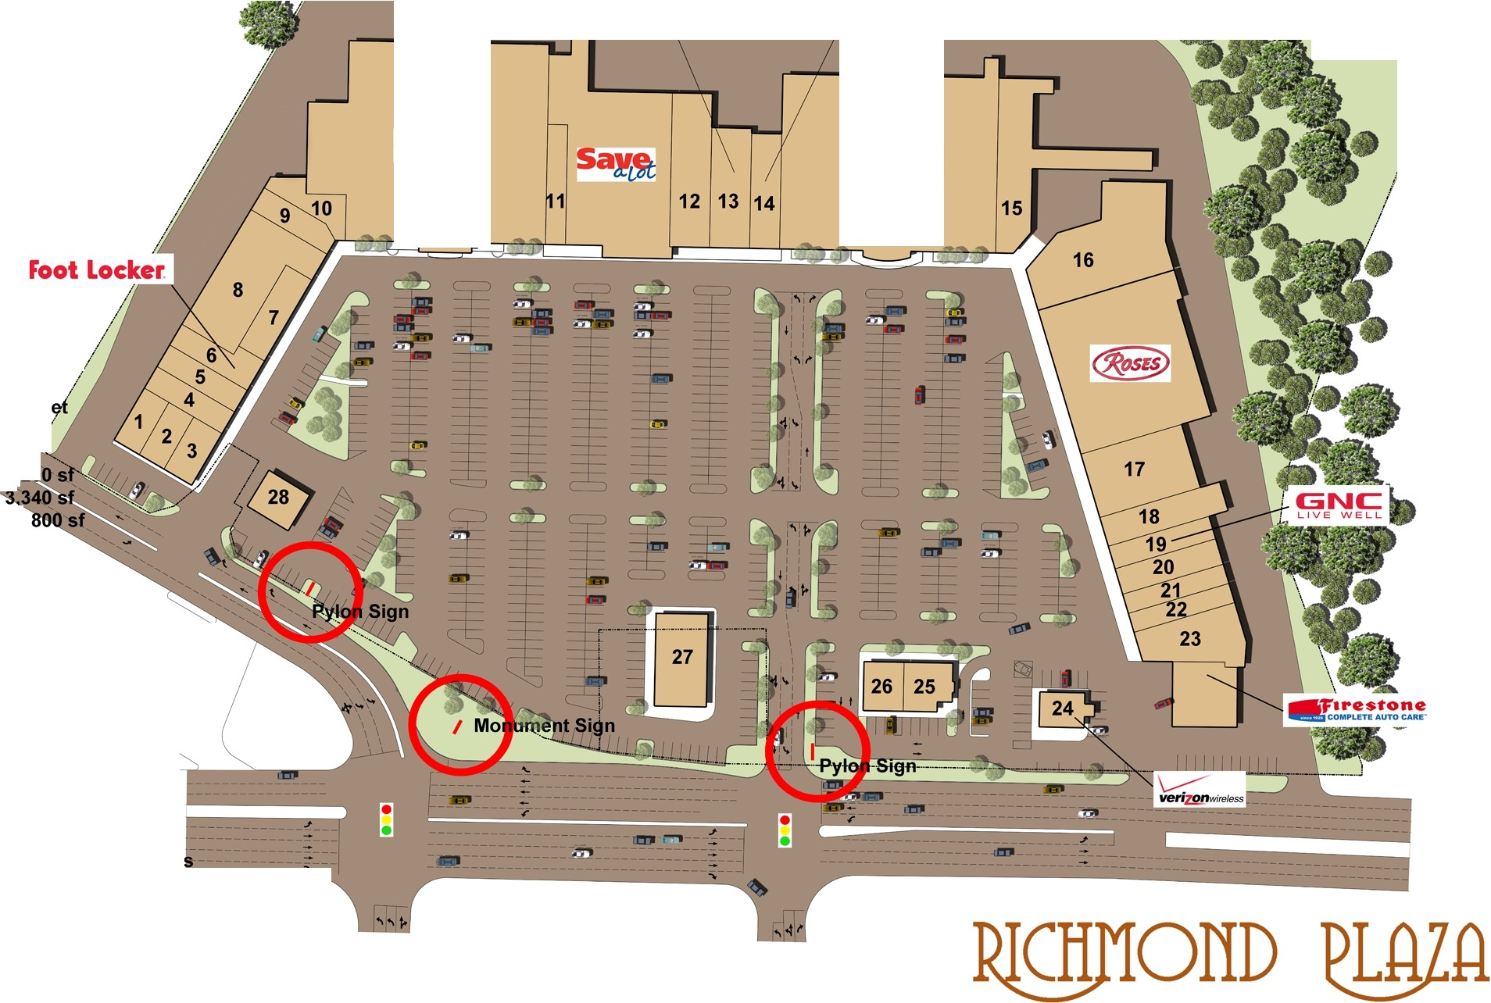
Exhibit C
= 'n Architecture

mdyersr@gmail.com

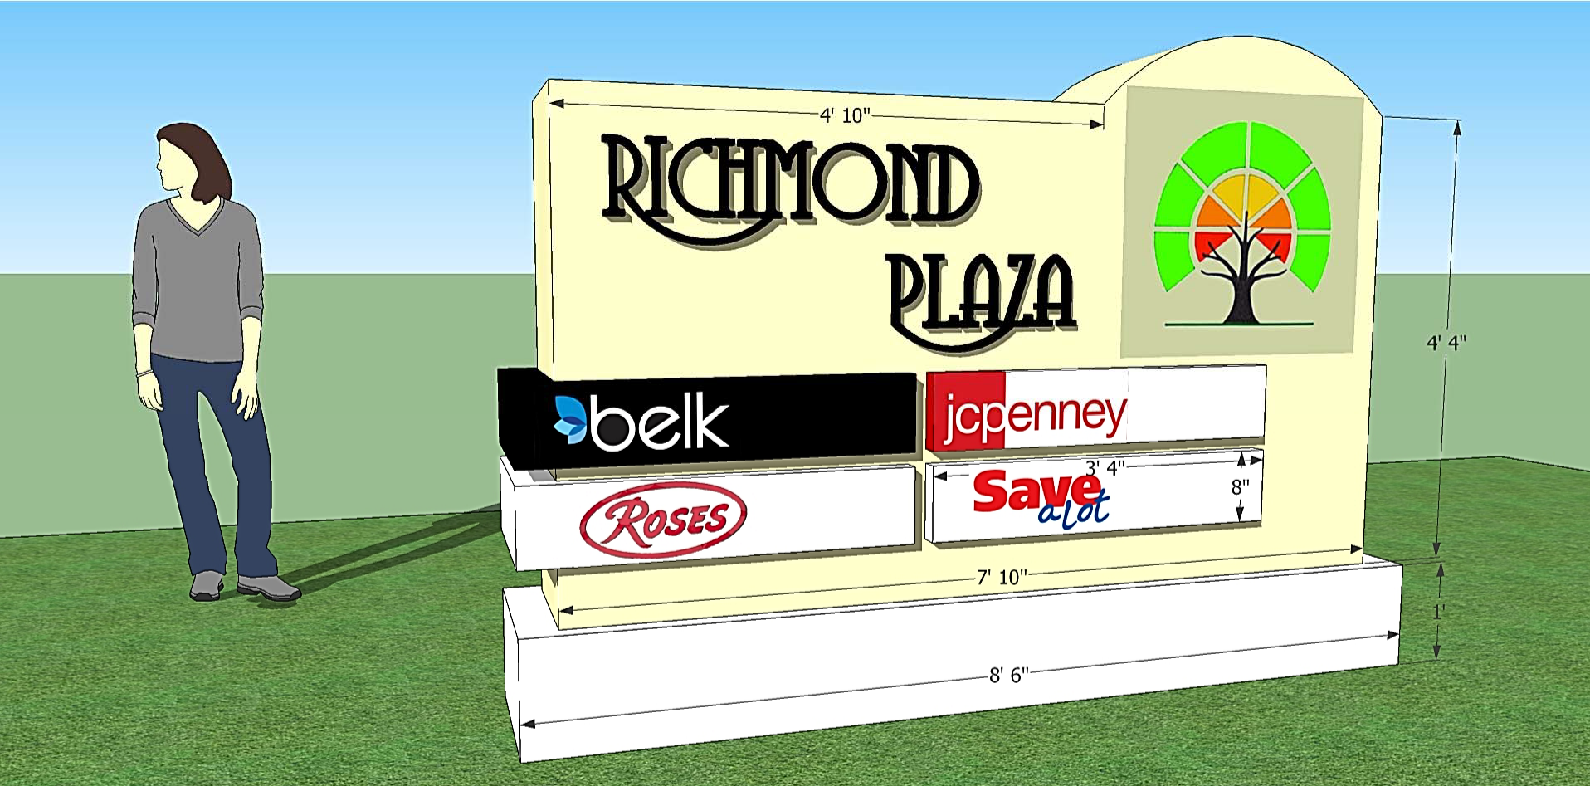
Exhibit D

