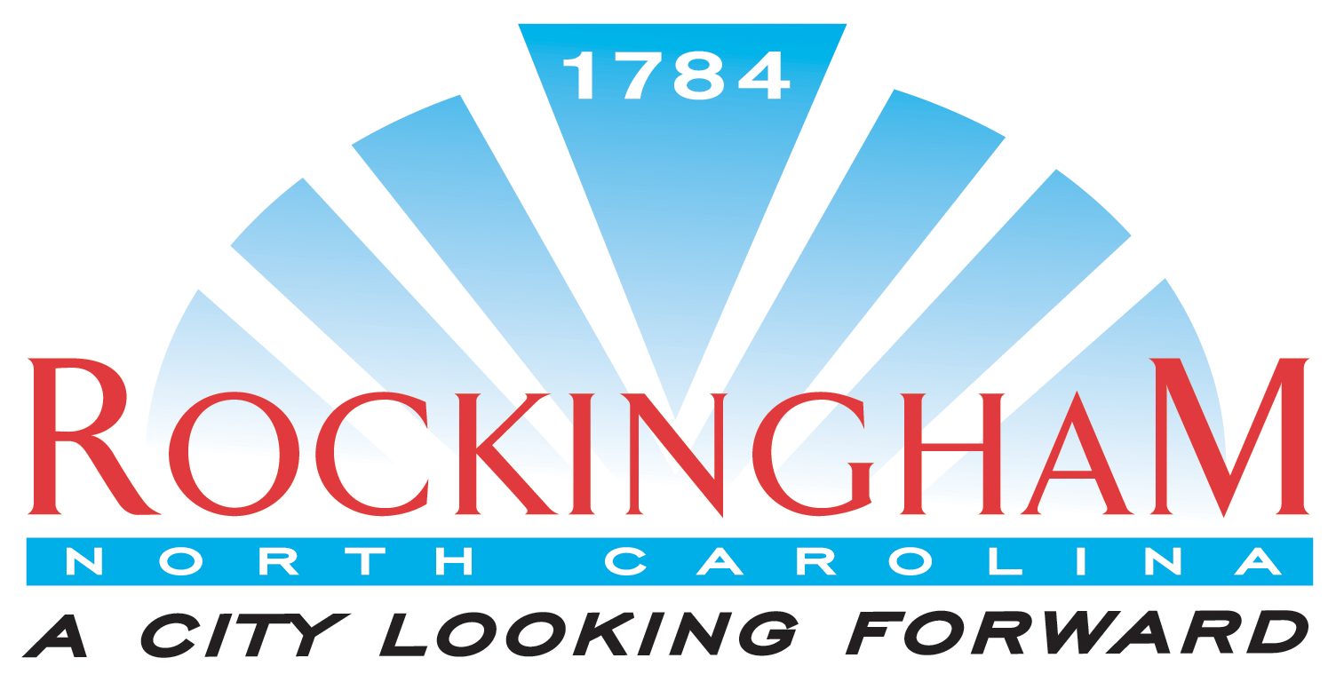

Permit Application

Type of permit (Circle One): Demo Electrical Mechanical Misc. Plumbing

Owner:__________________________________________________Phone:_________________

Address:_______________________________________________________________________________________________________________________________________________________
Site Directions:_____________________________________________________________________________________________________________________________________________________

Property Owner: _____________________________Tax Map ID:__________________________

Contractor: _______________________________________ License #:_____________________

Address: _________________________________________ Phone: ________________________

Check all that apply: Commercial: ______ Duke: _____
Residential: _______ Pee Dee: _____
Description of Improvement:_________________________________________________________________________________________________________________________________________________________________________________________________________________________________

Cost of improvement: $____________________ (Demo permit: Where will debris be taken?)
Cost of electrical permits (required): _____________________________________
Check one: Below $50,000 _____ below $130,000_____ Unlimited______

I hereby agree to conform to all applicable City of Rockingham Ordinances and State Building Code laws of North Carolina:

______________________________________________________________________________
Signature of Contractor Print Name Date

Office Use Only

Exam Y/N

______________________________ ___________________ _________________________
Approved by Date Fee Permit Number

City of Rockingham 514 Rockingham Road Rockingham, NC 28379 (910) 997-5546

