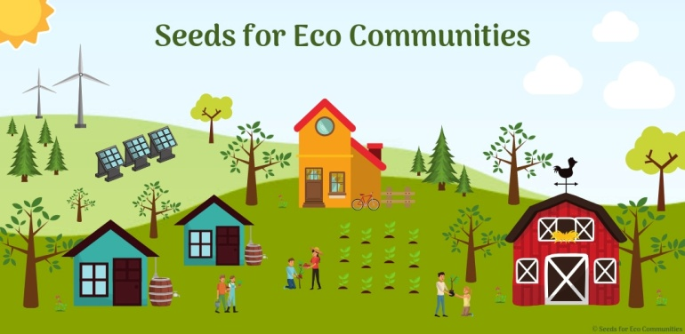

Global List of Established Eco Communities
North America

Name | Location | Website | Contact Info
Alpha Farm Community | 92819 Deadwood Creek Rd  Deadwood  Oregon  USA  97430 | http://alphafarmcommunity.org | alpha@peak.org
Belfast Cohousing & Ecovillage | 25 Village Rd  Belfast  Maine  USA  04915 | http://www.mainecohousing.org/index.html | info@mainecohousing.org  207-338-9200
Cinderland EcoVillage | 4610 Cinder Rd  Pāhoa  Hawaii  USA  96778 | http://cinderland.org | cinderlandmail@gmail.com
Cite Ecologique de Ham-Nord | 689 8e Rang  Ham-Nord  Québec  Canada  G0P 1A0 | https://citeecologique.org/en_US | info@citeecologique.org
Cite Ecologique of New Hampshire | 85 Angels Road  Colebrook  New Hampshire  USA  03576 | http://citeecologiquenh.org | info@citeecologiquenh.org
Clearwater Commons | 1402 194th St. SE  Bothell  Washington  USA  98012 | http://clearwatercommons.com/wp | info@clearwatercommons.com
Coastal Roots Farm | 441 Saxony Road  Encinitas  California  USA  92024 | https://coastalrootsfarm.org | hello@coastalrootsfarm.org  760-479-6505
Coffee Creek Community & Gardens | P.O. Box 1525  Centralia  Washington  USA  98531 | https://coffeecreekcommunitygardens.com | coffeecreekcommunity@gmail.com  360-807-4949
Dreamtime Village | 10375 County Highway A  La Farge  Wisconson  USA  54639 | http://www.dreamtimevillage.org | people@dreamtimevillage.org  608-625-4619
Earth Mountain Education Farm | 17613 CR 31.9  Weston  Colorado  USA  81091 | http://earthmountainfarm.org/index.htm | earthmountainfarm@gmail.com  719-680-0215
Earthworks Eco Villages | PO Box 93  Wolfe Island  Ontario  Canada  K0K 1H0 | http://www.earthworksecovillage.com/index.html | earthworksecovillages@gmail.com  888-844-3444 x7
East Wind Community | C.R. 547  Tecumseh  Missouri  USA  65760 | http://www.eastwind.org | ew.membership@gmail.com
Elphinstone Rainbow Village | Roberts Creek  British Columbia  Canada  V0N 2W1 | https://elphinstonerw.wixsite.com/home | elphinstonerainbowwarriors@gmail.com
Emerald Earth Sanctuary | P.O. Box 764  Boonville  California  USA  95415 | http://emeraldearth.org | community@emeraldearth.org  707-972-3096
Gurukul Garden | 510 Route 735  Mayfield  NB  Canada  E3L 5G4 | http://gurukulgarden.com | Sanjibh@hotmail.com
Headwaters  Garden and Learning Center | 40 Garden Way  Cabot  Vermont  USA  05647 | https://www.headwatersvermont.org/home.html | gwendolyn@headwatersvermont.org  802-851-7697
Hummingbird  Transformational Living Center | 132 CR B-028  Cleveland  New Mexico  USA | https://hummingbirdtlc.org | info@hummingbirdtlc.org
Le Manoir | Paspébiac  Quebec  Canada | http://manoir.community | manoir.intentionnel@gmail.com  418 751-3669
Living Energy Farm | 1022 Bibb Store Road  Louisa  Virginia  USA  23093 | http://livingenergyfarm.org | livingenergyfarm@gmail.com  540-205-9815
Living Roots Farm and Organic Farm School | 5907 W. County Road 375 South  French Lick  Indiana  USA  47432 | www.livingroots.org | Michael1@indianacommunity.org  812-727-5444
Manzanita Village | 258 Benjamin Drive  Prescott  Arizona  USA  86303 | http://www.manzanitavillage.com | 928-445-3015
Pacific Gardens Cohousing Community | 312 - 347 Seventh Street  Nanaimo  British Columbia  Canada  V9R 1E3 | http://www.pacificgardens.ca | info@pacificgardens.ca  250-754-3060
Polestar Gardens | 7 Noni Farm Rd.  Pahoa  Hawaii  USA  96778 | https://polestargardens.org | info@polestargardens.org  808-430-8009
Rocky Corner Cohousing | 58 Old Amity Road  Bethany  Connecticut  USA  06524 | http://www.rockycorner.org | welcome@rockycorner.org  203-903-COHO (2646)
Shekinah EcoVillage | Little Pigeon Hollow  Spring City  Utah  USA | http://www.shekinahecovillage.com | susanmanningsells@gmail.com
Threehands Land Share Network | Box 7293  Peace River  Alberta  Canada  T8S 1S9 | https://threehands.weebly.com | terrifiedprojects@gmail.com
Twin Oaks Community | 138 Twin Oaks Road  Louisa  Virginia  USA  23093 | https://www.twinoaks.org | twinoaks@ic.org  540-894-5126

