How to remove rounds from the rounds list?
In this example we will prevent all AA (Archery Australia) rounds from being shown.
Note: Filtering at a round name level is not supported, e.g. filtering out of only the round named, WA 70/720 round
- Navigate to the Plot Tab

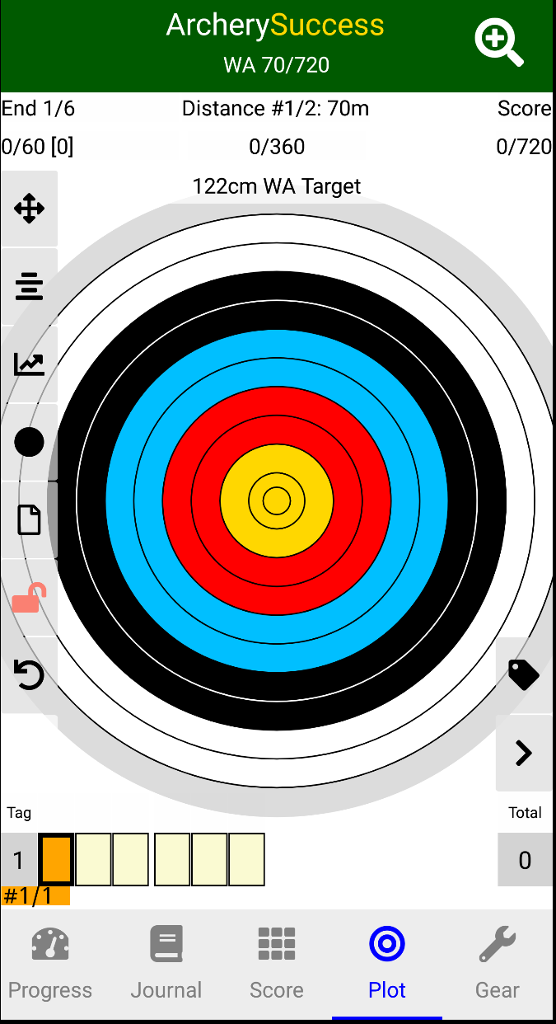
To open the Select a round page, tap

- In this example we will prevent all AA (Archery Australia) rounds from being shown. To highlight, in the screenshots, AA rounds are circled with yellow.
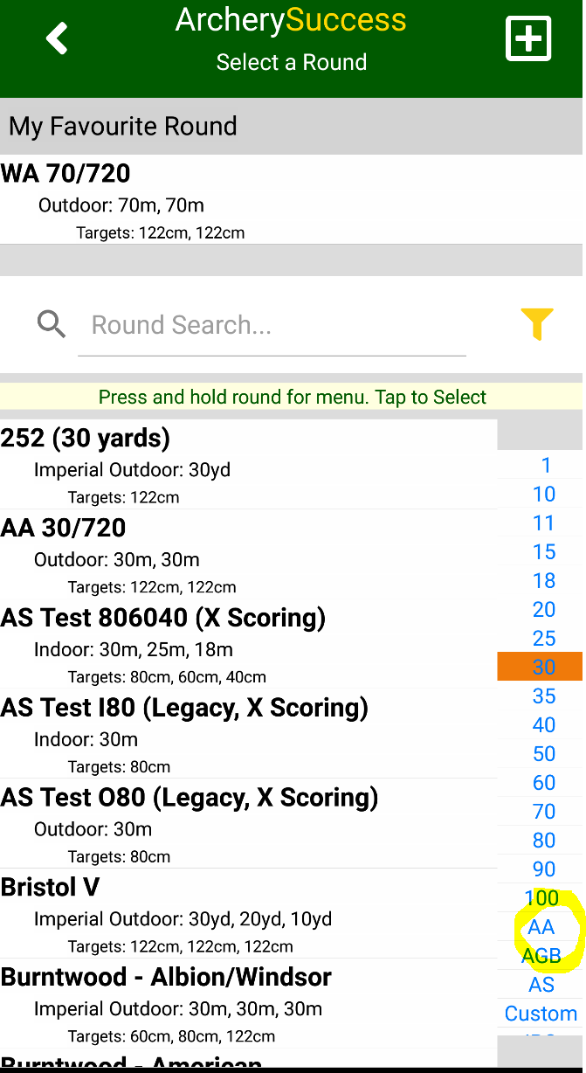

Tap the round filter icon next to Round Search, to show a page which allows for the filtering of rounds.
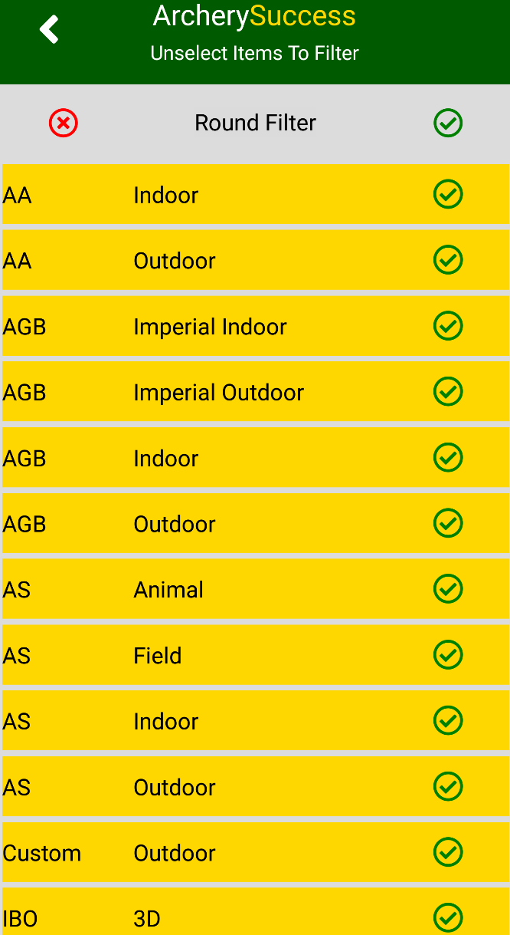

- a. On the Round Filter, to remove round groupings, simply tap on a row to change the row status, this will be indicated by a row colour change; For example, with the yellow background, AA rounds will be shown;

With the white background, AA rounds will not be shown;
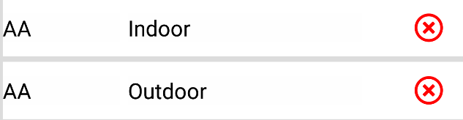

b. Quick all rounds filtering options
To quickly filter all rounds, tap at the top of the list
To quickly remove all filters, tap at the top of the list

- When done; tap to save the filter

- As can be seen in the screenshot AA rounds are no longer listed
