How do I use Arrow Tagging and Tag Analysis to identify arrow grouping issues?
The Tag Analysis feature in ArcherySuccess allows you to identify arrows which do not group well and may potentially cost points during a scoring round.
Tagging is done by assigning arrow numbers to each of your arrows and then plotting and tagging the arrows at distances you group well.
Tag Analysis is done, by looking at where an arrow with a specific tag (arrow number) groups in relation to the ‘all arrows’ group.
Arrows which do not group or tend to group to one side of the main group are the ones to further investigate and adjust.
Contents
How do I use Arrow Tagging and Tag Analysis to identify arrow grouping issues? 1
Preparation tasks 1
STEP 1: Get to know how to Tag Arrows in ArcherySuccess 1
STEP 2: Weigh your arrows 2
STEP 3: Number your arrows 2
Shooting rounds, Scoring and Tagging 3
Step 4: Plot And Tag arrows 3
Do Tag Analysis 3
Step 5: Open the Tag Analysis Page 3
sTEP 6: Remove Untagged Arrows from the Analysis 4
STEP 7: Identify arrow tags which do not group 4
References and further reading: 5

Preparation tasks

STEP 1: Get to know how to Tag Arrows in ArcherySuccess
Tagging arrows in ArcherySuccess is done as part of plotting at the target:
- First plot the arrow, then click the Tag icon (the icon looks like a tag).

Notes:
- Clicking the Tag icon is only needed if you have not enabled the “Plot and Tag” feature.
- If you are tagging all scored arrows, turn the “Plot and Tag?” switch to ON in the Assign Tag page. Doing this will speed up the tagging process as the Assign Tag page will be displayed after each arrow plot.
- Arrow tagging is only supported for plotted arrows.

- On the Assign Tag page, click the tag number that corresponds to the arrow number.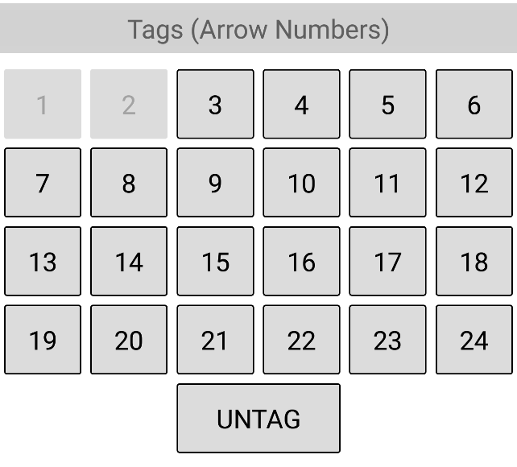
- The arrow will be tagged, and the App will automatically return of the Plot page?
- The Tag number assigned will be displayed above the arrow score at the bottom of the Plot Tab.
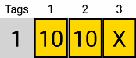

STEP 2: Weigh your arrows
Ensure all your arrows are the same weight by using a grain scale to weigh and note down the weight of each completely assembled arrow (aim for +/- 2 grains or better). Arrow weight can be adjusted by reinstalling the arrow point with less or more glue, swapping out arrow points or filing down the arrow point.

STEP 3: Number your arrows
Next, to tag arrows using ArcherySuccess, you will need to number each of your arrows with a unique number. ArcherySuccess supports numbers between 1 and 24. Most commonly arrows are numbered either by writing a unique arrow number on the arrow shaft for each arrow in the set, or by using numbered arrow wraps.

Shooting rounds, Scoring and Tagging

Step 4: Plot And Tag arrows
With your numbered arrows, score and tag rounds at distances where you can consistently shoot groups. Only Tag arrows which you feel you shot well, i.e. if for whatever reason you didn’t shoot an arrow well, use the ‘Untag’ button.

Do Tag Analysis

Step 5: Open the Tag Analysis Page

To access the Tag Analysis screen from the Journal Tab:
- iPhone/iPad: slide left on the round and choose Analysis from the menu
- Android: press down on the round you want to resume until a menu appears at the top of the screen and select Analysis from the menu.

To access the Tag Analysis screen from the Plot Tab:

- Tap the Tag Icon

- On the Assign Tag page, click the graph icon in the top right hand corned of the page

sTEP 6: Remove Untagged Arrows from the Analysis

  - The yellow area on the target shows the ‘all arrows’ group, by default this group includes untagged arrows. If you only tagged well executed arrows, then you want to remove the untagged (or not well executed) arrows from the analysis.
    - To remove untagged arrows from the ‘all arrows’ (yellow) group, use the U button on the right-hand side of the page. When the U button is enabled, the button background will be a dark color.
  - To remove sight adjustment errors, centralize the arrow group by pressing the Circle with the X button on the right-hand side of the screen. This will change the button background to purple and move the ‘all arrows’ group to the center of the target.
  - If you still have tagged arrows which you feel should not be part of the ‘all arrows’ group (yellow), you can remove arrow outliers from the ‘all arrows’ group by using the slider at the bottom of the screen. As you move the slider from left to right, the arrow furthest from the center of the main cluster will be removed. Arrows removed will highlighted in a light red color.
  - To get a better idea of the tagged arrows removed using the slider, a graph button on the left side of the page can be enabled (button has a gold background when enabled). The graph shows each arrow tag and the count of the tag in and out of the ‘all arrows’ group as a percentage (%).

STEP 7: Identify arrow tags which do not group

- Ensure that the Tags button on the right-hand side of the screen is on.
When selected:
    - the button will have a green background
    - the arrow tag buttons will be displayed at the bottom of the screen
    - a green group will be displayed on the target face. This represents the grouping of the Tag selected.

- By clicking each arrow Tag, the corresponding green group will move, and it can be seen where the arrow tag grouped in relation to the ‘all arrows’ group (yellow).
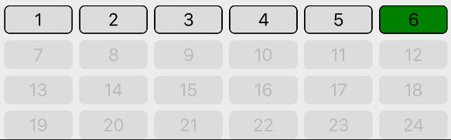

- Arrow Tags which do not group or tend to group to one side of the main group are the ones to further investigate and adjust.
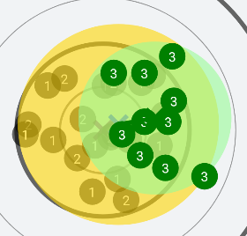

References and further reading:
For more information on arrow culling, refer to the excellent article by Rod White, NFAA Bowhunting and Event Coordinator: https://www.nfaausa.com/2018/05/arrow-culling/

