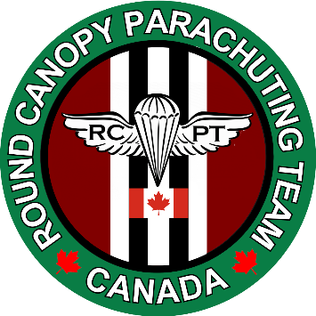
ROUND CANOPY PARACHUTING TEAM – CANADA

Membership Application 2026 -2027

Personal Information
Full Name: Mailing Address: Phone: Cell: Email: Emergency Contact: Phone:
Date of Birth: / / Male: Female: Height: Weight: Vision: Corrective Lenses: Medical/Physical Conditions: Medications:
Current Medical Insurance: YES___ NO___ Current Drivers License: YES___ NO___ Current Passport: YES___ NO___ Admissible to Canada & US: YES___ NO___
Special Educational/Vocational Skills:

First Aid Training: YES___ NO___
Service Experience: Active ____ Retired____ Branch: ______________ Reserves:____ Reserve Auxiliary: ____ First Responder: ____
Civilian Parachute Licenses & Ratings
CSPA/USPA Ratings: Member Number: Aviation Ratings & Licenses:
Military Parachute Ratings
Jumpmaster: Loadmaster: Rigger:
Other:

Experience to Date
Number of Static Line Round Parachute Jumps: Date of Last Jump: Number of Steerable Round Canopy Jumps: Date of Last Jump: Number of Sport Skydiving Freefall Jumps: Date of Last Jump:_________________
Number of Water Jumps: Number of Night Jumps:
Other Round Canopy Parachute Team Memberships:

Types of Membership
- ____ Jumping Member
- ____ Freefall EJR/PRO Member
- ____ Non-Jumping Member
- ____ Other: ___________________________________________________
Annual membership donation: $100.00 CAD
>Send payment To PayPal: inf@rcptca.org reference: RCPT-CA Membership >Email your membership application to info@rcptca.org, . please include a clear 1”x”1 headshot photo for ID card

Acceptance
I, have voluntarily applied to participate as a member of the Round Canopy Parachuting Team - Canada and in consideration of my acceptance as a member I agree to abide by the Team’s rules and regulations and all pertinent Transport Canada/FAA rules and regulations while participating in Team activities and I further acknowledge that flying and parachute jumping are dangerous high risk activities than can result in my serious injury and death, and I have voluntarily assumed all risks associated with those activities and do hereby expressly indemnify, release, and hold harmless the Round Canopy Parachuting Team - Canada, it’s directors, officers, and members, from any and all claims of liability I may have or may result from my actions and participation as a Team member of the Round Canopy Parachuting Team – Canada.

PHOTO & VIDEO RELEASE.
I, ________________________________ hereby grant the Round Canopy Parachuting Team - Canada the irrevocable and unrestricted right to use and publish photographs and video images of me, or in which I may be included, for editorial, trade, advertising, and any other purpose and in any manner and medium and in any jurisdiction, to alter the same without restriction, and to copyright the same. I hereby release the Round Canopy Parachuting Team - Canada from all claims and liability relating to any photographs or video images of me.
Signature of Member: on / / Approved by: on / /
Board of Directors
ROUND CANOPY PARACHUTING TEAM – CANADA P.O. Box 403 Ridgeway, ON L0S 1N0

