Tabit develops best-in-class, cloud-based solutions to help restaurants transform their business to be fully mobile, more efficient, and more profitable, while increasing customer satisfaction. Tabit is built to help restaurants protect their profit margins, creating a technology shield that safeguards against inflated transaction and processing fees.

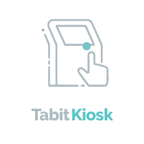
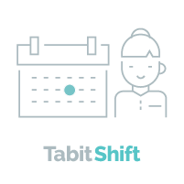
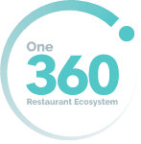
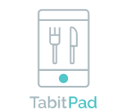
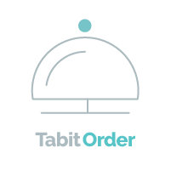
Tabit’s MobileFirst Restaurant Operating System was designed from the ground up to be truly mobile. It has restaurant point-of-sale and back office functionality at its’ core and utilizes tablets and smartphones as the primary touch points, eliminating the need for static server stations. The friendly interface uses familiar swipe and tap gestures that mobile users are accustomed to for intuitive everyday use, and easy training. Tabit’s 360-degree integrated ecosystem enhances the customer experience by connecting and bringing efficiencies to every interaction point.
Tabit
Office
MDM
Mobile Device
Ma
nagement

MobileFirst – TabitPad devices allow staff to bring the point-of-sale to the point of sale: table-side.
Upsell Opportunities – Built-in sales tools help servers increase guest spend and enhance customer experience, all while enabling faster table turns.
Operational Efficiencies - Tabit solutions communicate with each interaction point driving efficiency and freeing up staff and management to focus on selling and guest experience.
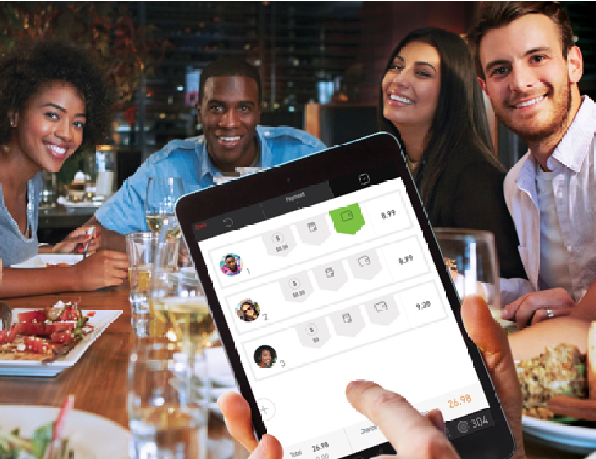
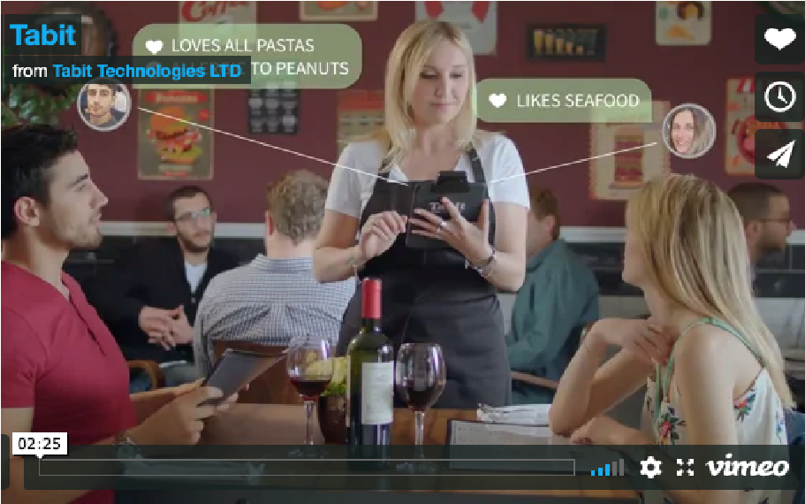
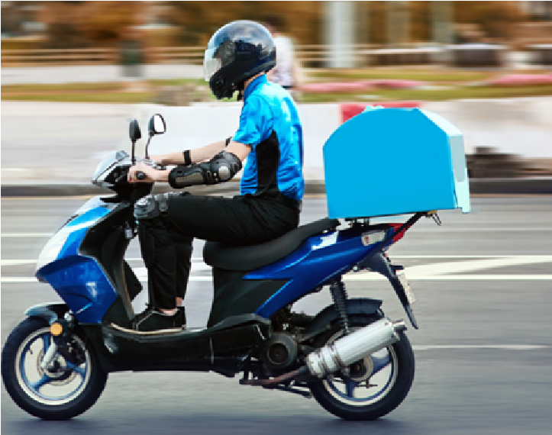
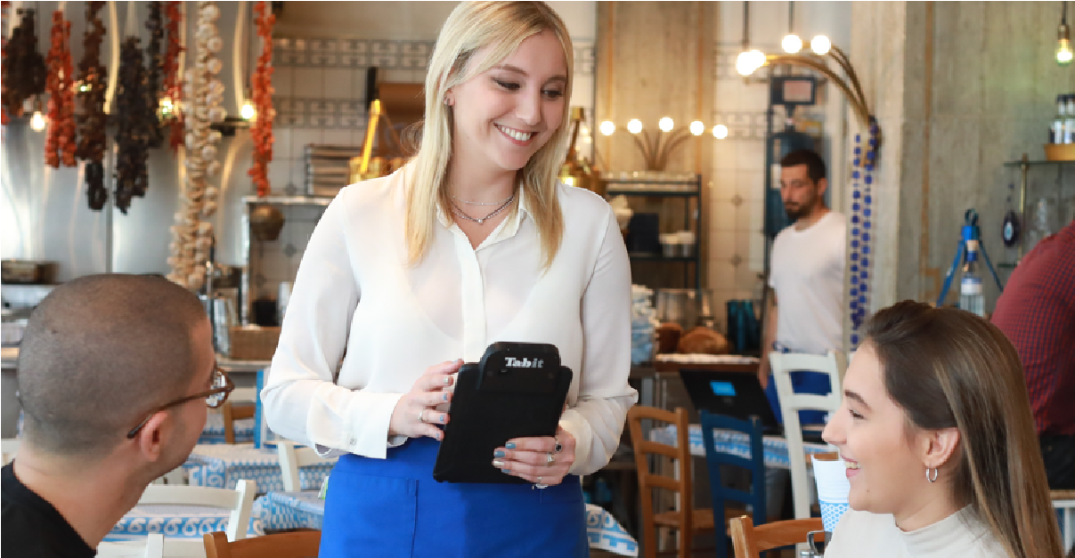
Customer Loyalty – Delight your customers, build your brand, grow your customer base, and drive repeat business.
COVID-19

Relief for

Restaurants

Offe
r
Click Her
e
Tabit Mobile
First
Restaurant Operating System
Real Time Data Access – TabitChef is a browser and mobile app enabled system providing real-time reporting of KPI’s that are vital for operations management, keeping leadership always up to date.

Cloud Based – Tabit’s cloud-based solution gives you access to data and analytics from anywhere, anytime.
Online Ordering, Takeout & Delivery - Tabit solutions allow you to adapt to COVID conditions quickly so restaurants can sell online and provide takeout, curbside pickup and delivery services.
Contactless Functionality – Tabit provides
COVID-19 relevant solutions including contactless menus, ordering, and payments.
Business Intelligence & Data Analytics –
Get actionable intelligence and key business insights such as specific menu item sales, labor costs, and overall performance to find opportunities for improvement and growth.
Focus on Guest Experience – The Tabit restaurant ecosystem focuses on enhancing guest experience resulting in higher customer satisfaction and loyalty.

