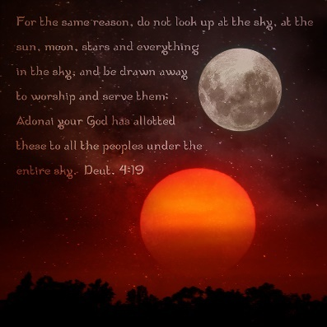
THEME – PURPOSE DRIVEN BY THE HEAVENLY BODIES

Subject: What’s the Problem?
(Deuteronomy 4:19)

Scripture Passage:

"And lest thou lift up thine eyes unto heaven, and when thou seest the sun, and the moon, and the stars, even all the host of heaven, shouldest be driven to worship them, and serve them, which the LORD thy God hath divided unto all nations under the whole heaven." (KJV)

Introduction:

The last couple of weeks we have discussed and dove into the meaning of praise. One conclusion, praise can lead one into worship. Our thoughts on worship, an intimate space where we surrender to the Holy Spirit. During worship we loose self and pour out our gratitude to the Almighty in different ways.

Worship as defined by the Strong Hebrew Dictionary means to prostrate (especially reflexive, in homage to God; bow (self) down, crouch, fall down (flat), humbly beseech, do (make) obeisance, do reverence, make to stoop, worship.

However, there are those that worship creation instead of the Creator. Thus, the basis for our lesson.

Scripture References: Deuteronomy 18:9-12, 29:29; 17:2-5; Jeremiah 10:2-3; Isaiah 47:11-15; Genesis 1:14-18; Psalm 19:1-4; Romans 1:20; Psalms 119:105

Biblical Applications:

- God set lights in the firmament for His specific purpose. (Genesis 1:14-19)

- Job recognized the power of God through the creation. (Job 9:1-12)

- The Lord declared his glory to Job through his creation. (Job 38:1-33)

- Astrologers and stargazers exposed. (Isaiah 47:12-15; Daniel 2:1-12)

- Man continues to pervert what God intended. (Romans 1:20-25)

- Give some popular modern-day examples of New Age worship of the creation.

Closing:

People adjust their thoughts and activities based on horoscopes. Some couples adjust their thoughts, activities, and attraction for one another on the Zodiac. The worship of the creation instead of the Creator has occurred for millennia. Unfortunately, many Christians participate in some form of idolatry. One recent Pew research survey found that 26% of Christians believe in astrology. (Pew, 2018)

The Lord knew this would occur and gave clear warnings against worship of the moon, stars, and creation. Be purposeful in your worship. Remember, according to John 4:24, “God is a Spirit: and they that worship him must worship him in spirit and in truth.” Knowing the truth is worshipping the Creator!

References:

http://www.pewresearh.org/fact-tank/2018/10/01, New Age Beliefs Common Among Both Religious and Non-Religious Americans
Coltran, S., 2009.The Christian’s View of Astrology
MacArthur, J., https://www.gty.org/library/questions/QA204, What is the biblical teaching on Astrology?

