Adobe
AGDIA EMEA
Agdia, Inc.
AGV Helmets
Alpine Rivers® | RFID Blocking Sleeves & Belts
Alpinestars
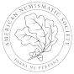American Numismatic Society
ASUS
AXIL
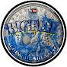BIGFLIP COINS
Bluelab
BMLEH
Boston Whaler
Brinks Locks
British Society for Plant Pathology
Brooks Running
Byrna
Canadian Weed Science Society
Car Talk
CHANNELLOCK® TOOLS
Chevrolet

Cobra Electronics
Coca-Cola
CropKingInc
CSIS Canada - SCRS Canada
DASANI
Deer Park Spring Water
DGH Graphic Design
DHL
Diplomatic Security Service
Dr. Bronner's
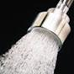Dramm Corporation
Farmers' Almanac
FIGS Scrubs
Fine Minerals International
Fisher Space Pen Co.
FoxFarm Soil and Fertilizer Company
Gildan
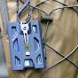GOVO
GOVO Products
Griot's Garage
GSA (General Services Administration)
Helly Hansen
HISEA Outdoors
Hurley
Hurst Performance
Husqvarna
Injen Technology
John Deere
Johnny's Selected Seeds
Johns Hopkins Art as Applied to Medicine
Johns Hopkins Medicine
Kestrel Ballistics
Kestrel Weather
KEXP
KICKER
Klein Tools
Knaack
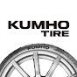Kumho Tire Global
LC Engineering
magnaflow
Metro by T-Mobile
Milwaukee Tool
Mitsubishi Electric - Global
Montana Fly Company
National Geospatial-Intelligence Agency
Nectar Sleep
New Era Cap
NHK WORLD-JAPAN
Nintendo of America
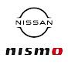NISMO
NISMO_Official
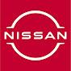Nissan
noaa
North American Vexillological Association (NAVA)
NVIDIA
NVIDIA GeForce
NVIDIA Insider
NVIDIA Studio
Obsidian
Official Tor Browser Channel
Okatsune Europe
Old Bones Therapy
Parasites Without Borders
Pathology Mini Tutorials
Pathology Simplified
PhilipsHorticulture
Plasti Dip International
Premier Body Armor
Proton
Proton Guides & Updates
Psych2Go
Purina Institute
R for Ecology
radiowv
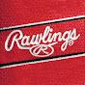Rawlings Sporting Goods
Raycon
Razor-Back Professional Tools
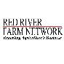Red River Farm Network
Rome Tech Cases
ROXY
Royal Entomological Society
RTeam RalliArt
Samsung US
Saratoga Spring Water
ShakespeareFishingUS
Signal Dynamics Co.
Skype
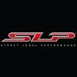SLP - Street Legal Performance
SoFi
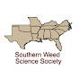Southern Weed Science Society
Special Operations Warrior Foundation
Stoko
T-Mobile
T-Mobile for Business
Team Mexico Baseball
TEINJAPAN
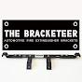The Bracketeer
The Collector Of Coins
The Graphic Design School
The Hershey Company
The Tor Project
The Weather Channel
This Week in Louisiana Agriculture
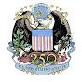U.S. Department of State
U.S. Indian Affairs
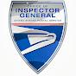U.S. Postal Service Office of Inspector General
USPS
USPS Insider
Vexillology
Voice of America
Wahl SA
Warhammer
WeatherTech
Western AF
Wilwood Disc Brakes
Yamaha Motor USA
Yubico

