TIMES |  | MEMORIAL OR FEAST |  | INTENTIONS
SAT | 5.30pm | Vigil Mass: All Saints Year A
SUN | 10.30am | Mass: All Saints Year A
FRI | 9.00am  9.30am | Exposition  Mass: Friday of Week 30 in Ordinary Time
SAT | 5.30pm | Vigil Mass: 32nd Sunday in Ordinary Time Year A
SUN | 10.30am | Mass: 32nd Sunday in Ordinary Time Year A
Last week |  | Collection: £270.90 MISSIO: £48 Candles: £7 Att: 52
MINISTRIES |  | 1/11/2026 |  | 8/11/2026
Church Cleaning |  | T & P Brennan (Nov) |  | T & P Brennan (Nov)
Counters |  | Reid |  | Foote
Welcome |  | Collins/Harvey |  | Gray/James
Hall keeper |  | M Collins |  | K Gray
Sat Reader |  | T Brennan |  | K Cruickshank
Sat EMoHC |  | R Hendry |  | M Collins
Sun Reader |  | T Coull, E Danby |  | I Grant, M Le Mero
Sun EMoHC |  | C Moir, I Grant |  | M Moir, A Mitchell
Flowers |  | Artificial |  | Artificial
Teas |  | Brenda & Mike |  | Kevin
Useful contacts:
Parish Priest:  Assistant priest:  Permanent Deacon: | Fr Kingsley Chigbo email  Fr Peter Ezekoka  email  Dcn Graeme Morrison  email |  | 01542 780208  cilk@rcda.scot  01542 780208  poe@rcda.scot  07387008498  deacon.graeme@rcda.scot
PPC Chair: | Dcn Graeme Morrison |  | 07387008498
Parish Safeguarding Co-ord: | Elizabeth Danby |  | stthomasPSC@rcd-abdn.org
Health & Safety: | Keith Gray |  | 07547 653902
Newsletter: | Margaret Farrell or |  | 01542 882116  mcfarrell@btinternet.com
Hospital Chaplains: Elgin  Aberdeen | Dcn Graeme Morrison  Fr Emmet O’Dowd or |  | 07387008498  01224 482657  ARI@rcda.scot
Facebook: St Thomas’ RC Church, Keith |  | YouTube: St Margaret’s RC Church, Huntly
Email: chapelstthomas@yahoo.co.uk |  | Website: www.stthomaskeith.com


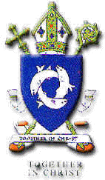
ST. THOMAS R.C. CHURCH, KEITH
DIOCESAN SHRINE OF THE BIRTHPLACE OF ST JOHN OGILVIE

1st November 2026
Solemnity of All Saints (AII) Psalter Week 3

THE ANNOUNCER!

Today we celebrate the solemnity of All Saints. The saints are all those in heaven. They passed through this world, are purified in the saving blood of Christ, and are clothed in glory in God’s kingdom. We are celebrating the communion of Saints, and we are reminded that the whole aim of our life on earth is to be counted among the saints in heaven on the last day. The readings remind us that we are children of God, called to become saints and to share in the joy of His Kingdom.
In the first reading, John saw a great multitude from every nation, tribe, people, and language, standing before the throne of God. Clothed in white robes, they worshipped God. These are people who have come through great suffering and have washed their robes white in the blood of the Lamb. Their lives might not have been easy, but they remained faithful to Christ till the end and are now clothed in God’s glory.
In the second reading, St John reminded us that we are already children of God. That is because God loves us first. We are invited into a special relationship with Him: to be like Him who we see as He really is. To see God (who is love) is to love Him who loves us, and be like Him in the world.
Those who are like God and live the life of Christ are called blessed and holy. Thus, in the gospel reading, Jesus proclaimed the Beatitude: the blessedness of those who are living by the principles of the heavenly kingdom – the blessedness of the poor in spirit, the gentle, those who mourn, those who hunger and thirst for righteousness, the merciful, the pure in heart, the peacemakers, and those persecuted for doing what is right. Theirs is the kingdom of heaven – theirs is sainthood.
How are we practising these principles to be counted among the saints? That is a question we answer for ourselves individually. However, being a saint does not mean never making mistakes; rather, it means allowing God to change us, getting up when we fall, seeking forgiveness, and continuing to follow Christ every day. Sainthood is our goal: let us keep pursuing it because that is when we become the person God created us to be.
Fr. Kingsley
Welcome: to all our visitors, feel free to look around our beautiful church, particularly the St John Ogilvie Chapel & Exhibition.
November: is the month when we remember especially those who have died. The Remembrance Book will be placed in front of the altar throughout November, please add the names of your deceased family and friends. The fathers will be offering their Masses for the repose of the souls of all our deceased friends and family.
Hall Committee: Raymond Hendry has stepped down as chairman of the Hall Committee, but is remaining as a committee member. He has been chairman for much of his 30 plus years on the committee and is thanked for that sterling service. The new chairman is Keith Cruickshank. Keith Gray continues as vice chairman, Kathleen Foote as treasurer, Mike Collins as secretary and Kevin James as a committee member.
Toilet: thanks to all concerned, the repair work to the toilet is now complete, and the path restored and cleaned. We now await the invoice in fear and trembling!
Thank you: Fr Peter has sent his thanks following his 10th Anniversary celebrations in August. The card has been placed in the porch for anyone who wishes to see it.
Tombola: Many thanks to everyone who was involved in this, our main fundraiser of the year. Whether you were behind the scenes, in the kitchen, front of house, donating prizes or playing the game, everyone played their part well. The hall was almost full, and the proceeds of £2039 have been banked.
Weekday Mass: we will move into the chapel in the house from Friday 30th October for the winter months. Entry via the sacristy.
Youth Events: 13-15 November S4-6 Retreat, Tomintoul.
26-28 February: TOB Girls’ Retreat
17 April: NET Retreat Inverurie
For more information, Contact Sr. Angela Marie at op@rcda.scot or 07938 729895. Also at https://www.rcda.scot/diocese-of-aberdeen-youth-events-2026-27
Special collections in November: 14/15 Maintenance Fund; 28/29 Scottish Catholic Education Commission
Hospital visiting: please remember to contact Deacon Graeme if you or any of your family are in hospital. He is always happy to visit.
Prayer Group: Monday evenings, 7pm in the hall. Contact: Elizabeth Danby.
Tea & coffee in the hall, after Sunday Mass. All welcome.

Apologies for the lack of a printed newsletter last week. Normal service is resumed!
Pope’s Prayer Intention: November: For the proper use of wealth: Let us pray for the proper use of wealth, that not succumbing to the temptation of selfishness, it may always be put at the service of the common good and solidarity of those who have less.
Safeguarding: The Parish Safeguarding Coordinator is Elizabeth Danby, and she can be contacted as shown overleaf. The diocesan Safeguarding page can be found at Safeguarding – Roman Catholic Diocese of Aberdeen (rcda.scot) and the text of In God’s Image (V2) is accessed through the Bishops Conference website.
Diary Dates
Fabric & Finance Committee | Thurs 12th November 7pm
Parish Pastoral Council | Wed 18th November 7pm
Confirmation | Sun 20th December 10.30am
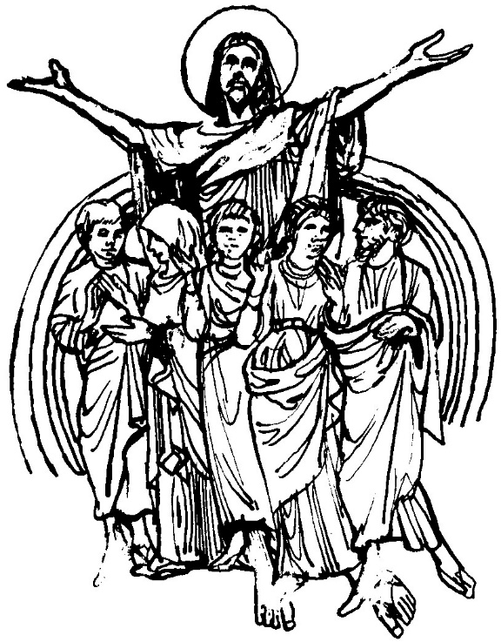

St Thomas’ Church is open each day from 10am to 3pm for private prayer. Please note, the church may not be open on weekdays in the event of severe weather.
A parish of the R.C. Diocese of Aberdeen Charitable Trust
Registered Charity Number SC005122

