TIMES |  | MEMORIAL OR FEAST |  | INTENTIONS
SAT | 5.30pm | Vigil Mass: 27th Sunday in Ordinary time Year A
SUN | 10.30am | Mass: 27th Sunday in Ordinary time Year A
FRI | 9.00am  9.30am | Exposition  Mass: Friday of Week 27 in Ordinary Time
SAT | 5.30pm | Vigil Mass: 28th Sunday in Ordinary time Year A
SUN | 10.30am | Mass: 28th Sunday in Ordinary time Year A
Last week |  | Collection: £ 388.95 Att: 67  20/9/2026 Collection: £318.96 Candles:£9.04 Shop:10.16 Att: 65
MINISTRIES |  | 4/10/2026 |  | 11/10/2026
Church Cleaning |  | S Burts (October) |  | S Burts (October)
Counters |  | Foote |  | Mitchell
Welcome |  | Collins/Harvey |  | Gray/James
Hall keeper |  | K Gray |  | K James
Sat Reader |  | T Brennan |  | K Cruickshank
Sat EMoHC |  | K Schouwenaars-Harms |  | R Hendry
Sun Reader |  | A Mitchell, T Coull |  | E Danby, I Grant
Sun EMoHC |  | I Grant, E Danby |  | A Mitchell, R Harvey
Flowers |  | Artificial |  | Artificial
Teas |  | Kevin |  | Michele & Louis
Useful contacts:
Parish Priest:  Assistant priest:  Permanent Deacon: | Fr Kingsley Chigbo email  Fr Peter Ezekoka  email  Dcn Graeme Morrison  email |  | 01542 780208  cilk@rcda.scot  01542 780208  poe@rcda.scot  07387008498  deacon.graeme@rcda.scot
PPC Chair: | Dcn Graeme Morrison |  | 07387008498
Parish Safeguarding Co-ord: | Elizabeth Danby |  | stthomasPSC@rcd-abdn.org
Health & Safety: | Keith Gray |  | 07547 653902
Newsletter: | Margaret Farrell or |  | 01542 882116  mcfarrell@btinternet.com
Hospital Chaplains: Elgin  Aberdeen | Dcn Graeme Morrison  Fr Emmet O’Dowd or |  | 07387008498  01224 482657  ARI@rcda.scot
Facebook: St Thomas’ RC Church, Keith |  | YouTube: St Margaret’s RC Church, Huntly
Email: chapelstthomas@yahoo.co.uk |  | Website: www.stthomaskeith.com



ST. THOMAS R.C. CHURCH, KEITH
DIOCESAN SHRINE OF THE BIRTHPLACE OF ST JOHN OGILVIE

4th October 2026
27th Sunday in Ordinary Time (AII) Psalter Week 3

THE ANNOUNCER!

Today's central message is about the fruits we bear in our lives. The readings used the image of the vineyard to show our relationship with God and how God expects us to be fruitful, accountable and live responsibly as His people.
In the first reading, Isaiah used the image of a friend’s vineyard to represent what was happening between God and His people. A friend carefully planted a vineyard. He chose fertile ground, cleared it of stones, planted the best vines, built a watchtower, and prepared a wine press. Everything was done well for the vineyard to produce good grapes. Yet, it produced wild grapes at harvest time. Isaiah was critiquing the people because God had given them everything they needed to live faithfully, but instead of justice, they practised injustice; instead of righteousness, they practised oppression.
In the second reading, St. Paul tells us how to live as God's people: we should not be consumed by anxiety but commit every situation to God in prayer. He invites us to fill our minds with what is true, honourable, just, pure, lovely, and worthy of praise. He knows that it is from the richness of the mind that our words and actions will flow, so the mind must be noble. That is the key to bearing the good fruit.
In the Gospel, Jesus told a parable of the vineyard to the chief priests and elders of the people – who had people under them to look after. A landowner planted a vineyard, entrusted it to tenants, and went away. At harvest time, he sent servants to collect his produce. Instead, the tenants beat some, killed others, and finally killed the landowner's son. At the end of the parable, the Chief priests and elders agreed that the landowner should deal with those tenants and give the vineyard to others, but what they didn’t realise was that the parable was about them.
The central message for us today is that the vineyard represents our responsibilities: to live out our faith, care for one another, do what is right, just, holy and admirable before God and for the good of his people. God has given us every grace we need to be productive. When he comes at the harvest time of eternity, will He find us fruitful?
Fr. Kingsley
Welcome: to all our visitors, feel free to look around our beautiful church, particularly the St John Ogilvie Chapel & Exhibition.
Special welcome: to Fr Michael MacDonald from the Diocese of Argyll & the Isles, who will celebrate Mass here on Sunday. He is visiting friends in the area.
Annual Safeguarding statement: this weekend is designated across the diocese as a reminder of safeguarding practices in the Church. Our Parish Safeguarding Coordinator, Elizabeth Danby, will read the statement out.
Tombola Prizes: This weekend and next, you will be able to register prizes you can give for the Tombola. It is the parish’s main fundraiser of the year so please give generously. Details will be taken at the door. For house prizes a value of £40 is suggested, and £20 for line prizes, and/or anything suitable for the raffle. Any help you can give on the night of Wednesday, October 21, will also be welcomed.
St John Ogilvie: October 17th 2026 -to celebrate the 50th anniversary of the canonisation of St John Ogilvie, there will be a Deanery gathering with other invited guests. This will consist of a short talk recounting memories of that day in Rome, Mass and then a light lunch in the hall.
Grief to Grace – A Healing Retreat for Victims of Abuse – 22nd to 27th February 2027 – Perth Grief to Grace is a specialised 5-day programme of spiritual and psychological healing for anyone who has suffered from sexual, physical, or emotional abuse or neglect in childhood, adolescence or adulthood, including those abused by a religious / member of the clergy. If you are interested in this confidential healing retreat, please contact: margaret.clarke@grieftograceuk.org
Youth Events: 13-15 November S4-6 Retreat, Tomintoul.
For more information, Contact Sr. Angela Marie at op@rcda.scot or 07938 729895. Also at https://www.rcda.scot/diocese-of-aberdeen-youth-events-2026-27
Special collections in October: 10/11 Maintenance Fund; 24/25 MISSIO
Hospital visiting: please remember to contact Deacon Graeme if you or any of your family are in hospital. He is always happy to visit.
Prayer Group: Monday evenings, 7pm in the hall. Contact: Elizabeth Danby.
Tea & coffee in the hall, after Sunday Mass. All welcome.
St Thomas’ Church is open each day from 10am to 3pm for private prayer. Please note, the church may not be open on weekdays in the event of severe weather.
Pope’s Prayer Intention: October: For mental health ministry: Let us pray that mental health ministry be established throughout the church, helping overcome the stigma and discrimination of persons with mental illness or poor mental health.
Safeguarding: The Parish Safeguarding Coordinator is Elizabeth Danby, and she can be contacted as shown overleaf. The diocesan Safeguarding page can be found at Safeguarding – Roman Catholic Diocese of Aberdeen (rcda.scot) and the text of In God’s Image (V2) is accessed through the Bishops Conference website.
Diary Dates
St John Ogilvie 50th anniversary | Sat 17th October 11am
Parish Tombola | Wed 21st October 7pm
Fabric & Finance Committee | Thurs 12th November 7pm
Parish Pastoral Council | Wed 18th November 7pm
Confirmation | Sun 20th December 10.30am
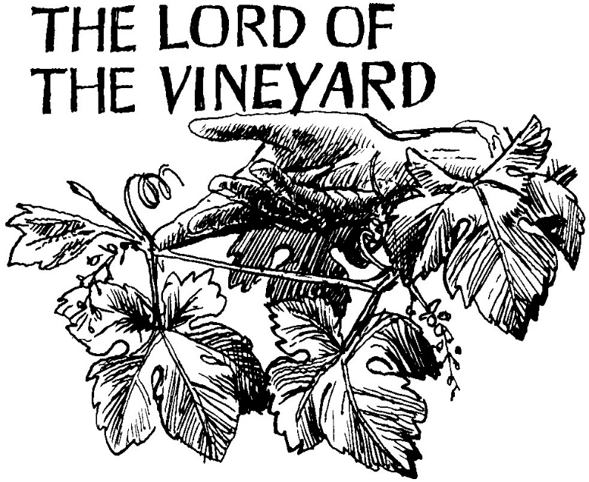

A parish of the R.C. Diocese of Aberdeen Charitable Trust
Registered Charity Number SC005122

