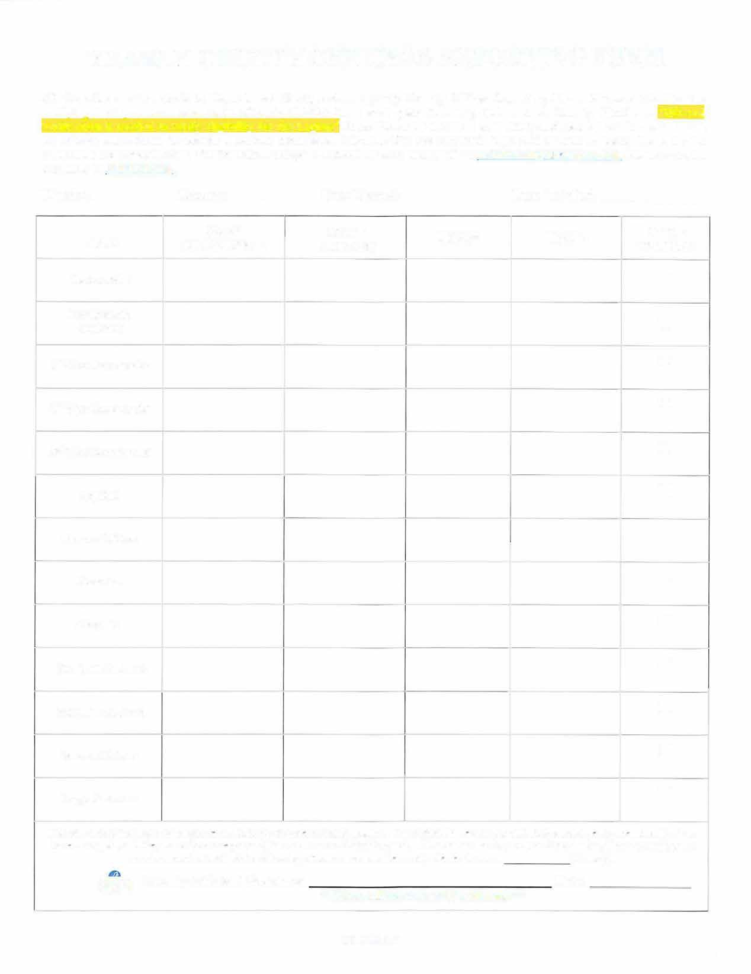
YEARLY COUNTY OFFICERS REPORTING FORM
All Counties are to submit to Department Headquarters a yearly County Officer Reporting Form. Please check the box verifying that you have seen each officer's DD-214 form each year following their annual County Elections. "DD-214 verification is needed to verify eligibility for the Legion" Note: Please fill out form completely and check the information with all officers beforehand to ensure a correct submission. Member IDs are required. Sign and submit complete forms to the Wisconsin American Legion PO Box 388, Portage, Wl 53901 or save and email to membershipmwilegion.org. Forms are also available at wilegion.org.

District: County: Date Elected: Date Installed:

TITLE | NAME  &MEMBER ID | HOME PHONE  ADDRESS |  | EMAlL | DD-214  VERIFIED
Commander
Membership Chairman
I st Vice Commander
2nd Vice Commander
3'd Vice Commander
Adjutant
Finance Officer
Historian
Chaplain
Sergeant-At-Arms
Sergeant-At-Am1s
Service Officer
Judge Advocate
I hereby certify that each of the above officials are eligible for membership in The American Legion and that their current yearly membership dues have been paid, and they have the consequent right to serve in an Official capacity. Pursuant to the Department Constitution, I have examined the service record of each of the following officers who have been duly elected to serve (County).
� County Adjutant Signature: **(Form will be returned if1111sig11ed) ** Date:

08.4.26 CV

