
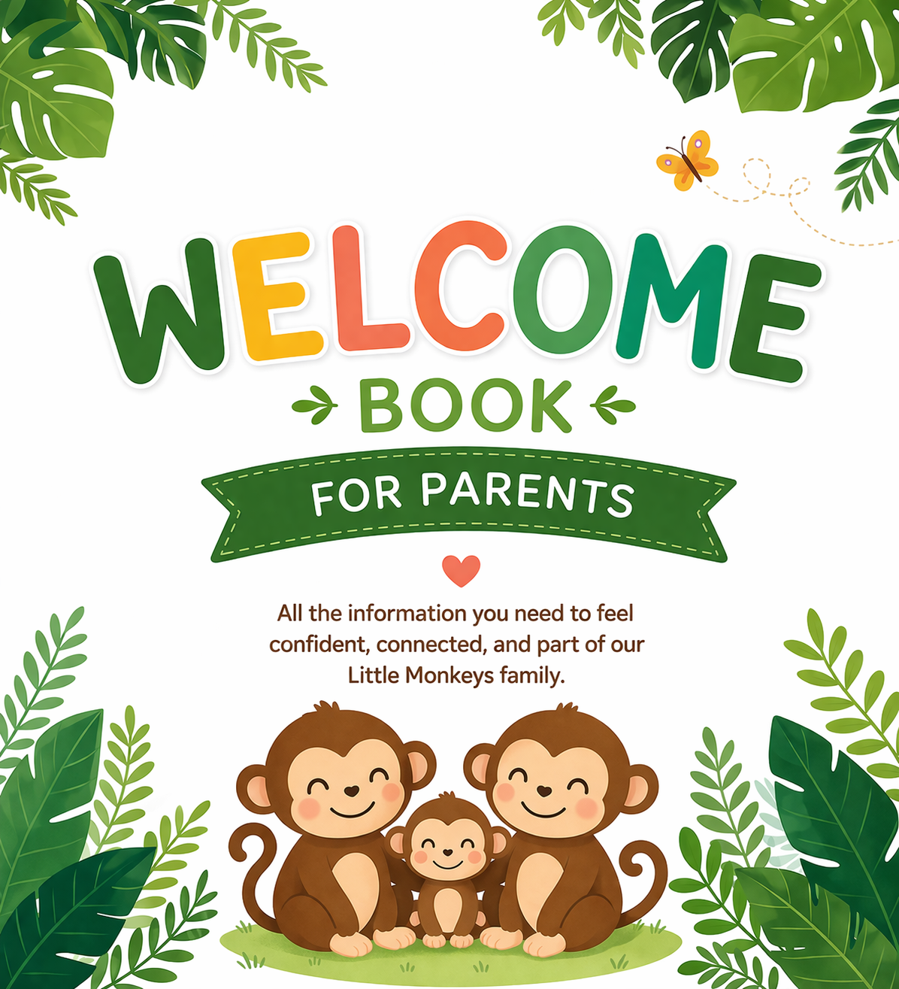

Welcome to Little Monkeys Charlbury
A very warm welcome to Little Monkeys Charlbury. We are delighted that you have chosen us to be part of your child’s early years.
We understand that starting nursery is a big step for both children and their families, and we are here to support you every step of the way. Our aim is to create a safe, nurturing, and inspiring environment where your child feels happy, secure, and valued.
At Little Monkeys, we believe every child is unique. We celebrate individuality, encourage curiosity, and support each child to grow in confidence as they learn and explore the world around them.

🌟 Our Vision
At the heart of everything we do there are three simple but powerful principles:
Achieve • Belong • Thrive
✨ Achieve
We support every child to reach their full potential by building strong foundations in learning, confidence, and independence. Achievement looks different for every child, and we celebrate all progress—big and small.
🤝 Belong
We create a safe, inclusive environment where every child and family feels valued, respected, and part of our community. Strong relationships are at the centre of our practice.
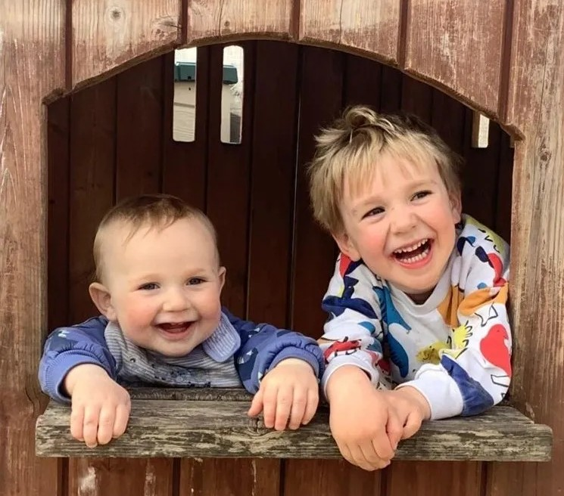
🌱 Thrive
We nurture happy, curious, and resilient learners who feel confident to explore the world around them and develop a lifelong love of learning.

What Makes Little Monkeys Charlbury Unique
At Little Monkeys Charlbury, we pride ourselves on creating a warm, nurturing environment where every child is truly known, valued, and supported.
Our strong focus on relationships means children feel safe and secure, supported by our Key Person approach and close partnerships with families. Our play-based curriculum has a strong emphasis on communication and language development, supported by tools such as WellComm and our dedicated Language Leads.
We also offer enriching experiences such as our “Little Wild Things” woodland sessions, encouraging exploration, confidence, and a love of nature.
Our inclusive ethos is at the heart of everything we do, ensuring all children can achieve, feel they belong and thrive.
We look forward to getting to know you and your child, and to building a strong partnership together. If you ever have any questions, please don’t hesitate to speak to a member of our friendly team.

Opening Hours and Sessions
Little Monkeys Charlbury is open from 8:00am to 6:00pm, with a range of flexible sessions available to suit families’ needs. An early drop-off from 7:30am is also available.
We offer both term-time only and full-year places and are registered to provide working parents’ funded entitlement.

Belongings
Please ensure all belongings are clearly named, as we cannot accept responsibility for lost items. We kindly ask that children do not wear their “best” clothes, as nursery play can be messy.
Children should bring:
- A spare change of clothes in a named bag
- A coat during colder months
We provide hats, gloves, sun hats, and sun cream, although you may provide your own if preferred.
Children may bring a comforter if needed (at your own risk), and we ask for one family photo to support settling in. Each child will need a nursery book bag (one is included), which should be brought in weekly.
Pushchairs and car seats can be stored if needed, but these must fold down as small as possible please.

Arrivals and Departures
Please arrive on time for your sessions (by 9:30am for morning sessions and 2:30pm for afternoon sessions) and please collect promptly, as we work within strict ratios. Late arrivals can disrupt activities, so please inform us if you are delayed.
Additional time outside your booked session may be charged in line with our terms and conditions.
Children must be collected by a responsible adult aged 16 or over. Before your child starts, you will be asked to provide a password for use if someone different is collecting your child. Parents must inform us in advance and provide details (and a photo where possible). This helps ensure your child’s safety.
Once children are settled, drop-off and collection will take place at the front door to support health, safety, and smooth routines. Parents are always welcome to come in—please speak to a member of staff.

Famly App
We use Famly to keep you updated on your child’s day, including photos, meals, sleep, and development.
You will receive your login details before your child starts. Please ensure your child’s profile is fully completed, including contacts, health information, and permissions.
The app allows you to:
- Message staff
- Report absences
- View accident forms
- Add observations
- Check your balance
We also share weekly updates and photos so you can see what your child has been enjoying. If you need any help using the app, please just ask.

Emergency Contacts
Please ensure your details on Famly are accurate and kept up to date.
We ask that you provide at least two emergency contacts, who will only be used if we are unable to reach a parent or carer.

Settling In
At Little Monkeys Charlbury, we work in partnership with parents to help children feel safe, secure, and confident when starting nursery. We understand that every child is different, and we tailor the settling-in process to meet each child’s individual needs.
Each child is allocated a Key Person who builds a close, supportive relationship with both the child and their family. We gather information about your child’s routines, interests, and preferences to help them feel comfortable and settled from the start.
We offer settling-in sessions before your child begins, allowing them to become familiar with the environment, staff, and routines. Parents are welcome to stay during initial visits, gradually building up to longer periods of separation as their child becomes more confident.
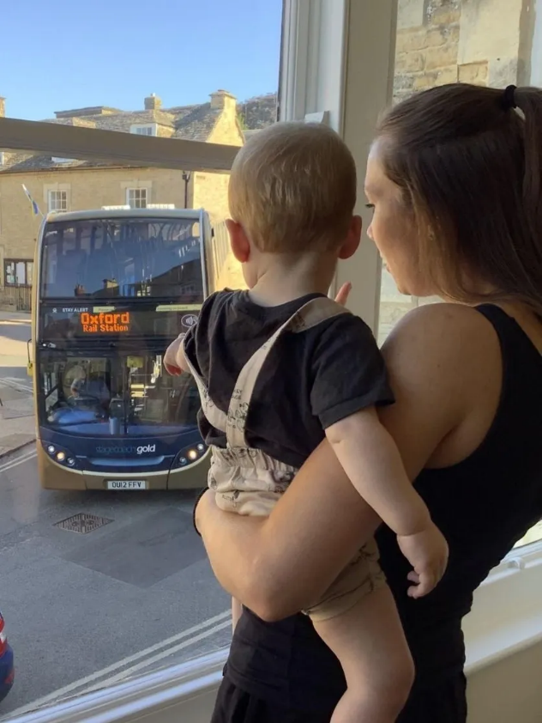
We support children through strong attachments, familiar routines, and consistent care, and provide regular updates to reassure parents. Where needed, we will work with families to adapt the settling process, ensuring a positive and smooth transition into nursery life.

Children’s Wellbeing
At Little Monkeys Charlbury, we promote children’s overall wellbeing, supporting their physical, emotional, social, and personal development in line with the EYFS.
We support physical wellbeing through active play, healthy meals, good hygiene routines, and opportunities for rest and sleep. Children’s social wellbeing is nurtured through strong relationships with their Key Person and peers, helping them feel a sense of belonging.
We place a strong emphasis on emotional wellbeing, supporting children to recognise, express, and manage their feelings. Through a safe and nurturing environment, staff help children develop confidence, resilience, and self-regulation skills using age-appropriate strategies and activities.
By supporting all aspects of wellbeing, we help children feel happy, secure, and ready to learn.

Daily Routines
At Little Monkeys Charlbury, we provide consistent and flexible daily routines to help children feel safe, secure, and confident.
Our routines include opportunities for play, learning, meals, rest, and outdoor experiences, while also allowing for children’s individual needs and interests. We understand that every child is different, so routines are adapted where needed to support their wellbeing and development.
Clear and predictable routines help children develop independence, build confidence, and understand what to expect throughout the day, creating a calm and positive environment for learning.
Meals

We provide healthy meals and snacks throughout the day, including breakfast (8–9am), lunch, afternoon tea, and snacks. Our menu runs on a two-week rota and caters for dietary needs.
Please inform us of any allergies or dietary requirements and update us via Famly.

We work closely with parents during the weaning stage to support individual needs. We support babies with formula (up to age one).
For funded sessions, meals are a voluntary charge—parents may provide food instead if preferred. Any food brought in must be prepared, clearly labelled, include allergen information, and stored appropriately. If food is not provided when needed, we will contact parents.
Safer sleep
Safe, peaceful sleep is an important part of every child's health, happiness and wellbeing.
At Little Monkeys Charlbury, we understand that every child has their own sleep needs and routines. We work closely with parents to provide a calm, comfortable and nurturing environment where children can rest safely, following the Early Years Foundation Stage (EYFS) requirements and current safer sleep guidance.
Our Baby Room has a separate, peaceful sleep room, equipped with cameras to provide additional monitoring alongside regular physical checks by our practitioners.

How We Keep Little Ones Safe
- Babies under 6 months: A member of staff will remain in the sleep room and supervise babies under six months at all times while they are sleeping.
- Children under 12 months: All babies under one year old will sleep in a cot with a firm, flat mattress.
- Children over 12 months: Children over one year old may sleep on an appropriate floor mattress, depending on their individual needs and development.
- Back to sleep: Babies are always placed on their backs to sleep, in the feet-to-foot position, with their feet towards the bottom of the cot.
- Safe sleep spaces: Cots are kept clear of pillows, duvets, cot bumpers, soft toys, comforters and other loose items.
- Regular monitoring: All sleeping children are checked regularly by our practitioners. Our cameras provide additional reassurance but never replace direct supervision and physical checks.
- Individual bedding: Every child has their own bed linen, which is washed weekly and sooner if it becomes wet or soiled.
- Safe sleeping bags: Sleeping bags brought from home must meet the UK safety standard BS EN 16781:2018 and be the correct size and tog rating for the child and room temperature. Unfortunately, we cannot use sleeping bags that do not meet this standard.
- Comfortable temperatures: We monitor the sleep environment and ensure children are appropriately dressed to prevent overheating.
- Individual routines: We respect each child's sleep needs and routines wherever possible, working closely with parents to provide consistency between home and nursery.

What We Don't Do
- We never place babies on their tummies or sides to sleep.
- We do not use buggies, pushchairs, swings, bouncers or chairs as sleeping spaces.
- If a child falls asleep during play or arrives at nursery asleep, they will be gently transferred to an appropriate cot or floor mattress as soon as possible.
- We do not allow comforters, soft toys, pillows or loose items in babies' cots, even if they are part of their usual sleep routine at home.
- We do not use sleep positioners, cot bumpers, weighted blankets or other unsafe sleep accessories.
- We never rely solely on cameras to monitor sleeping children.
- We never force children to sleep or keep them awake when they are tired.

Working Together with Parents
We recognise that every child is different, and their sleep needs will change as they grow. We aim to follow home routines wherever possible, while always ensuring our nursery's safer sleep procedures are followed. Our practitioners will share information about your child's sleep each day, including when they slept and for how long. We kindly ask parents to support our safer sleep practices by ensuring any sleeping bags provided from home meet the required safety standards and by understanding that some home sleep arrangements may not be suitable within the nursery environment.
Our aim is simple – to provide every Little Monkey with a safe, peaceful and comfortable place to sleep, giving parents confidence that their little one is being cared for with kindness, attention and safety at the heart of everything we do.
For further information, please see our Safer Sleep Policy or speak to a member of our team.
Nappy changing and potty training
We provide safe, hygienic, and respectful nappy changing tailored to each child’s individual needs.
Strict hygiene procedures are always followed, and children are always supervised. We work closely with parents to ensure consistency and, when developmentally appropriate, sensitively support toilet training in a way that suits each child’s individual needs and ensures consistency between home and nursery.
Nappy changing is also a valuable one-to-one time to support children’s comfort, communication, and development.

Outdoor Play
At Little Monkeys Charlbury, we recognise the importance of daily outdoor play and ensure all children have regular access to outdoor experiences, whatever their age or stage of development.
Outdoor play supports children’s physical health, confidence, and overall development, providing opportunities to explore, take risks, and develop independence in a natural environment. We play outside in all weathers where it is safe to do so, with appropriate clothing and supervision.
Our outdoor provision includes both planned activities and child-led play, supporting all areas of learning. We carry out regular risk assessments and maintain high levels of supervision to ensure children can explore safely while benefiting from rich, engaging outdoor experiences.

Curriculum, Learning and the Early Years Foundation Stage (EYFS)

Our Curriculum
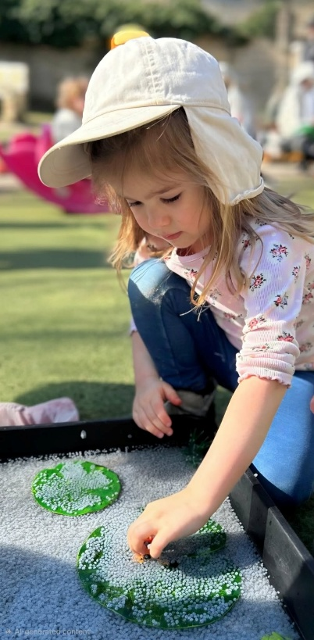
We have developed our own curriculum in line with the Early Years Foundation Stage (EYFS), supporting the seven areas of learning and key skills for children’s development.
Our approach is guided by the Development Matters framework and tailored to meet each child’s individual needs.

What Do We Want our Children to Learn?
We aim for all children to feel confident, valued, and able to reach their full potential. We support them to build confidence, develop communication skills, form positive relationships, and become curious, independent learners.
Through a balance of play-based learning, adult-led activities, and children’s interests, we support all seven areas of learning within the EYFS, helping every child to thrive.

How We Meet the Needs of our Children
We support children’s development by following the Early Years Foundation Stage principles, delivering a broad and balanced curriculum, and creating a safe, nurturing, and language-rich environment.
We recognise each child as unique, building on their individual interests and experiences, and work closely in partnership with parents to support their development. A range of teaching approaches and play-based experiences are used to engage and motivate children.
We monitor progress through ongoing observation, assessment, and planning, adapting learning to meet each child’s needs. We also use the WellComm screening tool to support children’s speech and language development, helping us identify any potential delays early and provide targeted support.
Where additional support is required, we work closely with parents and external professionals to ensure the best outcomes for every child.

The Impact of Our Curriculum
We measure the impact of our curriculum by how well children develop, make progress, and gain key skills from their starting points.
Our broad and balanced approach supports children’s emotional, social, creative, and physical development. Working closely with parents, we ensure each child progresses at their own pace and grows into a confident, capable learner.

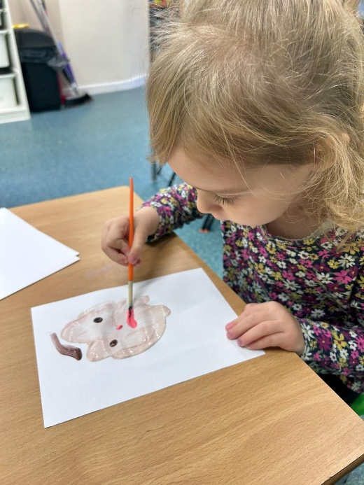
Observation, Assessment and Learning Journeys
Assessment helps us understand each child’s development and plan appropriate support. Practitioners observe children through everyday play, recording key moments and sharing updates with parents verbally and via Famly.
Each child has an annual written assessment shared with parents on famly.
Assessment is meaningful and does not interrupt children’s play, with staff using professional judgement to support each child’s progress.

Planning, Concepts, Topics and Interests and Achievements
Parents are asked to complete “Interests and Achievements” forms at least three times a year. This helps us:
- Plan activities based on children’s interests
- Identify and support any developmental needs
- Create engaging and meaningful learning experiences
These insights, alongside planned concepts and topics, shape the activities provided in each room.

Development Checks and School Transitions
In line with EYFS requirements, children aged 2–3 receive a developmental check, which is shared with parents via Famly.
When children move on to school, we provide a transition report to support a smooth and positive start in their new setting.

The Importance of a Language-Rich Environment

A Language-Rich Environment
We recognise that spoken language underpins all areas of learning and is key to children’s development, particularly in the early years.
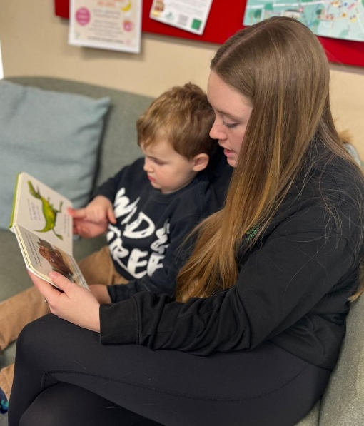
We provide a language-rich environment where staff model language, extend vocabulary, and engage children in meaningful conversations, storytelling, and play. Through daily interactions, reading, and discussion, children are supported to build confidence and communication skills.

Core Stories
Books are central to our curriculum, and children enjoy them through group times, one-to-one sessions, and independent play.
We have carefully chosen our core stories because they are engaging, repetitive, and rich in language, helping children to build vocabulary, confidence, and a love of reading. By revisiting these familiar texts, children begin to join in, remember key phrases, and retell stories independently, supporting early literacy skills.
Through repetition and discussion—including exploring illustrations—children gain a deeper understanding of language and meaning.
Our core books include: The Gruffalo, Owl Babies, We’re Going on a Bear Hunt, Handa’s Surprise, Stick Man, Monkey Puzzle, Whatever Next! Each Peach Pear Plum, Dear Zoo, The Tiger Who Came to Tea, The Very Hungry Caterpillar, and Alan’s Big Scary Teeth.

Core Rhymes
We use a set of core rhymes to support children’s language development, memory, and rhythm. These are shared regularly during group and carpet times, helping children build confidence and enjoy joining in.
Our core rhymes include: I Had a Little Turtle, Twinkle, Twinkle Little Star, Incy Wincy Spider, Baa Baa Black Sheep, 1, 2, 3, 4, 5 Once I Caught a Fish Alive, Five Little Ducks, Miss Polly, There Was a Little Mouse, There Was a Terrible Crocodile, Up the Tall White Candlestick, The Foolish Man, and Wind the Bobbin Up.

Sign language
We incorporate signing into our daily practice, including learning new signs each week and sharing these with staff and parents.
Signing builds on children’s natural gestures, supports attention and listening, and acts as a bridge to spoken language. We use familiar signs across the nursery and enjoy learning new ones alongside the children.

Phonological Awareness and Early Phonics
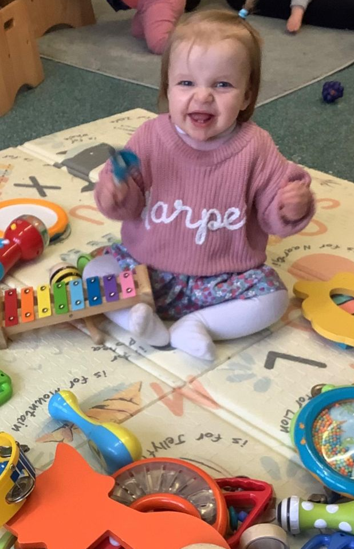
We support children’s phonological awareness and early phonics through play-based experiences such as songs, rhymes, listening games, storytelling, and role play. These activities help children recognise sounds, patterns, and rhythm in language while developing their listening, speaking, and vocabulary skills.
We begin to introduce letter sounds when children are developmentally ready and support them to recognise their own names, rhyme and begin to use alliteration.
We kindly ask parents to use pure sounds (e.g. “sss” rather than “suh”) to support consistency in learning if teaching phonics. Please visit oxford owl.co.uk and search pure sounds.
This approach helps build strong foundations for early reading and writing.

English as an Additional Language (EAL)
We are committed to creating an inclusive environment where all families feel welcome and supported.
To support children with English as an additional language, we use a range of strategies including visual aids, signing and gestures, home language labels, multi-language resources, and key words from children’s home languages.

Book Library
To encourage a love of reading, we offer a lending library where children can take books home to share with their families.
We kindly ask that children bring their nursery book bags each week so they can choose and change their book regularly.

WellComm
We use WellComm, a speech and language screening tool, to support children’s communication development. It helps us identify needs early, provide targeted support, and inform referrals where needed. Assessments are carried out by your child’s Key Person, with outcomes shared with parents.

Language Leads
We have dedicated Language Leads with additional training in communication and language to support children, staff, and families across the nursery.
Our Language Leads are Kelly Harley, Kailey Harley, Zoe Masters, and Meghan Francis.
Parents in Partnership
We value parents as partners and recognise you as your child’s first and most important educator. We promote open, two-way communication to build strong, trusting relationships and support each child’s individual needs.
Through our Key Person approach, regular updates, and shared observations, we work closely with families to support children’s learning and development both at nursery and at home. We welcome parents into nursery life, encourage involvement, and ensure information is accessible and inclusive for all families.
We are always open to feedback, suggestions, and discussions, working together to provide the best possible care and experiences for every child.

Sharing Information
We encourage regular communication between parents and staff. Information is shared daily, as well as during annual parents’ evenings, where you can book time to discuss your child’s progress with their key person.
Key persons will gather meaningful observations of your child’s development, including “wow” moments, which are recorded in their developmental profile alongside progress against expected milestones.
We rely on parents to keep us informed of any updates at home, including changes to routines, diet, health, or wellbeing. We believe that strong communication between home and nursery leads to the best outcomes for children.
The nursery also shares regular updates and information via the Famly app.
Involvement in Nursery Life
We believe parental involvement enriches children’s experiences and encourage parents to take part in nursery life, whether by sharing skills, reading stories, or attending events.
Mothers are welcome to visit the nursery to breastfeed during the day.

Supporting Families with English as an Additional Language (EAL)
We are committed to ensuring all families feel welcome and supported. We use a range of strategies such as visual aids, signing, home language resources, and key words to support communication and inclusion.

Induction and Transitions

We understand that children experience many transitions, such as starting nursery, moving rooms, or starting school. We support children through these changes by working closely with parents and providing a consistent, caring approach.
Children are given time to settle into new environments, with visits and support from familiar staff where possible. We also prepare children for school through activities, discussions, and sharing information with new settings to ensure a smooth transition.

Family Changes and Parental Responsibility
We understand that family changes, such as separation, can be a difficult time. We support children’s emotional wellbeing and work closely with parents to provide consistency and care.
We ask parents to share any relevant information, including parental responsibility and court orders, so we can support your child safely and appropriately. We do not restrict access to any parent with parental responsibility unless a formal court order is in place.
We treat all information confidentially, remain neutral, and always prioritise the child’s best interests.
Safeguarding
At Little Monkeys Charlbury, the safety and wellbeing of all children is our highest priority. We provide a safe, nurturing environment where children feel valued and protected.
All staff are trained to recognise and respond to safeguarding concerns and follow clear procedures, working with external agencies where needed. We carry out safe recruitment, regular training, and risk assessments to keep children safe.
We work in partnership with parents and encourage open communication—please speak to us if you have any concerns.
You can read the Settings full Safeguarding Children Policy and other safeguarding policies the nursery holds in the Nursery Policies section on our website.

Little Monkeys Designated safeguarding leads are Kelly Harley, Karen Cox, Simon Harley and Zoe Masters, please ask to speak to one of them regarding any concerns or queries you may have.
Health and safety
We are committed to providing a safe, secure, and healthy environment for all children, staff, and visitors. We follow all relevant health and safety guidance and carry out regular risk assessments to minimise hazards.
Our staff are trained in areas such as first aid, safeguarding, and fire safety, and children are always supervised. We maintain safe premises, equipment, and procedures, including regular fire drills and infection control measures.
We encourage parents and visitors to report any concerns so we can act quickly to keep everyone safe.
Illness and Medication.

Children may catch common illnesses such as coughs and colds. Children with a temperature (38°C+) must stay home for at least 24 hours after it returns to normal. Sickness or diarrhoea requires 48 hours away from nursery.
Children sent home due to illness must complete the full exclusion period and should not return part-way through a session.
Children with mild coughs or colds who are otherwise well are welcome to attend.
We follow the public health exclusion periods for other recognised illnesses.

Medication
We can administer prescribed medication with parental consent via Famly. Records are updated each time medication is given.
All medication must be in its original packaging, clearly labelled, and include dosage instructions.
We are not obliged to administer non-prescription medication and will not give any medication containing aspirin unless prescribed. Non-prescription medication will only be given for a short period—if symptoms persist, medical advice should be sought.

Long-Term Medication
For children requiring long-term medication, an action plan and long-term medicine form will be created on Famly with clear instructions. Parents must approve this before medication is given.
Medication will be stored safely on site and must be replaced before it expires.

Calpol and Antihistamines
At parental request, we can set up a medication form on Famly for Calpol and antihistamines. These will only be given with prior consent and after speaking with parents.
Calpol is used for teething or high temperatures where immediate collection is not possible. Antihistamines may be given for allergic reactions or insect stings.
We do not routinely administer Calpol for general discomfort, and if a child requires it for other reasons, they may not be well enough to attend. Medication does not override illness exclusion periods—children with a temperature must remain at home.

Attendance and Illness
We reserve the right to refuse admission to any child who appears unwell. This decision will be made by the manager on duty and is final.

Immunisations and Health Information
We promote children being vaccinated in line with current guidance and ask parents to inform us if their child is not immunised so we can manage any risks.
We respect family choices and keep all information confidential. Please ensure your child’s health and emergency contact details are kept up to date.
Accidents
If an accident occurs, your child will be comforted and cared for, and first aid given by a trained staff member. Medical support will be sought if needed.
All accidents are recorded on Famly, and parents are asked to review and acknowledge them.
Pre- Existing injuries
If your child arrives with an injury that occurred outside of nursery, please inform a member of staff on arrival.
We will record the details on Famly, and parents will be asked to review and acknowledge the form.

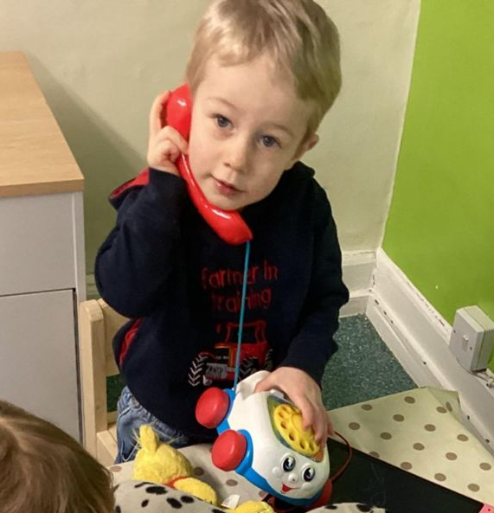
Mobile Phones, Devices and Photographs
To keep children safe and ensure staff remain fully attentive, personal mobile phones are not used during working hours—only nursery devices are used when needed.
We ask parents and visitors not to use phones or cameras inside the nursery. Photos are only taken on nursery devices with parental consent and stored securely.
Children should not bring devices such as smartwatches or cameras into nursery.

Social Media and Online Safety
We use social media to share updates and celebrate children’s experiences, with parental consent and managed by authorised staff only.
To protect privacy, we ask parents not to share nursery photos or images of other children or staff online.
All staff communication with parents takes place through official nursery channels.

No Smoking, Alcohol and Substance Use
We are committed to providing a safe and healthy environment. Smoking, vaping, alcohol, and substance misuse are not permitted on the premises or during nursery activities.
We ask all adults to act responsibly. If we have concerns about a child’s safety, we will follow safeguarding procedures.
We promote positive role modelling and thank you for helping keep our nursery safe.

Inclusion

Inclusion and Equality
We believe every child and family is unique and deserves respect and fairness. We provide an inclusive environment where all children can thrive and have equal access to opportunities.
We celebrate diversity, work in partnership with families, and have a zero-tolerance approach to discrimination.
Special educational needs and disabilities
We are committed to supporting all children to reach their full potential in an inclusive and welcoming environment. We work closely with parents and other professionals to identify and support individual needs as early as possible.
Our experienced SENCo team supports staff, children, and families, ensuring appropriate strategies and support are in place.
We follow a clear assess, plan, do, review approach and work in partnership with families to provide the best outcomes for every child.

English as an Additional Language (EAL)
We are committed to creating an inclusive environment where all families feel welcome and supported.
To support children with English as an additional language, we use a range of strategies including visual aids, signing and gestures, home language labels, multi-language resources, and key words from children’s home languages.
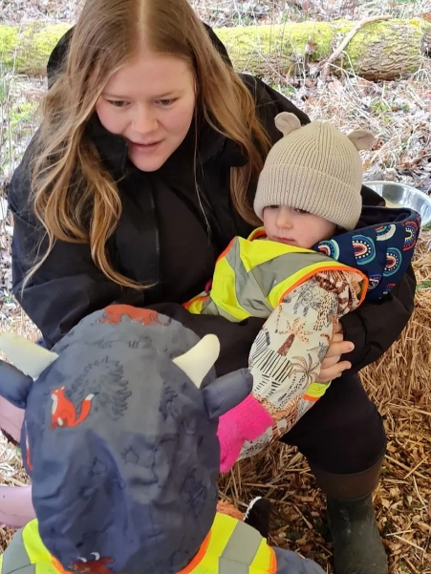
Our Staff Team
We value our staff and are committed to ongoing training and professional development to ensure high-quality care and education. Our team is well-qualified, supported through regular supervision, and encouraged to continually develop their skills.
The quality of our staff is very important to us. We maintain low staff-to-child ratios to support strong relationships and positive learning outcomes:
- 3:1 for under 2s
- 5:1 for 2–3-year-olds
- 8:1 for 3–8-year-olds
We take great pride in our team and their role in providing a nurturing, high-quality environment for every child.
Meet the team

👶 Baby Room Team
 | Lily – Baby Room Coordinator  Level 3 Nursery Practitioner  Lily has been part of Little Monkeys since it opened and brings a wealth of experience working alongside Karen and Kelly. She lives locally with her husband Liam, their son Alfie who is at primary school and daughter Harper, who is in the baby room.
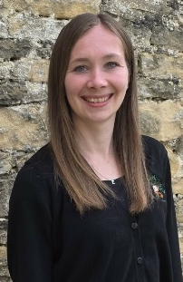 | Bryony – Assistant Baby Room Coordinator  Level 3 Nursery Practitioner | Behaviour Coordinator  Bryony has been part of the Little Monkeys team for 8.5 years and plays a key role as Assistant Baby Room Coordinator, as well as one of the nursery’s Behaviour Coordinators. She brings valuable experience and knowledge to the team, supporting children’s development and wellbeing.  She lives locally with her partner Gary and their daughter Emilia, who is in the Preschool.
 | Meghan – Nursery Practitioner  Level 3 Nursery Practitioner | Language Lead  Meghan has been part of the Little Monkeys team for 5.5 years and is a valued Level 3 Nursery Practitioner, as well as one of the nursery’s Language Leads. She plays an important role in supporting children’s speech, language, and overall development.  She lives locally with her husband Charlie and their daughters Arabella, who is at primary school, and Daisy, who is in the Preschool.
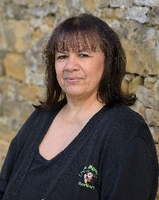 | Sonia – Nursery Practitioner  Level 2 Nursery Practitioner  Sonia has been part of Little Monkeys since it first opened and brings a wealth of experience, having previously worked with both Karen and Kelly in childcare. She plays an important role in supporting children’s care and development within the nursery.  She lives locally and enjoys spending time with her two daughters and her grandchildren.
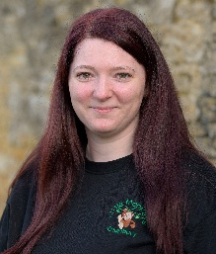 | Laura – Nursery Practitioner  Level 3 Nursery Practitioner  Laura has been part of Little Monkeys for 9 years and is an experienced Level 3 Nursery Practitioner, supporting children’s learning and development within the setting.  She lives with her children Charlie and Jess, who are at college and secondary school, and Albie, who is in the Preschool. She is currently on maternity leave after welcoming her daughter Olivia.
 | Ella – Nursery Practitioner  Level 3 Nursery Practitioner | Behaviour Coordinator  Ella has been part of Little Monkeys for 3.5 years and is a valued Level 3 Nursery Practitioner, as well as one of the nursery’s Behaviour Coordinators. She supports children’s development and promotes positive behaviour across the setting.  She lives locally with her mum and sister.
 | Beth – Trainee Nursery Practitioner – Level 3  Training towards Level 3  Beth has been part of the Little Monkeys team for nearly a year and has recently begun working towards their Level 3 Nursery Practitioner qualification. They are developing their skills while supporting children’s care and learning within the setting.  Beth lives locally with their partner Kailey and their cats, Mabel and Dottie.
 | Sophie – Nursery Assistant  Sophie has been part of the Little Monkeys team for nearly a year and mainly works in the baby room, where she continues to develop her skills and knowledge while supporting children’s early development.  In her spare time, she enjoys spending time with her family.

🌱 Little People Room Team
 | Sophie – Little People Room Coordinator  Level 3 Nursery Practitioner | SENCo | Behaviour Coordinator  Sophie has been part of the Little Monkeys team for 10.5 years and is the Little People Room Coordinator, as well as one of the nursery’s SENCo’s and Behaviour Coordinators. She brings a wealth of experience and plays a key role in supporting children’s individual needs and development.  She lives locally with her partner and her daughter Isabella, who is at secondary school.
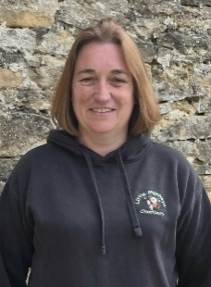 | Tracey – Assistant Little People Room Coordinator  Level 3 Nursery Practitioner  Tracey has been part of Little Monkeys since it first opened and brings a wealth of experience, having previously worked with both Karen and Kelly. Alongside Laura, she supports Sophie in the running of the Little People room and in supporting children’s development within the setting.  She lives locally with her partner Bob and their daughter Imogen, who is at secondary school, as well as their grown-up son Thomas.
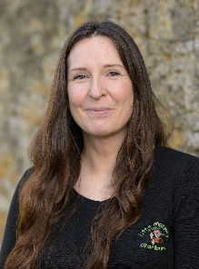 | Laura – Assistant Little People Room Coordinator  Level 3 Nursery Practitioner  Laura has been part of Little Monkeys since it first opened and brings a wealth of experience, having previously worked with both Karen and Kelly. Alongside Tracey, she supports the running of the Little People room and children’s development within the setting.  She lives locally with her partner Paul and their children Ethan and Oli, who are both at school, and Elsie, who is in the Preschool.
 | Izzy – Nursery Practitioner  Level 2 Nursery Practitioner  Izzy has been part of the Little Monkeys team for 7 years and is a valued Level 2 Nursery Practitioner, supporting children’s care and development within the setting.  She lives locally with her sons Cruze, who is at primary school, Cody, who is in the Preschool room, and Cooper, who is in the baby room.
 | Harry – Nursery Assistant  Harry works mainly in the Little People room, supporting children’s learning and development within the setting. He has officially been part of the team since September, although he has grown up around Little Monkeys as Kelly and Simon are his parents. He also has previous experience working with children.  In his spare time, he works as a Community First Responder.

🎓 Preschool Team
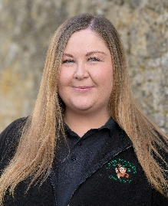 | Zoe – Preschool Coordinator & Deputy Manager  Level 3 Nursery Practitioner | Language Lead | Designated Safeguarding Lead  Zoe has been part of the Little Monkeys team for 13.5 years and is the Preschool Coordinator and Deputy Manager. She is also one of the nursery’s Language Leads and a Designated Safeguarding Lead, playing a key role in supporting children’s development and wellbeing across the setting.  She lives locally with her partner Phil.
 | Kailey – Assistant Preschool Coordinator  Level 3 Nursery Practitioner | Language Lead  Kailey has been part of the Little Monkeys team for 7 years and is the Assistant Preschool Coordinator, as well as a valued Level 3 Nursery Practitioner and one of the nursery’s Language Leads. She also attended Little Monkeys as a child, making her journey with the nursery especially meaningful.  She lives locally with her partner Beth.
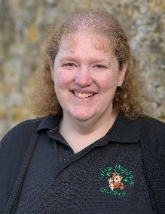 | Sarah – Nursery Practitioner  Level 3 Nursery Practitioner  Sarah has been part of the Little Monkeys team for 8 years and is a valued Level 3 Nursery Practitioner, supporting children’s learning and development within the setting.  She lives locally with her parents.
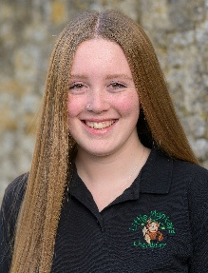 | Zoe (Mills) – Nursery Practitioner  Level 3 Nursery Practitioner  Zoe joined the Little Monkeys team in September 2024 after completing two years of student placement with the nursery while gaining her qualifications. She is a valued Level 3 Nursery Practitioner, supporting children’s learning and development within the Preschool and Little People room.  She lives locally with her parents and siblings.
 | Skye – Nursery Practitioner  Level 2 Nursery Practitioner  Skye joined the Little Monkeys team in September 2023 and has recently completed her Level 2 Nursery Practitioner qualification. She works across both the baby room and Preschool, supporting children’s learning and development.  She lives locally with her mum, dad, and siblings.

⭐ Leadership & Support Team
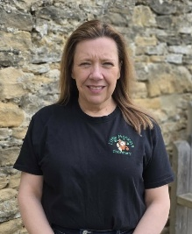 | Kelly – Nursery Manager & Co-Owner  Level 6 Nursery Practitioner & Early Years Leader | DSL | SENCo | Behaviour Lead | Language Lead  Kelly is the Nursery Manager and co-owner of Little Monkeys Charlbury and brings over 30 years of experience in childcare. As a highly qualified Level 6 Practitioner and Early Years Leader, she plays a key role in leading the nursery and supporting both children and staff. She is also the Designated Safeguarding Lead, SENCo, Behaviour Lead, and Language Lead within the setting.  She lives locally with her husband Simon, and they have three grown-up children—Millie, Kailey, and Harry—as well as their two dogs, Jock and Lennie. In her spare time, she enjoys volunteering with the One Wish Dog Foundation, where she helps foster dogs, supports them in finding their forever homes, and takes part in fundraising activities.
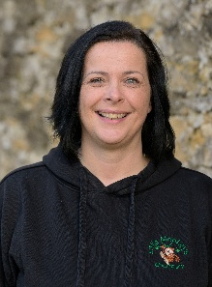 | Karen – Nursery Manager & Co-Owner  Level 3 Nursery Practitioner | Designated Safeguarding Lead  Karen is the Nursery Manager and co-owner of Little Monkeys and brings over 25 years of experience working in childcare. She plays a key role in leading the nursery and ensuring a safe, nurturing environment for every child. As the Designated Safeguarding Lead, she is committed to making the safety and wellbeing of all children a top priority.  She lives locally with her teenage son Jacob, her grown-up children Isabelle and Thomas, and their much-loved sausage dogs.
 | Simon – Premises Manager  Simon is the Premises Manager and is responsible for the nursery environment and all aspects of Health and Safety. He has worked at Little Monkeys full-time for 6 years, having previously carried out the role alongside his career as a contracts manager in construction.  He lives locally with his wife Kelly, and they have three grown-up children—Millie, Kailey, and Harry. In his spare time, he enjoys spending time with his family and walking his dogs.
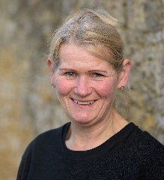 | Gill – Nursery Cook  Gill has been part of Little Monkeys since it first opened and brings a wealth of experience, having previously worked with both Karen and Kelly. As Nursery Cook, she plays an important role in preparing home cooked meals for the children and supporting their wellbeing.  She lives locally with her husband Paul and enjoys spending time with her family.

Fees and Payments
Fees are payable monthly in advance on the first of each month and are based on your child’s booked sessions.
Fees are not reduced for holidays or illness, but deductions for bank holidays, Christmas closure, and any funding will be shown on your invoice.
Invoices are issued via Famly, where you can view your balance and payment history at any time.
Up to date fees can be found on our website.

Late Payments
A late fee of £10 per day may be charged for overdue payments. Fees are due on the 1st of each month, with a grace period until the 5th.
A reminder will be sent on the 5th, and late fees will be applied from the 6th onwards for any outstanding balance.

Payment Methods
We accept payment via:
- Bank transfer
- Tax-Free Childcare
- Salary sacrifice schemes
For more information on Tax-Free Childcare, please visit the official government website.

Additional Charges
Any extra sessions will be charged at the standard session rate. Additional costs—such as meals for funded children, activities (e.g. Little Wild Things), book bags, registration fees, and trips—will be clearly itemised on your invoice.
All additional charges for funded places are voluntary and not a condition of accessing a funded place. Please note that refunds are not provided for unforeseen circumstances.

Fee Increases and Notice Periods
The nursery reserves the right to increase fees at any time, with a minimum of one calendar month’s written notice.
A minimum of one calendar months’ notice is also required for any changes to sessions or if your child is leaving the nursery (for sessions outside of funded entitlements).

Closures
The nursery is closed for approximately 8–10 days over the Christmas period, as well as on all bank holidays. Parents are not charged for these closures.

Support with Fees
We understand that circumstances can change. If you are having trouble in paying your nursery fees, please speak with us as soon as possible so we can offer support where appropriate.

Universal Funding (3–4 Year Olds)
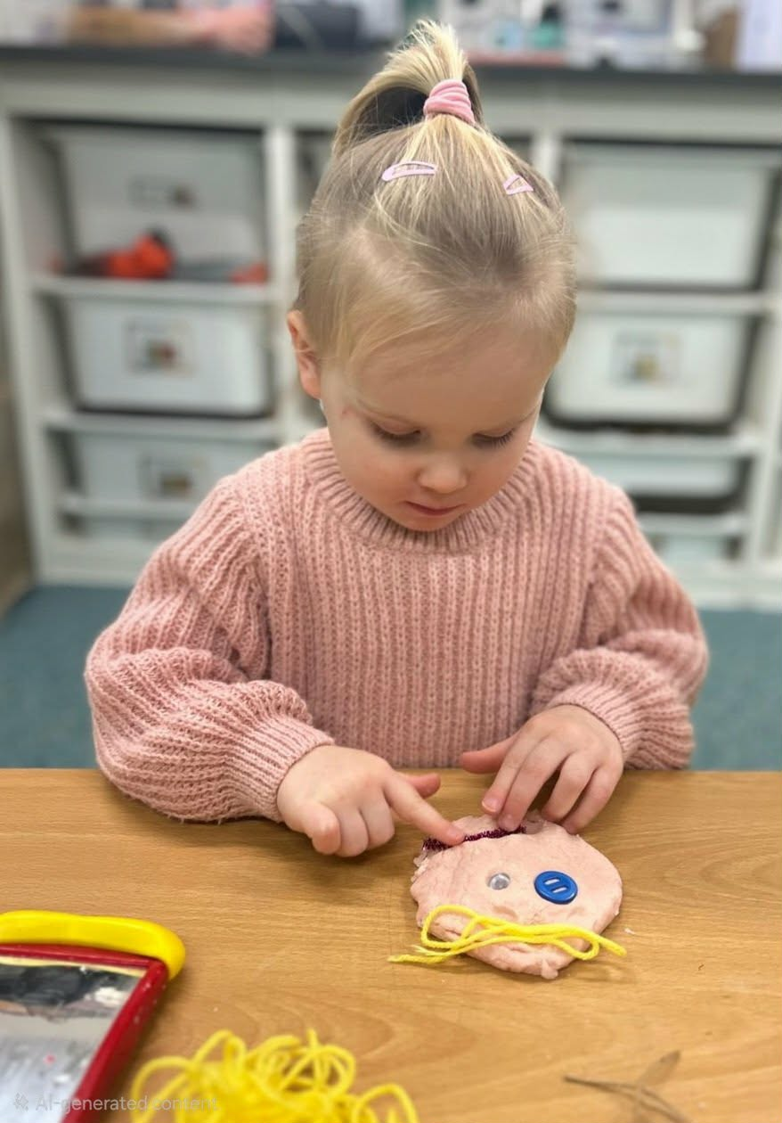
All 3- and 4-year-old children are eligible for 15 hours of funded childcare per week (38 weeks per year), which can be stretched across the year for consistency.
Funding is calculated based on your child’s booked sessions and nursery closure days. Any additional hours outside the funded allowance will be charged at the standard rate.
No code is required, but parents must complete a funding form via Funding Loop.
30 Hours Funding (Working Parents’ Entitlement)
Eligible families may receive up to 30 hours of funded childcare, from the term after a child turns 9 months old (subject to eligibility).
For 3–4-year-olds, this includes 15 hours universal entitlement and 15 hours working parents’ entitlement. For younger children, it is made up of 30 hours working parents’ entitlement.
Funding is available for 38 weeks but can be stretched across the year. Hours are calculated based on your child’s sessions and nursery closures.
Parents must obtain a valid eligibility code and complete a funding form via Funding Loop. Until confirmed, places are offered on a provisional basis.

How “Stretched” Funding Works – Examples
Example 1: Charlotte
Charlotte attends nursery four days per week (Monday to Thursday), from 8:00am to 4:30pm, using her funding over 38 weeks.
- Total funded hours per year: 1140
- Total attendance days across the year: 152
1140 ÷ 152 = 7.5 hours funded per day
This means Charlotte has 7 hours 30 minutes funded each day she attends and pays for the remaining 1 hour per day.
Example 2: Freddie
Freddie attends nursery four days per week (Monday to Thursday), from 8:00am to 6:00pm, and stretches his funding across the full year.
- Total funded hours per year: 1140
- Total attendance days across the year: 200
1140 ÷ 200 = 5.7 hours funded per day (5 hours 42 minutes)
This means Freddie has 5 hours 42 minutes funded each day and pays for the remaining 4 hours 18 minutes per day.
If you would like help calculating how funding will apply to your child’s specific sessions, please speak to a member of the management team.

Working Parents’ Entitlement – Eligibility
You may be eligible for working parents’ funded childcare if you (and your partner, if applicable) each earn at least £167 per week on average. You may still qualify if you are on leave or unable to work due to disability or caring responsibilities.
You will not be eligible if either parent earns £100,000 or more per year.
Eligible families of 3–4-year-olds can receive up to 30 hours of funded childcare per week, including both universal and working parents’ entitlement.

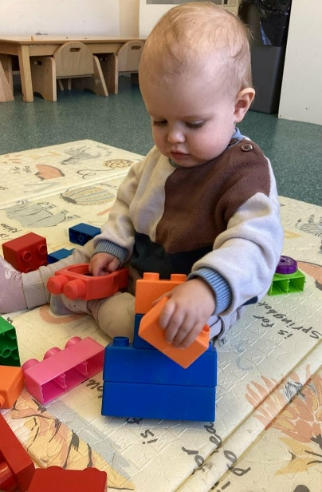
When Will My Child Become Eligible for Funding?
If eligible, your child can access funding from the start of the term after they turn 9 months old.
- 1 April – 31 August → Funding from September
- 1 September – 31 December → Funding from January
- 1 January – 31 March → Funding from April

How Do I Check My Eligibility and Get a Code?
Eligibility is assessed by HMRC via the Childcare Choices website. If eligible, you will receive an 11-digit code, which must be provided to the nursery along with your National Insurance number and your child’s birth certificate for verification.
You must reconfirm your eligibility every 3 months. If this is not completed on time, funding may be withdrawn and full fees will apply.
Your code must be obtained before the start of the funding term:
- August → September start
- December → January start
- March → April start
We recommend applying in advance. A funding form must also be completed and kept up to date for funding to be claimed.

What Happens if I Become Ineligible?
If you no longer meet the eligibility criteria, your child’s funding will continue for a short grace period.
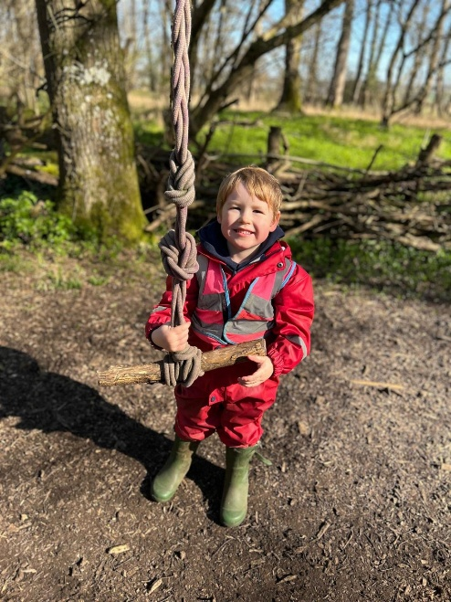
We recommend speaking with us as soon as possible so we can support you and advise on any changes.

Will I Have to Pay for Anything?
Government funding covers childcare hours only and does not include meals, consumables, additional hours, or extra services.
We charge for extras such as meals and consumables and optional activities (e.g. Little Wild Things). These are voluntary and not a condition of accessing a funded place.
If you prefer not to pay for extras, please speak to the nursery manager to discuss alternatives. You do not need to book additional paid hours to access funding, and children attending funded sessions only are not charged a registration fee.

Term-Time Only or Full-Year Nursery Place
If your child attends term-time only, funded hours are used during school terms, and any additional sessions outside these dates are charged at the standard rate. Our term dates follow the term dates of Charlbury Primary School.
For full-year places, funding can be stretched across the year to help spread costs more evenly.
You may use more than one childcare provider, but no more than 10 funded hours can be claimed in one day.

Other Funding – Two-Year-Old Funding
Some two-year-olds may be eligible for 15 hours of funded childcare, even if they do not qualify for working parents’ entitlement.
Eligibility may be based on certain benefits, low household income, or specific circumstances such as being looked after, having an EHC plan, or receiving Disability Living Allowance.
Some families with “no recourse to public funds” may also be eligible—please speak to us for further guidance.

Early Years Pupil Premium (EYPP)
The nursery may receive additional funding (up to £342 per year) to support your child’s learning and development through EYPP.
Children may be eligible if their family receives certain benefits or if they have been in care, adopted, or left care under specific arrangements.

Additional Support
Children eligible for two-year funding and/or Early Years Pupil Premium (EYPP) will not be charged for food while attending the nursery.

Funding Loop
We use Funding Loop to manage funding information. You will receive an email to complete a funding form and upload your child’s identification when they start.
Details must be reconfirmed termly or if circumstances change. If the form is not completed, funding cannot be claimed and standard fees will apply.

Notes Regarding All Funding
• A place is offered in principle until a valid funding code is received and verified.
• Invoices will clearly show funded hours and any voluntary charges for extras.
• All parents must complete and update funding forms via Funding Loop.
• Funded weeks are calculated from your child’s start date to the end of the funding year (31st August).
• Funding will be adjusted if sessions or circumstances change.
• A clear breakdown of funding and any charges will be provided before your child starts.
• Parents must reconfirm eligibility with HMRC every 3 months where applicable.
• If eligibility is not reconfirmed or forms are not completed, funding may be withdrawn and full fees will apply.
Complaints Procedure
We believe all children and families should be treated with respect and care. We welcome feedback and suggestions and aim to resolve any concerns quickly and fairly.
Most concerns can be addressed informally by speaking with a member of staff or management. If this does not resolve the issue, a formal complaints procedure is available, and we will work to reach a satisfactory outcome for all involved.
If a concern remains unresolved, parents and carers can contact Ofsted:
- Telephone: 0300 123 1231
- Address: Piccadilly Gate, Store Street, Manchester, M1 2WD
Data Protection and GDPR
We are required to hold information about children and staff for purposes such as registers, invoicing, and emergency contacts. All data is stored securely and in line with data protection requirements—please see our GDPR Privacy Notice for full details.
We use trusted systems such as Famly, Funding Loop, and Oxfordshire County Council to securely store and process information. Parents will be asked to read and acknowledge our Privacy Notice as part of registration.
All information is treated confidentially and shared on a need-to-know basis. Parents can access their child’s records, and we follow all data protection legislation, including GDPR and the Data Protection Act 2018. Safeguarding is always our priority, and information may be shared without consent where necessary to protect a child’s wellbeing.

Promoting Positive Behaviour
At Little Monkeys Charlbury, we support children to feel safe, secure, and valued, recognising that positive behaviour develops through strong relationships and guidance. We use a co-regulation approach, helping children understand and manage their feelings while building the foundations for self-regulation.
We encourage kindness, respect, and cooperation, with staff acting as positive role models and working closely with parents to ensure consistency. Children are supported to develop confidence, empathy, and an understanding of their own and others’ emotions through age-appropriate strategies, routines, and experiences.

We focus on praising positive behaviour and supporting children through challenges by helping them express their feelings, resolve conflicts, and learn appropriate ways to interact with others. Any behaviour that challenges is managed calmly and consistently, always recognising that it is the behaviour—not the child—that is unacceptable.
We have a zero-tolerance approach to bullying and promote a caring, inclusive environment where children learn to respect themselves, others, and their surroundings.
Closure of the nursery
On occasion, we may need to close the nursery due to circumstances beyond our control, such as severe weather conditions.
If a decision is made to close the nursery, we will keep parents informed through messages on the Famly app. We kindly ask that you check the app regularly for updates.

Attendance
Regular attendance supports children’s learning, wellbeing, and sense of security. We ask that children attend on time and that you inform us of any absence as soon as possible. In line with the Early years foundation stage we monitor funding to ensure that children are supported at all times.
Good communication between parents and staff is key, and we are always happy to offer advice or support. We monitor attendance to ensure children’s safety and will contact you if we have not been informed of an absence. In rare cases, we may follow safeguarding procedures if we are unable to make contact.
Please let us know in advance if your child will be leaving or moving to another setting.
Policies
We have a comprehensive range of policies and procedures that underpin our daily practice and form part of our operational framework.
All of our policies and procedures are available to view on our website.
Walks around Charlbury.
We regularly explore our local area, including visits to the park, library, and local walks.
All outings are risk assessed and supervised by qualified staff, with enhanced ratios and a qualified first aider present. Younger children use pushchairs or reins, and older children are assessed individually.
Some outings may be spontaneous, but we will always let you know at collection time if we have been out of the nursery.

Little Wild Things
Our preschool children attend “Little Wild Things” woodland sessions every Wednesday during term time, encouraging exploration and a love of nature. (Please note we do not go to forest from January to February half term?

Children travel by minibus or nursery car, and an additional cost applies, which is added to your invoice. By booking a Wednesday preschool session, you agree to your child’s participation.

Events and Celebrations
At Little Monkeys Charlbury, we enjoy celebrating a wide range of events throughout the year, creating meaningful experiences for children and families.
We celebrate seasonal events, cultural festivals, and special occasions, helping children to learn about the world around them and appreciate diversity. These may include celebrations such as Christmas, Diwali, Chinese New Year, and other important events relevant to our families and community.
We also host nursery events such as leavers evenings, celebrations, and special days like ‘bear hunt day’.
All celebrations are approached in an inclusive and respectful way, ensuring that every child feels valued and represented. We encourage parents to share their own skills, interests and knowledge with us and the children.

Open-Door Policy
We operate an open-door policy and welcome any questions or concerns.
Please speak to your child’s Key Person in the first instance, or the nursery manager for wider concerns. If needed, our formal complaints procedure can be followed.

Communication
Parents are welcome to contact us via Famly, telephone (01608 811828), or email. (office@littlemonkeyscharlbury.net).
For general day-to-day enquiries, please message your child’s room rather than an individual staff member. This helps ensure your message is seen and responded to promptly.
To support a healthy work–life balance, we kindly ask that messages are not sent to the staff team outside of nursery hours. If messages are sent during this time, please do not expect a response until the nursery reopens.
For sensitive matters (such as billing, funding, safeguarding, or complaints), please contact Kelly or the designated person directly.
Urgent queries outside of nursery hours can be directed to Kelly via Famly or WhatsApp on 077383080393.

Final Note
Thank you for choosing Little Monkeys Charlbury. We feel privileged to be part of your child’s early years and are committed to providing a safe, nurturing, and inspiring environment where every child can achieve, belong and thrive.
We look forward to building a strong partnership with you and supporting your child on their journey. If you have any questions at any time, please do not hesitate to speak to a member of our team.

