
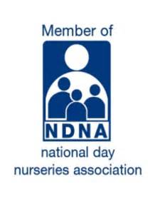

Availability Request Form
Thank you for your interest in Little Monkeys Day Nursery. Please complete this form to help us assess availability for your childcare requirements.

Child’s Information
Child’s Full Name: ________________________________________
Date of Birth: _____________________________________________
Gender: ___________________________________________________

Parent / Guardian Information
Parent / Guardian Name: ___________________________________
Relationship to Child: _____________________________________
Telephone Number: ________________________________________
Email Address: ____________________________________________
Home Address:

Requested Nursery Placement
Preferred Start Date: ______________________________________

Required Days
☐ Monday
☐ Tuesday
☐ Wednesday
☐ Thursday
☐ Friday

Sessions Required
☐ Morning Session
☐ Short Day
☐ Afternoon Session
☐ Full Day
Preferred Hours (if applicable):

Childcare Type Required
☐ Full Year Care
☐ Term Time Only

Funding Information

Will you be using funded childcare hours?
☐ Yes
☐ No

If yes, please select:
☐ 15 Hours Funding
☐ 30 Hours Funding
☐ Tax-Free Childcare

Do you already have a valid funding code?
☐ Yes
☐ No

Food & Consumables Contribution
Do you wish to make voluntary contributions towards food and consumables?
☐ Yes – I would like to make voluntary contributions
☐ No – I will provide my child’s own food

Little Wild Things Contribution (Preschool Only)
Do you wish to make voluntary contributions towards Little Wild Things activities?
☐ Yes
☐ No

Declaration
By signing below, I confirm that the information provided is accurate to the best of my knowledge. I also confirm that I have:
☐ Read and understood the GDPR Privacy Notice available on the nursery website
☐ Read and understood the Nursery Terms and Conditions
☐ Understood that Little Monkeys offers up to two weeks of settling-in sessions prior to a child’s official start date, and parents are encouraged to take advantage of this opportunity
☐ Understood that places offered under Working Families Funding are provisional until the funding code has been validated and approved

Parent / Guardian Signature: _________________________________
Date: ______________________________________________________

For Nursery Use Only
Date Request Received: _____________________________________
Availability Confirmed:
☐ Yes
☐ No
Notes:

