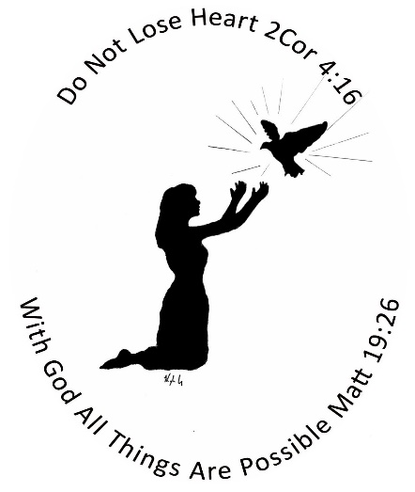

WOMEN’S MINISTRY CENTER
2418 BLOOMER DR., ALTON IL 62002
618 433-8308
WE ACCEPT DONATIONS OF THE FOLLOWING (ONLY):
- DEODORANT
- TAMPONS/SANITARY PADS
- TOOTHPASTE
- TOOTHBRUSHES
- BODY WASH OR BAR BATH SOAP
- SHAMPOO & CONDITIONER
- 4 PACK TOILET PAPER
- WOMEN’S CLOTHING (CASUAL/EVERYDAY/PROFESSIONAL—PAJAMAS, SCRUBS BRA’S, SOCKS AND SHOES (NEW OR GENTLY USED) UNDERWEAR (NEW ONLY) WINTER COATS
- CHILDREN’S AND INFANTS CLOTHING AND WINTER COATS
- SCHOOL SUPPLIES AND BACKPACKS
- JEWELRY
- DIAPERS
- BLANKETS
- SHEETS
- COMFORTERS

