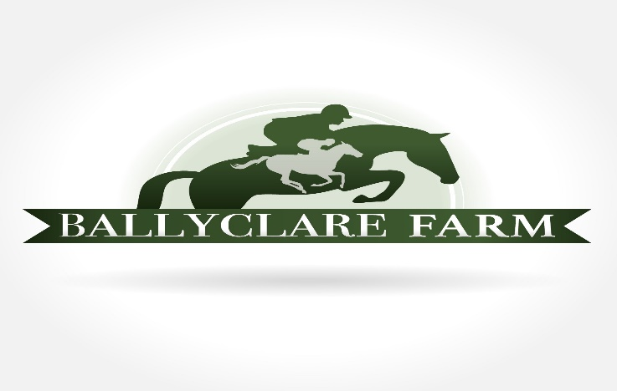

**ADOPTION CONTRACT**

This contract is entered into on this _______day of _____________, 20____between Ballyclare Off-Track Thoroughbreds, a 501©3 non-profit organization (hereinafter referred to as “Ballyclare”) and ___________________________________________ (hereinafter referred to as “Adopter.”)

The Adopter agrees, in accordance with the terms and conditions set forth in this Agreement, to adopt and care for the horse known as __________________________________(hereinafter referred to as “Horse.’)

Ballyclare agrees to transfer ownership of Horse to the Adopter subject to the conditions set forth in this agreement. The Adopter understands that an adoption fee in the amount of $__________ shall be made payable to Ballyclare Off-Track Thoroughbreds. The Adopter agrees to pay for the cost of any pre-purchase professional evaluations or veterinary exams contracted for by the Adopter. The Adopter agrees to pay the cost of transporting the Horse to its new facility. **The adoption fees are nonrefundable and must be paid in full on or before the day of delivery/pickup of the Horse.**

The Adopter will, at his or her expense, care for the Horse in a responsible and humane manner. Ballyclare guidelines for care of the Horse include, but are not limited to adequate shelter, feed, turnout, worming, farrier, veterinary, and dental care. The Adopter promises to NEVER allow the Horse to be sold at any auction or put at risk for slaughter, including selling to a horse dealer/reseller. If Adopter’s horse is found to be in a “risk for slaughter” situation or at an auction, Adopter must pay for all expenses incurred to return the horse to Ballyclare from such situations. In addition, Adopter agrees NOT to allow the Horse to race. In the event Adopter fails to adhere to these guidelines and the Horse becomes neglected or abused in the opinion of an independent professional, this agreement is void, and the Horse will be immediately returned to Ballyclare at the expense of the Adopter.

The Adopter understands that the Horse may need updated Coggins, vaccinations, worming, dental, and farrier care. There is **NO GUARANTEE** Jockey Club papers or veterinary records will be sent with or transferred to Adopter.

The adopter understands that many of the conditions of the Horse are not obvious, and Ballyclare cannot know all the details of the Horse’s history. The responsibility for determining if the Horse is fit for use by Adopter belongs solely to Adopter. Adopter acknowledges that Adopter has been advised by Ballyclare to engage the services of a licensed veterinarian and an experienced horseperson prior to adoption to evaluate the Horse. Adopter agrees to accept the Horse as is.

Adopter allows Ballyclare to publish pictures and progress reports on the Horse in written and/or electronic form.

In the event Adopter decides to sell, assign, or transfer ownership of the Horse, Adopter will notify Ballyclare in writing of this intent. Upon sale, assignment, or transfer, Adopter will provide Ballyclare in writing with the name, address, and phone number of new owner within 14 days of sale, assignment, or transfer of the Horse.

Adopter agrees to hereby indemnify and hold Ballyclare and its officers, directors, employees, and volunteers harmless from and against any and all claims, actions, damages, liability, and expense in connection with the loss of life, personal injury, and/or damage to property arising out of use or care of the Horse.

Signed (Adopter):_________________________________

Print Name (Adopter):__________________________________

Date:______________

Signed (Ballyclare Representative)_________________________________

Print Name (Ballyclare Representative):__________________________________

Date:______________