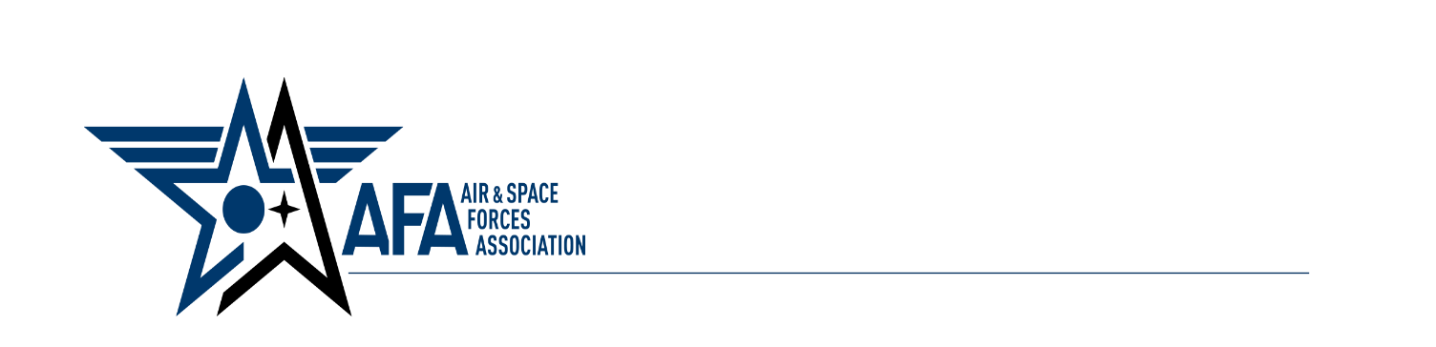

**Northern Utah Chapter 235**

Dear Industry Partner,

On the evening of 26 April 2023, the Air Force Association Northern Utah Chapter will recognize the “Top Logistic Performers” during the Annual Brent Scowcroft ICBM, Aerospace Dominance, Supply Chain and Munitions awards banquet. This year’s event will be held at the Davis Conference Center 1651 N 700 W, Layton, UT 84041. Utah. We will begin with a social hour at 6:00 pm followed by the dinner and awards at 7:00 pm.

We are very pleased to come together with the ICBM, Aerospace Dominance, Supply Chain and Munitions communities to recognize those individuals who are truly the best in acquisition, sustainment, logistics and maintenance.

The guest speaker for this year’s event is Angela T. Tymofichuk, Deputy Assistant Secretary of the Air Force for Logistics and Product Support, Office of the Assistant Secretary of the Air Force for Acquisition, Headquarters US Air Force, Arlington, Virginia.

We cordially invite you as an industry partner to attend the banquet and to reserve tables for your attendees.  This year, the tables are reserved in tiers according to their proximity to the stage and are priced accordingly.  Table prices are $700 tier I (closest), $600 tier II, and $500 tier III (furthest).  There are (9) tier I, seven (7) tier II and nineteen (19) tier III tables available on a first come, first served basis; (limitations may apply).  As usual, four seats at each table reserved will be for you and your representatives with the remaining seats for the Scowcroft Award nominees and their guests.

The banquet serves as an opportunity to recognize individual and group excellence.  The contractors are a very important part of this community and your support of the awards and banquet are greatly appreciated and essential for the event's success.

Please contact Scotty Nowlin at 385-268-3269, [afa.chapter.235@gmail.com](mailto:afa.chapter.235@gmail.com), or me directly at 478-320-7961 at [sdwarrenllc@gmail.com](mailto:sdwarrenllc@gmail.com) to reserve tables and answer questions. Please make all table reservations no later than 12 April.  If paying by check, please mail checks to Northern Utah Chapter, P.O. Box 151, Clearfield, UT 84089.  Please provide us with a list of your attendees, by table number, (i.e., Acme Tools 1) by the closeout date.  A **sponsorship form** is attached.

We are excited about hosting this year's Banquet and look forward to seeing you "in-person"!

Once again, we thank you for your continued support of the ICBM, Aerospace Dominance, Supply Chain and Munitions communities and in recognizing those superior performers of 2022.

R/

Scott

Scott D. Warren

President, Northern Utah AFA Chapter 235