**2023 SCOWCROFT AWARDS BANQUET**

**SPONSORSHIP FORM**

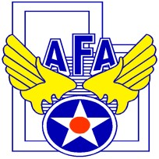**AFA NORTHERN UTAH CHAPTER 235**

P.O. Box 151

Clearfield, Utah 84089-0151

**Sponsor Information Sponsor POC**

Company Name: Name:

Address: Phone:

City, St, ZIP: Email address:

**Special Instructions or Comments:**

|  |  |  |  |
| --- | --- | --- | --- |
| **TABLE SPONSOR NAME** | **QUANTITY** | **UNIT PRICE** | **TOTAL** |
| Tier I (add name) |  | $700 | $ |
| Tier II (add name) |  | $600 | $ |
| Tier III (add name) |  | $500 | $ |
|  |  |  | $ |

**SPONSOR ATTENDEES (4 per table) – Provide attachment of names if more than one table.**

First Name Last Name

|  |  |
| --- | --- |
|  |  |
|  |  |
|  |  |
|  |  |

Make all checks payable to: AFA NORTHERN UTAH CHAPTER 235

If you have any questions concerning this form, contact Scotty Nowlin at 385-268-3269 or afa.chapter.235@gmail.com.

*The AFA Northern Utah Chapter 235 is a 501©(3) organization and as such the IRS requires us to inform you that each table sponsorship includes a quid pro quo contribution of $360.00. This contribution is based on a $500.00 table sponsorship and a good faith estimate of $140.00 services, four seats at $35.00 per seat.*