Car Hammock Sedan Setup Instructions

* Park your car in a safe location
* Open all the doors and pop the trunk
* 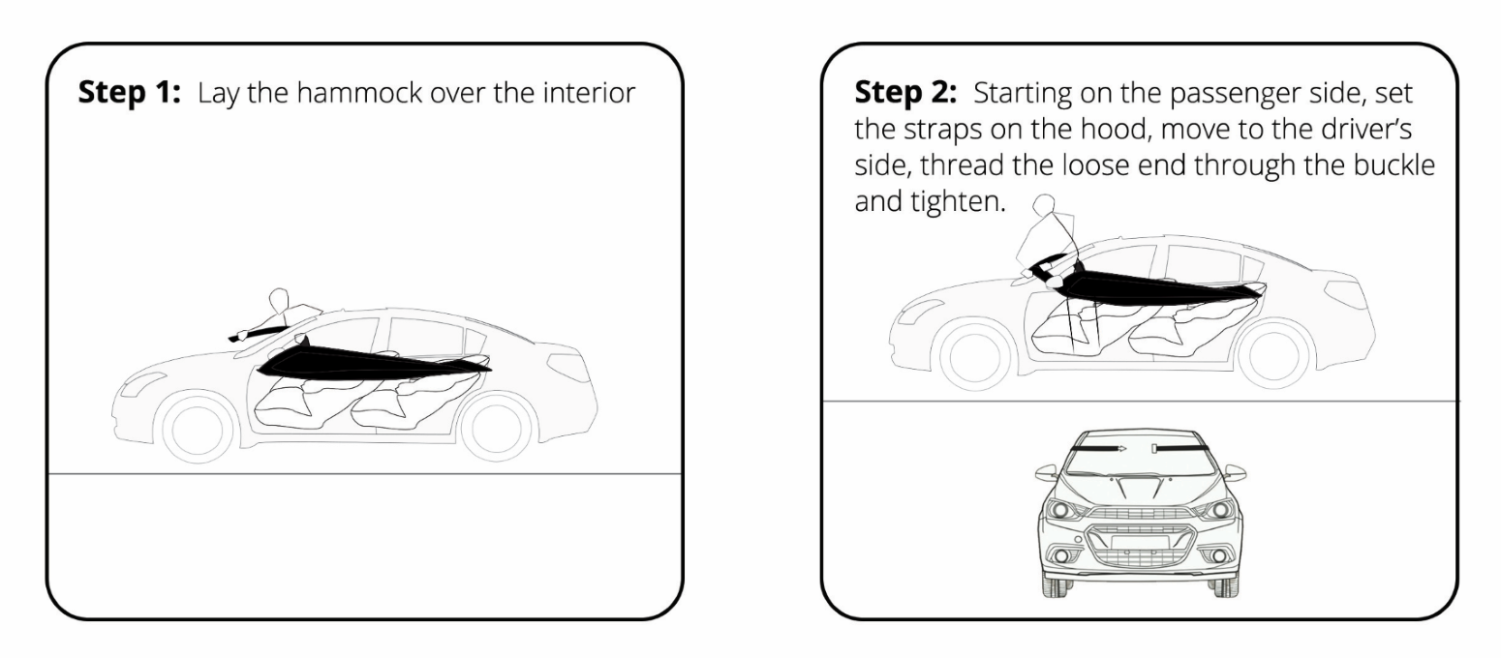Recline the front seats as far back as possible

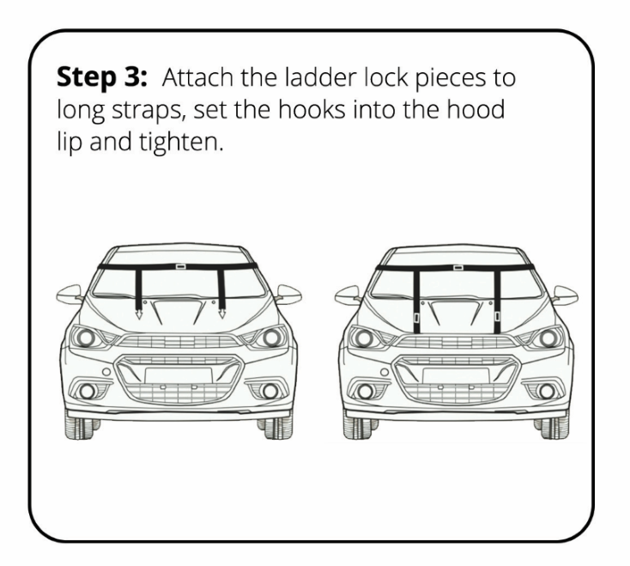

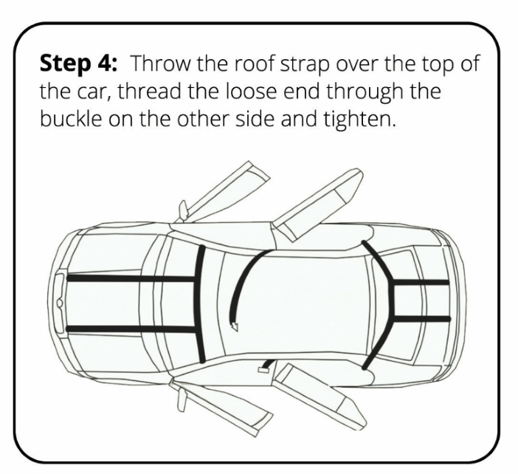

**Step 4 (Optional):** Throw the roof strap over the top of the car, thread the loose end through the buckle and do not tighten. **This strap is for minor, secondary support only. Over tightening will cause failure during use.**

