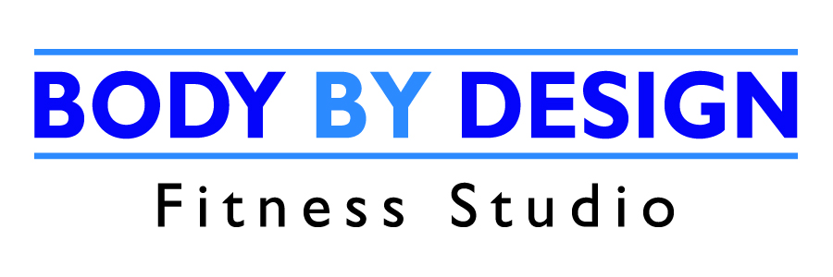

Client Agreement
Date
Name
Date of Birth
Phone (home)
Phone (work/cell)
Email

Welcome to Body By Design Fitness Studio!

We are very excited that you have decided to invest in your health and your future through fitness. We are dedicated to provide you with a fitness program that incorporates the latest fitness research and training techniques to ensure that your workouts will be effective, specialized, and goal-oriented. Our goal is to ensure that you have a safe, healthy, and rewarding fitness experience.

Please take a few moments to review Body By Design’s Policies and Procedures. If you have any questions, please do not hesitate to ask. PLEASE READ CAREFULLY

The following terms and conditions apply to your Program:

- You agree that if you feel dizziness, nausea, discomfort or pain at any time during your training session, you will immediately stop your activity and immediately inform me.

- You agree to inform me of any conditions or changes in your health at any time while participating in your Fitness Program, which might affect your ability to exercise safely and with minimal risk of injury.

- You are not obligated to perform or participate in any activity unless you wish to, and have the right to decline participation in your training session.

- You agree to provide at least twenty-four hours notice to Body By Design if you wish to cancel your scheduled appointment. If an appointment is cancelled with less than twenty-four hours notice, you will be charged for that session. If three consecutive appointments are cancelled, we will need to discuss and re-evaluate your situation.

- Personal Training Sessions and/or Class Sessions shall be paid prior to your first session.

- Please be ready to begin each personal training session at your scheduled appointment time. Unfortunately, if you do arrive late, your training session will finish at the originally scheduled completion time. Arriving early for a warm-up is beneficial to your body and will improve results and decrease risk of injury.

- Personal Training fees may be refunded in the event of you suffering a disability, verified by a doctor’s letter.

- You agree to follow all policies and procedures currently stated or as established in the future by Body By Design Fitness Studio.

- Body By Design Fitness Studio and its employees will not be held liable for contraction of COVID-19 arising from participation in any activities/programs held by the organization.

- Body By Design Fitness Studio and its employees will not be liable for any injury or illness arising from participation in any activity, and the signing party is giving up their legal right to any and all future claims.

You acknowledge that there is risk associated with participating in fitness programs and you assume all risk and release Body By Design Fitness Studio from any liability for damages or claims arising out of injury sustained by you while participating in personal training/fitness training at Body By Design Fitness Studio. You acknowledge that you have signed an agreement, release, and waiver of claims which shall form part of this agreement. By signing this Agreement, you confirm and acknowledge that you have read it, understand, and agree to all of its terms and are signing it of your own free will and without being pressured to do so. By signing this waiver, you are responsible for any minors participating in a program at Body By Design and accept their risk on behalf of them.

Please check the services you wish to purchase.
Check | Service | Fee with HST | Totals
 | One-On-One Personal Training
 | 1 Session | $45
 | 5 Sessions | $209.05
 | 10 Sessions | $372.90
 | 20 Sessions | $700.60
 | Partner Training
 | 5 Sessions | $226
 | 10 Sessions | $406.80
 | 20 Sessions | $700.60
 | Small Group Training: 3 People
 | 5 Sessions | $254.25
 | 10 Sessions | $440.70
 | 20 Sessions | $700.60
 | Program Design(Home/Gym) | $75.00
 | 2 MONTH UNLIMITED CLASS MEMBERSHIP | $190
 | 10 x Class Pass (3 mo. expiry/12 mo. expiry) | $140/170
 | Drop In Class | $20
 | 3 x Class Pass Intro Offer | $45
 | CASH CHEQUE DEBIT
PAYMENT

Client’s Signature: | _______________________ | Body By Design Signature: | _______________________
Date: | _______________________ | Date: | _______________________

