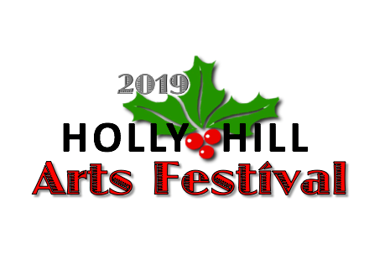
THE HOLLY HILL ARTS FESTIVAL
Enhancing Holly Hill Through the Arts
April 6 & 7, 2019, Holly Hill, Florida

ARTFUL PATRONS

Artful Patrons receive the following benefits:

- Invitation to the Festival Party at Copper Bottom Craft Distillery, Holly Hill, on Friday afternoon, April 5, with Artists, VIP’s and Patrons.

- Listing and weblink on Festival website

- Listing in Festival Program

- Opportunity to insert Promotional Material in Welcome Packets for 70+ Artists and Exhibitors

Minimum contribution of $100.
All Patron’s contributions will be given to the two Holly Hill Schools for Musical Equipment – The Holly Hill School and The UBIC Academy.

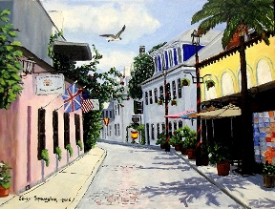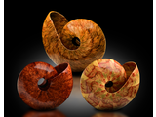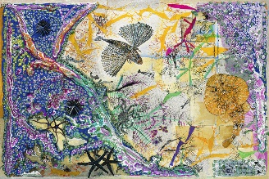
Jerry Spangler Alan Gessinger Leslie Young Peter Steenland Sheila Psaledas

The Festival is presented by Helping Hands Thru Arts and the City of Holly Hill.
www.HelpingHandsThruArts.com
2/25/19

