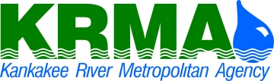

“Providing Wastewater Treatment to the Kankakee River Valley”

UPDATED DETAIL FOR: INVITATION TO BID

Due to the Coronavirus, Kankakee River Metropolitan Agency (KRMA) is informing you that the Bid Result is not open to the public on Friday, March 27, 2020.
However, the Bid Opening will be recorded, if you would like a recording, please contact the KRMA office.
KRMA would like to apologize, however, bid results will be posted on the KRMA website.
If you have any question and/or concerns, please feel free to call the office at (815) 933-0444.
KRMA will continue to monitor the COVID-19 situation and will follow the guidance from the Public Health Officials and Government Agencies, so we can make ongoing assessments and consider ways to further support our vendors and communities as needs unfold.

