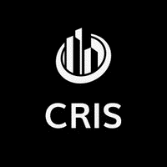 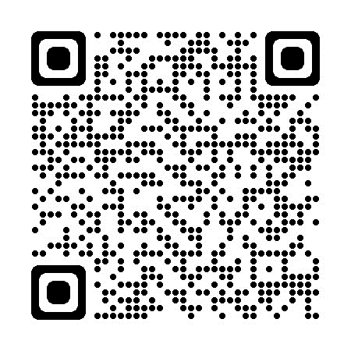

Hello and good day to you.

Do you ever do business with existing commercial roofs? If so, you will want to keep reading.

For roughly 15 years, my primary goal for professionals like you has been to deliver the most accurate Commercial Roof Inspection Services possible. My experience began as a Service Technician to being the first onsite at a natural disaster for multi-million-dollar projects. It is time to offer these services with no bias towards solution or vendor. I can inspect existing buildings as an independent contractor serving all my industry friends and colleagues. The company that can do it for you is Commercial Roof Inspection Services, LLC (CRIS).

You now have a partner for the inspection, takeoff, and overall assessment of every existing building with a commercial roof that you have been tasked with. With one email or phone call, you can have a trusted industry source get out onto the buildings for you and deliver all the information you need right to your inbox.

Imagine:

* Professional client representation onsite: inspections, bids, site discussions, scopes, etc.
* Individual project assessment with no ties to any one contractor – You are in control
* Manufacturer and contractor experience for scope and condition perspectives
* Real time photo access during the inspection with several reporting options
* Detailed drawings with measurements, penetrations, and structural components where possible
* A roofing industry partner to consult throughout the entire roof project – FULLY INSURED!

We all know when it is time to get others involved on a project. Allowing my industry colleagues to focus on their core responsibilities while getting them the information they need in a timely and accurate manner can change the game. Need a sample? Let us know!

Call CRIS today for the information you need tomorrow.

Sincerely,

Commercial Roof Inspection Services, LLC

610-442-5060

[www.commercialroofis.com](http://www.commercialroofis.com)

[info@commercialroofis.com](mailto:info@commercialroofis.com)