The Malibu Underwater Base
Investigation

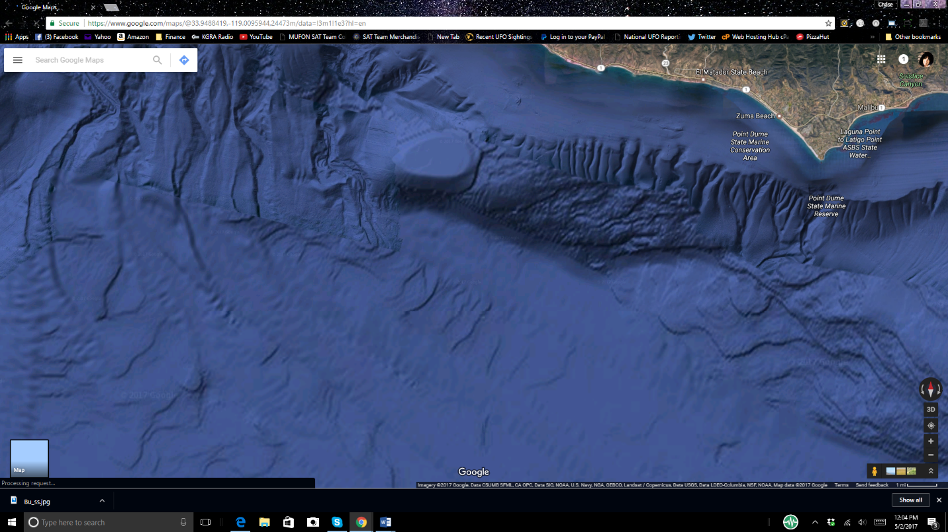
33.999754, -119.028777

By: Chase Kloetzke
MUFON Special Assignment Team Investigator
March 1st, 2017

Abstract

In the investigation of the alleged underwater “Alien” base off the coast of Malibu, a team of expert deep water surveyors, investigators and engineers were assembled on board the Bold Horizon Research Vessel with a Production team from A&E Television. The boat provided a wet lab and a dry lab for the analysis of information gathered by the sonar and Super Mohawk II, ROV, (Remote Operated Rover). The deployed rover provided a structural and seabed survey using a multi-beam, gradiometer, and profiling sonars with digital HD video, stereo sound recordings and survey data interfaces. The structure revealed many details that are not shown or accurately pictured on the Google images. The Malibu-base image was also researched and analyzed by experienced Satellite image experts familiar with the process used by Google for mapping. Other known indications of man-made features were investigated and a search for seabed and sediment disturbances were also included in this deployment of the ROV. The recorded data confirms the same conclusive results as was witnessed by the team monitoring the live data from the survey room. The scientific study and examination confirms a natural geological formation that is found at or around areas with confirmed faults, volcano tubes and in some rare cases, Abyssal or submarine fans.

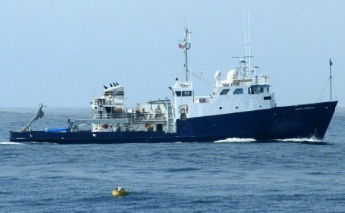

Introduction

The Malibu Mesa-like, Underwater Base allegation has been an active investigation and research project in MUFON for several years, by several MUFON investigators, starting in 2014. As speculation and inquiry has been equally active, The MUFON Communications Director, Roger Marsh accepted an invitation offered by a Production Company to send a MUFON investigator to San Diego to board the Bold Horizon research vessel. Also invited, was the Deep Water Salvage Team from the Eclipse Group for an expedition to the area of interest for a full underwater survey examination. The objective was to “put eyes” and recording equipment on the site to document the anomalous structure. Using the latest technology for sonar and video in deep water, the investigation offers conclusions from the expert team assembled with the examination results detailing the subsea survey applications, capabilities, tracking and recording sensors and the successful launch and deployment of the Super Mohawk Work Class ROV. Part of this expedition crew was a MUFON investigator that was recruited to provide a scientific investigation background of the allegations, UFO sighting reports, and to assist with the investigation protocols and procedures for an admissible conclusion that is required for the examination of anomalous structures. The close proximity of a military base [Point Magu] is often referenced in the theories of the underwater base off Point Dume. However, MUFON investigators argue, the often unmentioned and over looked Naval Base, Port Hueneme, just 11 miles north/west of Point Magu, would be the best candidate for information on underwater structures as it is home to the Seabees. The Construction Battalions in the Department of the Navy.

This command holds and operates the construction engineers and the underwater construction teams, UCT. The Underwater Construction Team 2, the divers that are responsible for all underwater construction, repair and maintenance. [“The Underwater Construction Team provides a capability for construction, inspection, repair, and maintenance of ocean facilities in support of Naval and Marine Corps operations”.]
The MUFON investigation begins with the Google Earth Satellite Image and concludes with the analysis of the collected data extracted from this prominent and active geological area. Is this seemingly man-made structure an underwater base or a natural formation?

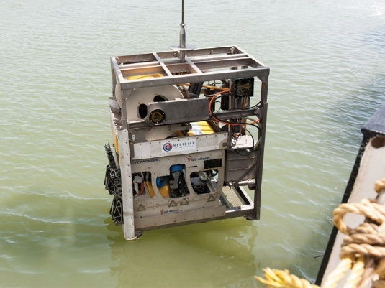
Investigation Method

The investigation started in the conference room on board the Bold Horizon research vessel. The navigation maps were laid out and the location was identified through GPS coordinates. [33.999754, -119.028777]
The fault lines and Abyssal or submarine fans were outlined and highlighted on the map.
The Team was instructed to develop a point of entry and to identify the best location to operate the side scanning sonar, video and ROV. The decision was made to first land the ROV on the platform top [measuring approximately 3 miles] and explore near what should be the right/front side of the plateau. To determine factual geological features of this area, a 400 foot decent would be necessary.
The ocean floor would be examined at the front of the structure near the right side to allow for sonar and video to examine and document the alleged formidable features. The ocean bottom required a descent of 1600 feet. There was a strong sonar return on this descent as the images received from the video showed no signs of manufacturing or man-made architecture.
The ROV was deployed in front of the structure and moved along the anterior wall. There was not any evidence of an opening nor pillars visible or indicated. There were no signs of typical man-made construction as found in a straight line, corners or a 90-degree angle. No machine markings or indications were found. The video clearly showed the same features of a geological environment that is normal for an area in a fault zone.
The visibility was clear and the sediment was untouched and in line with current activity.
The satellite image from Google was researched and analyzed. The process of how the imaging is constructed and detailed was the focus as the image is not a photograph but a product of a known Google Sat practice of screen stretching or manipulation to the image by “filling in the holes”.

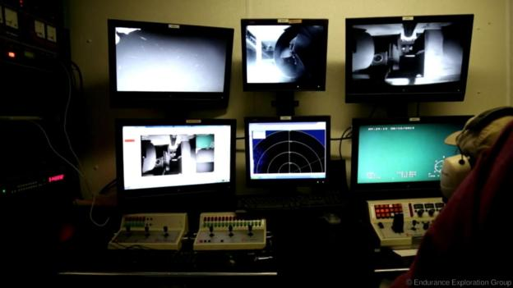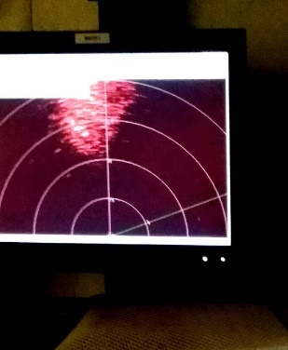

The Results

The ROV side scanning sonar and video allowed for an HD detailed view of the structure. The images produced nothing that would indicate a man-made or constructed base or building. The terrain was consistent with the geological features of the California coastline with the noted faults, abyssal or submarine fan locations and sediment.
The ROV presented a clear image of the right side of the structure that should have been the wall but instead a slumping decline or slope, angled approximately 30-60-degrees to the seabed below.
There were no pillars or an opening that could be found. Jagged edges and vertical ridges were obvious.
Side scanning Sonar although did offer a strong return, there was nothing in this data that would verify a man-made or constructed structure.
Activity marks were not located nor was evidence found to suggest any new or previous activity that would disturb the sediment on the platform of the structure or the seabed.
“The current google satellite imaging for Google earth and Google maps, comes from several sources and third party providers” according to a spokesperson at Google, Steve Laurence, Computer Scientist at the GooglePlex phone tech support Line.
“These current satellite cameras are able to see objects that are just 25cm (10 inches), although this resolution is offered ONLY to the government and blurred or “blacked out” images are often found on Google Satellite images. The U.S. military has their own imagery satellites that can pick up objects that are less than 10 cm (4 inches) across in size. If this is a secret base, the government has complete control to remove it from view. In fact, anyone can submit a report to Google to blur or black out certain exposed images that the viewer may find offensive or sensitive.

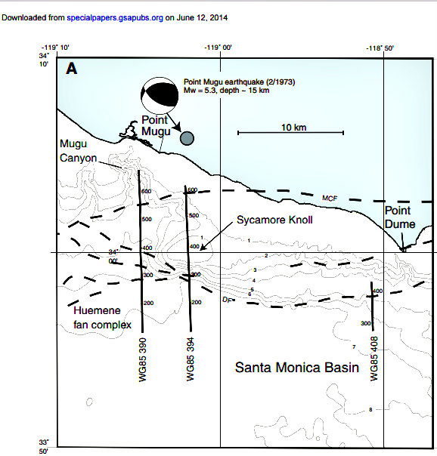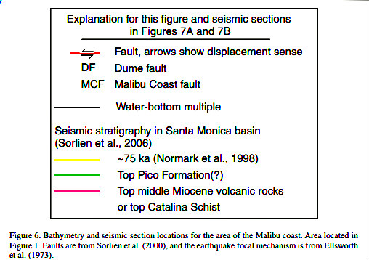
The confirmation/corroborative report located from geological fact data that was included in a Huffington Post article published by Lee Spiegel; [ HuffPost a research paper published in 2009 by the Geological Society of America], verify, more thrust faults and anticlines consistent along the region. This is a basin with a significant history of research and investigations because of the potential threat of earthquakes and tsunamis in the Santa Monica basin. The evidence of this study does include the alleged Malibu Underwater Base as a documented thrust fault known as the “Sycamore Knoll” illustrated by the pictures below. [reference: research paper published in 2009 by the Geological Society of America].

Discussion

The team of engineers, deep water survey experts and investigators observed and studied the video as it progressed and filmed the entire pre-planned exploration sites. There was nothing found that would indicate evidence or allow suspicions of man-made artifacts or construction on the Sycamore Knoll. The Eclipse experts stated; what was witnessed and explored by the ROV and sonar is exactly what they would expect to find in this area.
There were visible vertical striations and jagged formations expected in the bedrock and a normal formation that has been imaged as “pillars”. These vertical ridges are commonly developed with a thrust fault.
The top of the structure and the structure’s boarder were also surveyed for evidence of sediment disturbances. It was explained by the Eclipse Group experts that the ocean floor, when disturbed, reacts like a snow covered surface. When a car would drive over a snow area, the tracks are left. As the snow continues to fall, the tracks are still visible and as the snow fall continues, there is still evidence that something has left a trail. The sediments, when disturbed leave the same type of reaction. Any disturbances from movement on or near the structure would produce a signature. Much like the Abyssal or submarine fans. The turbulence from the cavitation caused by the propellers and the massive water displacement by a submarine or drone movement will leave the “fanning or evidence” of something in that specific space. This type of ocean floor disturbance was non-existent. There was no evidence that any kind of vessel has been near this Knoll.
The image from the Google Satellite is also misleading as it appears to be a structure with obvious details. This is because of the way Satellite images are “constructed”. They are not photographic images. This process is explained by the Google section on [“How Images Are Collected”].

- The satellite and aerial images in Google Earth are taken by cameras on satellites and aircraft, which collect each image at a specific date and time. Those images can be used in Google Earth as a single image with the specific collection date, but sometimes:
- The images are combined into a mosaic of images taken over multiple days or months. These images are displayed as one seamless image and the date may change as you move your cursor around the map.
- There is limited information about the image collection and the date displayed reflects the start of a date range when the image was most likely collected.
- When the "3D Buildings" layer is turned on, the detailed terrain and buildings images are derived from aerial images collected over multiple dates, so Google Earth does not display a collection date.
- The main sources Google uses for Satellite images are:

http://www.spatialenergy.com/
http://www.digitalglobe.com/
http://www.geoeye.com/CorpSite/
http://www.satimagingcorp.com/gallery.html
http://www.usgs.gov/pubprod/aerial.html

It is also true that not all images combined, stretched or pieced together come from satellites. Google earth also uses other Arial photography methods as airplanes with high resolution cameras, kites and balloons. Because images come from different sources, the process to get the imagery into Google Earth is complicated and can take a great deal of time.

The Google Earth image of the Malibu Underwater Structure cannot be analyzed as a photograph.

The conclusion of the Google satellite image of the alleged Malibu Underwater Alien/Military Base located at 33.999754, -119.028777 is a natural thrust fault that features all of the expected characteristics of a geological formation in an appropriate area such as the Dume and Santa Monica Faults.

Reference List
The Eclipse Group
http://www.eclipse.us.com/
The Bold Horizon
http://www.eclipse.us.com/pdfs/MV_bold_horizon.pdf
The underwater construction Teams
http://www.public.navy.mil/seabee/uct2/Pages/default.aspx

Works Cited
Speigel, Lee, “The Truth Behind The Malibu Underwater Alien Base” 06/19/2014 09:27 am ET | Updated Jun 19, 2014. Published: http://www.huffingtonpost.com/2014/06/19/malibu-underwater-alien-base_n_5493186.html

“The Geological Society of America Special Paper 454” 2009 Fisher, Michael A., Sorlien, Christopher C., Sliter, Ray W., “Potential earthquake faults offshore Southern California, from the eastern Santa Barbara Channel south to Dana Point” 2009.
Published: Speigel, Lee, “The Truth Behind the Malibu Underwater Base” Jun 19, 2014
http://big.assets.huffingtonpost.com/offshore.pdf

Ashok Peddi, “How does Google get its aerial photography for their maps?” January 4th, 2015. Published:
https://www.quora.com/How-does-Google-get-its-aerial-photography-for-their-maps

Google Staff, “About Google Earth Imagery” March 16th, 2009 (Originally posted Feb 2008) Published: https://www.gearthblog.com/blog/archives/2009/03/about_google_earth_imagery_1.html

The Eclipse Group US
Technical highlights from our teams’ past experience include the execution of search, investigation and recovery operations of six major civil aviation airliners, numerous military aircraft, two spacecraft, one military submarine and several historic shipwrecks. Each operation presented its own unique challenges. Our team responded to each operation with specialized experience and technology resulting in a successful operation.
Technical Past Experience
2011 - Recovery of Air France Flight 447
Depth 3,900 meters
2010 - Search and Inspection AHS CENTUAR
Depth 1,200 meters
2009 - Search and Recovery Yemeni Air Airbus 310
Depth 1,200 meters
2007 - Search and Recovery Adam Air, Boeing 737
Depth 1,400 meters
2005 - Search and Recovery Tunic ATR – 72
Depth 1,450 meters
2003 - Search and Recovery USN F-14 Tomcat
Depth 3,200 meters
2003 - Search and Recovery USN SH 60 Helicopter
Depth 2,900 meters
2000 - RMS Titanic Inspection
Depth 3,700 meters
2000 - Search and Recovery of a IAF F-16
Depth 1,400 meters
2000 - Search and Recovery of H-2 Rocket
Depth 3,400 meters

Google Earth Help: Google Earth Help: https://support.google.com/earth/answer/6327779?hl=en

