Ministries of our Parish
Christian Education Ministry
(RCIA, Religious Education, etc.)

Worship & Spiritual Life
(bulletin, schedule, music, etc.)

Social Action
(community outreach)

Hospitality
(Event planning, meals, etc.)

Family Life
(Parish activities, picnics, groups, etc.)

Parish Council
(meeting with committee heads in the operation of the parish)

Finance Council
(Financial planning, budget, etc.)

Communication
(directory, newsletter, etc.)

Maintenance/Grounds
(mowing lawn, building upkeep, etc.)

At-Large
(security, etc.)

Pastor
Fr. George Panthananickal, CMI
(Resides at St. Anthony’s in Fayetteville)

Secretary
HOURS: Mon., Wed., Fri.: 9-1

Mass: Sunday – 11:00 AM
Wednesday – 11:00 AM

All are welcome to attend; however, the Eucharist is reserved for Catholics in good standing!

Confessions:
Before or after Mass OR
by appointment.

Compassion/Mercy Ministries

Help Center

Life Choice Pregnancy Resource Center

Community Free Rural Delivery

Matthew 25

Welcome
to the
Catholic
Community in
Giles County!
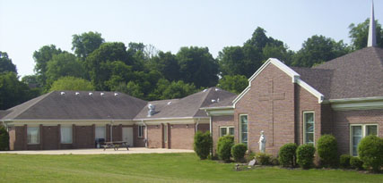
Immaculate Conception Catholic Church
100 Chapel Road
Pulaski, TN 38478
(931) 363-5776
E-mail: iccpulaski@energize.net
Website:www.ICCPulaskiTN.com

