WORSHIP/SPIRITUAL LIFE: JoAnne Beam

FEBRUARY 10
Mass Intention: William B. Hume (Katherine Braddock)
Lectors: Mike Manning & David Bossert
Extraordinary ministers of Holy Communion:
Lola Whitaker & Bill Trebing
Music: JoAnne Beam
Song Leader: Jennifer Duncan/Abby Lambert
Acolytes: Noelia Gonzales & Tala Gvozdas
Ushers: Chris Kidd & Justin Gvozdas
Gifts: Mary Ann & Stanley Trimble
Collection Counters: Jay Beam & Trudy Sumpter

FEBRUARY 13
Mass intention: William B. Hume (Katherine Braddock)

FEBRUARY 17
Mass Intention: Claire Bessette (Bessette & Fitch families)
Lectors: Mike Rekasis & Lola Whitaker
Extraordinary ministers of Holy Communion:
Jay Beam & Mary Ann Trimble
Music: JoAnne Beam
Song Leader: Jennifer Duncan & Choir
Acolytes: Jacob Lambert & Jackson Whitworth
Ushers: Stanley Sherman & Mark Ventura
Gifts: Trudy Sumpter & Lynette Savoy
Collection Counters: Jay Beam & Stanley Trimble

EDUCATION/FORMATION: JoAnne Beam
--Natural Family Planning Classes: A series of classes teaching Natural Family Planning will be offered to anyone who is interested. Call 565-3535.
--Marriage Preparation: Please contact the parish at least 6 months prior to the Sacrament of Matrimony. No date should be set until after that meeting. There are requirements necessary to meet.
--Adult Lenten Bible Study will begin after Mass on Feb. 24. Lunch will be provided. Please sign the sheet in the foyer if you are interested in attending (for materials).

SOCIAL ACTION: Linda Vanzant 363-6207
--HELP CENTER ITEMS: Please bring food items you care to donate and place your items in the box provided in foyer.
--COMMUNITY RURAL FOOD DELIVERY: Place monetary donations in jar in foyer. For info: contact Mike Rekasis 363-0379 or Kathy Grindrod (978) 473-2170. Peanut butter needed for February. Packing of boxes 2/21 & distribution 2/23 – Elkton.
--LIFE CHOICE PREGNANCY CENTER: 363-4133
See Deacon Mike or JoAnne Beam.
-MATTHEW 25: Donations accepted & needed.

SECRETARY: Lola Whitaker 363-6387
--New parishioners or anyone who has a change in address, phone, or e-mail, please call the parish or Lola Whitaker to update your registration.

GIFTS: Kathy Grindrod (978)473-2170
--If interested in bringing up the gifts, see Kathy.

PARISH FACEBOOK: Check this site regularly for any schedule changes, cancellations, funeral services, or updates. You can donate at that site.

PARISH COUNCIL CHAIR:

Mike Rekasis 363-0379
--Parish council meeting TODAY after Mass.

HOSPITALITY: Mary Ann Trimble 205-1284
**Bishop Mark Spalding will be with us next Sunday for Mass and reception following Mass.
--We need items to furnish the rectory. Please see the signup sheet in the foyer to help!!

FAMILY LIFE: Ruby Like (931)279-4342
-- Any suggestions towards parish unity appreciated.

**Welcome back, Father George!!

MAINTENANCE/GROUNDS:
Stanley Trimble (931)703-2835
To help with jobs that need to be done around the grounds and buildings, please contact Stanley Trimble, especially to finish the rectory!!

FINANCE COUNCIL CHAIR:
Jay Beam (931) 565-3535
Finance Report: Sunday Collection: 2/3/2019
Regular - $1028, bldg. fund - $290
- Mass stipends: Please place ($5/Mass) CASH only in the envelope provided.

COMMUNICATION: Christina Manning
(931) 309-2602 (newsletter & directory)

AT-LARGE: Mark Ventura (615)483-7305
(Security, etc.)

Prayer Intentions
Please pray for: Tony/Penny Wielicki, Terri Tompkins, Mary Ann Stafford, Cathryn Shelton, services (military, EMT’s police, firemen, etc.) & their families, Cathy Hume, Theresa Hughes, and all the sick of our parish.
**If you have a prayer need, call our secretary, Lola Whitaker at 363-5776 or 638-7597.

OUTSIDE THE PARISH
--If you realize now that it was a baby and you are hurting deep inside because of an abortion, We can help!! info@saveone.org; www.saveone.org.
-Come and pray the Rosary online at: www.comepraytherosary.org
- Catholic Imagination series on Thursday, February 21 at 7pm with local author Kim Teter. Kim will be discussing her work Isabella’s Libretto, a historical fictional novel that explores Catholic composer Antonio Vivaldi and many of his great works. All are welcome! Catholic Pastoral Center, 2800 McGavock Pike. RSVP/Questions: Joan Watson, joan.watson@dioceseofnashville.com, 615-783-0263.

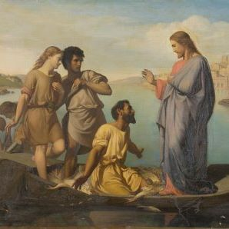

***Pray for the protection of ALL life
from the moment of conception to
natural death!!

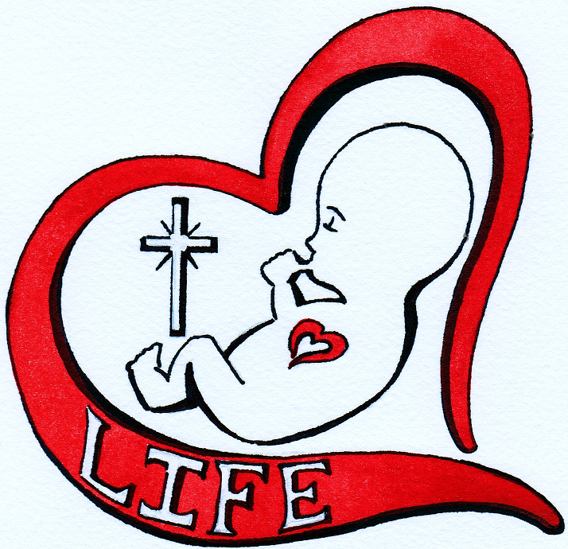

**PLEASE remember Immaculate Conception in your will, trust, and/or estate planning!!

