Upcoming Events:
**Parish picnic Saturday, September 13 at 3 PM, followed by a vigil Mass at 5 PM.

Anyone interested in joining the Catholic Church OR wanting to know more about our faith, please contact Jay/JoAnne Beam at: (931) 565-3535.

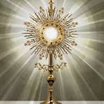

NO Adoration in July (July 4), but will resume on Friday, August 1 from 7-8 PM.

Matthew 25, located on Mill St. next to Chew & Chat restaurant, accepts gently used clothing, bedding, furniture and small appliances. They are open on Tues., Wed., & Thurs. from 9-3:15. When you bring in the items, let them know you are from Immaculate Conception.
**The Help Center has a basket near the front door of the foyer. They are in need of canned goods, boxed meals, noodles, etc. They need these non-perishable foods for the needy in our community.

**We need more people to sign up to help clean the church. Please see Mary Ann Trimble or JoAnne Beam to be put on the list.



St. Michael Prayer

St. Michael, the Archangel, defend us in battle. Be our protection against the wickedness and snares of the devil. May God rebuke him, we humbly pray, and do thou, Oh Prince of the Heavenly Host, by the power of God, thrust into Hell, Satan and all evil spirits who prowl around the world seeking the ruin of souls. Amen.

Our Prayer After Communion
O Sacrament most holy, O sacrament divine
all praise and all thanksgiving
be every moment thine.
We believe that Jesus Christ is really, truly,
and substantially present in
Holy Communion,
Body, Blood Soul and Divinity!!
O Sacrament most holy, O Sacrament divine
all praise and all thanksgiving
be every moment thine.
Mary, Blessed Mother, help us, your children,
to experience and develop in the Eucharist,
a deeper and more intimate relationship
with your son, Jesus Christ, our Lord. Amen

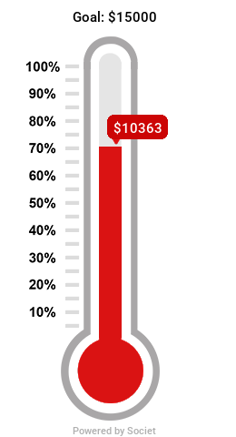

We currently had donated $10,363 towards the Bishop's Annual Appeal. Our goal is $15,000!!

CRFD NEEDS DONATIONS
There is a jar in the foyer labeled CRFD. We packed over 500 boxes in June and gave them to those in need in our area. PLEASE be generous to this cause. Just drop your donation into the jar, so we can help purchase more food for those in need!!

*Matthew 25 has a “bag” day every 4th Thursday where you can fill a bag of anything for $6. They also provide food on Mondays and Wednesdays from 9-11.

**NOTE: Check out the year-long calendar in the hallway above the pew for upcoming events.

Where can you help??
Call the Parish secretary for more information:

Parish Secretary – (931) 363-5776 iccpulaski@energize.net
Charities: Life Choice Pregnancy Resource Center, Inc. – JoAnne Beam (M, Th – 9-5, Tue & F – 9-1)
Matthew 25 – Linda Vanzant (Tue, W, & Th – 9-3:30, M&W – 9-12)
Community Rural Food Distribution –Kathy Grindrod (3rd Th pack 5:30 at the Old Sharp Motor building, distribute 3rd Sat. – 9:00 at the Agri-Park. Volunteers are needed!!
Help Center – Lucian Czejak (M-F 10-2)

**Bishop’s Annual Appeal’s envelopes are in the foyer. You can also donate online:
https://pushpay.com/g/immaculateconceptionpulaski

NOTE: Online donations to our church can be made at: https://pushpay.com/g/immaculateconceptionpulaski

PRAYER
The sole aim of whoever gives oneself to prayer must be to prepare themselves to the best of their ability to conform their will to that of God. In this consists the greatest perfection that can be acquired in the spiritual life. (St. Teresa of Avila)

Our prayer must be humble, fervent, resigned, persevering and deeply reverent, for we must reflect that we are in the presence of a God, and speaking with a Lord before Whom the angels tremble out or respect and fear. (St. Mary Magdalene de Pazzi)

