ADULTS: Bible study will resume on Sunday, Sept. 21 after Mass. Meal provided!!

Mass: Sunday and Wednesday at 11:00 AM; Monday at 9:00 AM

SUNDAY: (8/31) Sirach 3:17-29; Psalm 68; Hebrews 12:18-24; Luke 14:1-14
MONDAY: (9/1) I Thess. 4:13-18; Psalm 96; Luke 4:16-30
TUESDAY: (9/2) I Thess. 5:1-11; Psalm 27; Luke 4:31-37
WEDNESDAY: (9/3) Colossians 1:1-8; Psalm 52; Luke 4:38-44
THURSDAY: (9/4) Colossians 1:9-14; Psalm 98; Luke 5:1-11
FRIDAY: (9/5) Colossians 1:15-20; Psalm 100; Luke 5:33-39
SATURDAY: (9/6) Colossians 1:21-23; Psalm 54; Luke 6:1-5
SUNDAY: (9/7) Wisdom 9:13-18; Psalm 90; Philemon 9-17; Luke 14:25-33

August: Month of the Immaculate Heart
The month of August is dedicated to the Immaculate Heart. Since the 16th century Catholic piety has assigned entire months to special devotions. The month of August is traditionally dedicated to the Immaculate Heart of Mary. The physical heart of Mary is venerated (and not adored as the Sacred Heart of Jesus is) because it is united to her person and is the seat of her love (especially for her divine Son), virtue, and inner life. Such devotion is an incentive to a similar love and virtue. This devotion has received new emphasis in this century from the visions given to Lucy Dos Santos, oldest of the visionaries of Fatima, in her convent in Tuy, in Spain, in 1925 and 1926. In the visions Our Lady asked for the practice of the Five First Saturdays to help make amends for the offenses committed against her heart by the blasphemies and ingratitude of men. The practice parallels the devotion of the Nine First Fridays in honor of the Sacred Heart.

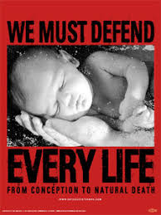

Please pray for the protection of ALL human life
from the moment of conception
to natural death!!

Immaculate Conception Parish
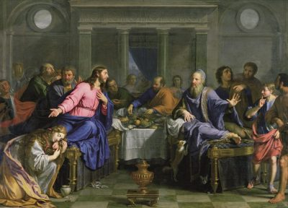
Pastor
Father George Panthananickal, CMI e-mail: gmariadoss@yahoo.com
(931) 433-6525
1900 Huntsville Hwy.
Fayetteville, TN 37334 Deacon Mike Hume: (931) 638-9700

Sirach 3:17-29; Psalm 68; Hebrews 12:18-24; Luke 14:1-14
We come to the wedding banquet of heaven by way of humility and charity. This is the fatherly instruction we hear in today’s First Reading, and the message of today’s Gospel. Jesus is not talking simply about good table manners. He is revealing the way of the kingdom, in which the one who would be greatest would be the servant of all (see Luke 22:24–27). This is the way, too, that the Father has shown us down through the ages—filling the hungry, sending the rich away empty, lifting up the lowly, pulling down the proud (see Luke 1:52–53). We again call to mind the Exodus in today’s Psalm—how in His goodness the Lord led the Israelites from imprisonment to prosperity, rained down bread from heaven, made them His inheritance, becoming a “Father of orphans.” We now have also gained a share of His inheritance. We are to live humbly, knowing we are not worthy to receive from His table (see Luke 6:7; 15:21). We are to give alms, remembering we were ransomed from sin by the price of His blood (see 1 Corinthians 6:19–20). The Lord promises that if we are humble we will be exalted and find favor with God; that if we are kind to those who can never repay us, we will atone for sins and find blessing in the resurrection of the righteous. We anticipate the fulfillment of those promises in every Eucharist, today’s Epistle tells us. In the Mass, we enter the festal gathering of the angels and the firstborn children of God. It is the liturgy of the heavenly Jerusalem in which Jesus is the high priest, the King who calls us to come up higher (see Proverbs 25:6–7).
--Dr. Scott Hahn, PhD

