ADULTS: Bible study resumes NEXT Sunday after Mass. Meal provided.

Mon., Wed., Fri. from 9:00 AM to 1:00 PM the Church is open for quiet reflection with Jesus. Mass: Sunday at 11:00 AM, Monday at 9 AM and Wednesday at 11 AM

SUNDAY: (9/15) Isaiah 50:5-9; Psalm 116; James 2:14-18; Mark 8:27-35
MONDAY: (9/16) I Corin. 11:17-26; Psalm 40; Luke 7:1-10
TUESDAY: (9/17) I Corin. 12:12-14, 27-31; Psalm 100; Luke 7:11-17
WEDNESDAY: (9/18) I Corin. 12:31-13:13; Psalm 33; Luke 7:31-35
THURSDAY: (9/19) I Corin. 15:1-11; Psalm 118; Luke 7:36-50
FRIDAY: (9/20) l Corin. 15:12-20; Psalm.17; Luke 8:1-3
SATURDAY: (9/21) Ephesians 4:1-13; Psalm 19; Matt. 9:9-13
SUNDAY: (9/22) Wisdom 2:12-20; Psalm 54; James 3:16-4:3; Mark 9:30-37

September: Month of the Seven Sorrows of Mary
TO OUR LADY OF SORROWS O most holy Virgin, Mother of our Lord Jesus Christ: by the overwhelming grief you experienced when you witnessed the martyrdom, the crucifixion, and the death of your divine Son, look upon me with eyes of compassion, and awaken in my heart a tender commiseration for those sufferings, as well as a sincere detestation of my sins, in order that, being disengaged from all undue affection for the passing joys of this earth, I may sigh after the eternal Jerusalem, and that henceforward all my thoughts and all my actions may be directed towards this one most desirable object. Honor, glory, and love to our divine Lord Jesus, and to the holy and immaculate Mother of God. Amen.

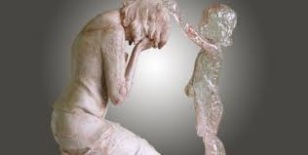
Please pray for the protection of ALL human life
from the moment of conception
to natural death!!

Immaculate Conception Parish
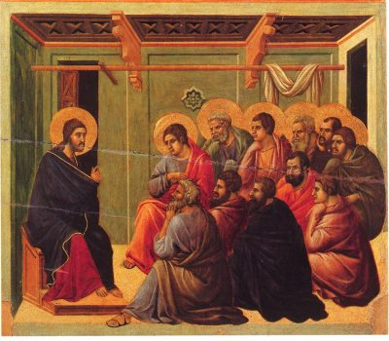
Pastor
Father George Panthananickal, CMI e-mail: gmariadoss@yahoo.com
(931) 433-6525
1900 Huntsville Hwy.
Fayetteville, TN 37334 Deacon Mike Hume: (931) 638-9700

Isaiah 50:5-9; Psalm 116; James 2:14-18; Mark 8:27-35
In today’s Gospel, we reach a pivotal moment in our walk with the Lord. After weeks of listening to His words and witnessing His deeds, along with the disciples we’re asked to decide who Jesus truly is. Peter answers for them, and for us, too, when he declares: “You are the Messiah.” Many expected the Messiah to be a miracle worker who would vanquish Israel’s enemies and restore the kingdom of David. Jesus today reveals a different portrait. He calls Himself the Son of Man, evoking the royal figure Daniel saw in his heavenly visions. But Jesus’ kingship is not to be of this world. And the path to His throne, as He reveals, is by way of suffering and death. Jesus identifies the Messiah with the suffering servant that Isaiah foretells in today’s First Reading. The words of Isaiah’s servant are Jesus’ words—as He gives Himself to be shamed and beaten, trusting that God will be His help. We hear our Lord’s voice again in today’s Psalm, as He gives thanks that God has freed Him from the cords of death. As Jesus tells us today, to believe that He is the Messiah is to follow His way of self-denial—losing our lives to save them in order to rise with Him to new life. Our faith, we hear again in today’s Epistle, must express itself in works of love. Notice that Jesus questions the Apostles today “along the way.” They are on the way to Jerusalem, where the Lord will lay down His life. We, too, are on a journey with the Lord. We must take up our cross, giving to others and enduring all our trials for His sake and the sake of the Gospel. Our lives must be an offering of thanksgiving for the new life He has given us until that day when we reach our destination and walk before the Lord in the land of the living.
( by Scott Hahn, PhD)

