Upcoming Events:
**We are looking for more lectors, servers, musicians, gift bearers and Extraordinary ministers of Holy Communion. See Lola Whitaker if you are interested for training.

Anyone interested in joining the Catholic Church OR wanting to know more about our faith, please contact Jay/JoAnne Beam at: (931) 565-3535

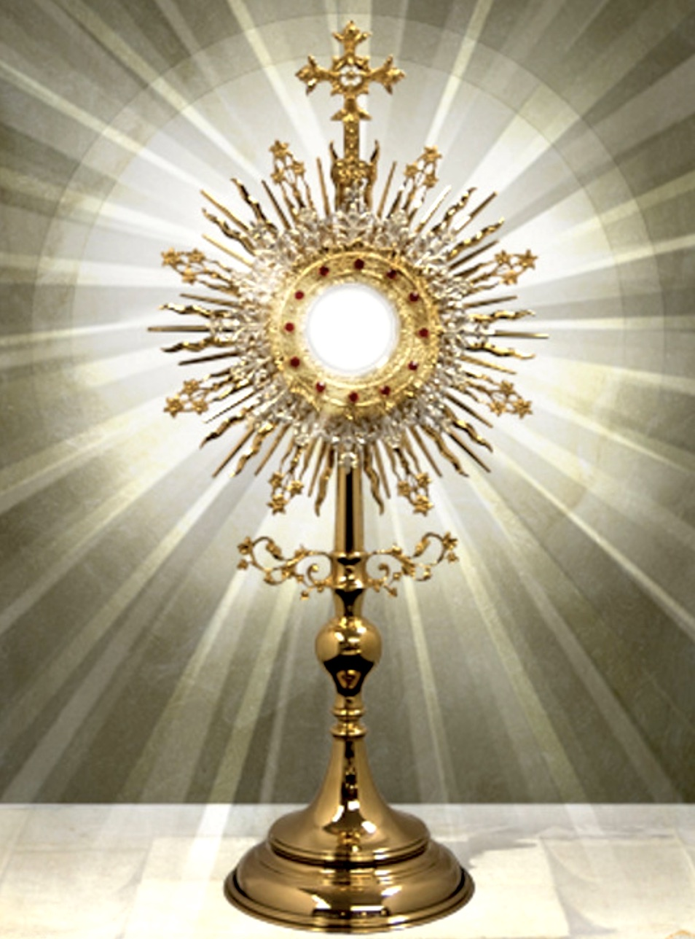

To deepen our love for Jesus in the Blessed Sacrament, we will be having Adoration of the Blessed Sacrament on First Fridays, from 7-8 PM.

Parish Council meeting TODAY after Mass. Minutes from the previous meeting are on the bulletin board in the foyer.

Bible study: “Mary – The Bible and the Mother of God” resumes September 29 after Mass. Meal provided.

**Matthew 25 has a “bag” day every 4th Thursday where you can fill a bag of anything for $6. They also provide food on Mondays and Wednesdays from 9-11.
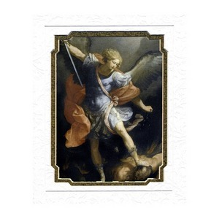

St. Michael Prayer

St. Michael, the Archangel, defend us in battle. Be our protection against the wickedness and snares of the devil. May God rebuke him, we humbly pray, and do thou, Oh Prince of the Heavenly Host, by the power of God, thrust into Hell, Satan and all evil spirits who prowl around the world seeking the ruin of souls. Amen.

Our Prayer After Communion
O Sacrament most holy, O sacrament divine
all praise and all thanksgiving
be every moment thine.
We believe that Jesus Christ is really, truly,
and substantially present in
Holy Communion,
Body, Blood Soul and Divinity!!

O Sacrament most holy, O Sacrament divine
all praise and all thanksgiving
be every moment thine.
Mary, Blessed Mother, help us, your children,
to experience and develop in the Eucharist,
a deeper and more intimate relationship
with your son, Jesus Christ, our Lord. Amen
We are planning a parish picnic NEXT Sunday, September 22 after Mass with hotdogs, burgers, and lots of sides. There is a signup sheet in the foyer for the sides. We will also have games for the young people on our lawn, organized by our youth.

Exaltation of the Holy Cross: September 14th
O Cross, blessing of the world,
our hope and sure redemption,
once the harbinger of hell,
now the bright gate of heaven.

On you the Victim is lifted up,
who has drawn all things to himself,
whom the price of this world attacks,
and it avails him nothing.

Glory be to the Father,
equal glory to the Holy Spirit,
[and] to you, O Jesus,
who grant unto us
to enjoy fully the victory of the Cross.
Amen

Where can you help??
Due to a possible “scam” issue, it was decided to NOT print our personal phone numbers/e-mails. IF you need either, just call the secretary to obtain this information.

Charities: Life Choice Pregnancy Resource Center, Inc. – JoAnne Beam (M, Th – 9-5, Tue & F – 9-1)
Matthew 25 – Linda Vanzant (Tue, W, & Th – 9-3:30, M&W – 9-12)
Community Rural Food Distribution – Mike Rekasis & Kathy Grindrod (3rd Th pack 5:30 at the Old Sharp Motor building, distribute 3rd Sat. – 9:00 at the Agri-Park. Volunteers are needed!!
Help Center – Lucian Czejak (M-F 10-2)

Parish Secretary – Lola Whitaker (931) 363-5776 iccpulaski@energize.net

Together in Holiness
September 21, 2024 from 9-4 at the Pastoral Center (2800 McGavock Pike, Nashville) Cost is $64/couple. Childcare is provided.
A day-retreat for married couples and/or engaged couples.
Register at: TH@forlifeandfamily.org or call at: (832) 779-1070

