Upcoming Events:
**We are looking for more lectors, servers, musicians, gift bearers and Extraordinary ministers of Holy
Communion. JoAnne Beam if you are interested.

Anyone interested in joining the Catholic Church OR wanting to know more about our faith, please contact Jay/JoAnne Beam at: (931) 565-3535.

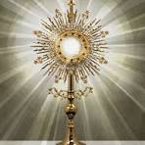

To deepen our love for Jesus in the Blessed Sacrament, we will be having Adoration of the Blessed Sacrament on First Fridays from 7-8 PM.

Today at 2 PM, the Lawrence County Right-to-life organization is having a “Celebrate Life” event at the First Baptist Church, 2100 Springer Rd., Lawrenceburg, TN. There will be a baby shower for Hope Haven Pregnancy Center.
Parish Council meeting today after Mass. Meal provided after the meeting.



St. Michael Prayer

St. Michael, the Archangel, defend us in battle. Be our protection against the wickedness and snares of the devil. May God rebuke him, we humbly pray, and do thou, Oh Prince of the Heavenly Host, by the power of God, thrust into Hell, Satan and all evil spirits who prowl around the world seeking the ruin of souls. Amen.

Our Prayer After Communion
O Sacrament most holy, O sacrament divine
all praise and all thanksgiving
be every moment thine.
We believe that Jesus Christ is really, truly,
and substantially present in
Holy Communion,
Body, Blood Soul and Divinity!!
O Sacrament most holy, O Sacrament divine
all praise and all thanksgiving
be every moment thine.
Mary, Blessed Mother, help us, your children,
to experience and develop in the Eucharist,
a deeper and more intimate relationship
with your son, Jesus Christ, our Lord. Amen

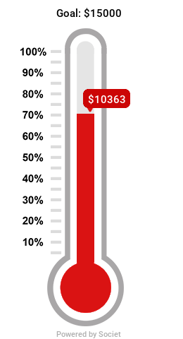

We currently had donated $10,363 towards the Bishop's Annual Appeal. Our goal is $15,000!!

CRFD NEEDS DONATIONS
There is a jar in the foyer labeled CRFD. Last year we donated $1870 to this ministry. $170 provides 1000 lb. of food for those in need. PLEASE be generous to this cause. Just drop your donation into the jar, so we can help purchase more food for those in need!!

*Matthew 25 has a “bag” day every 4th Thursday where you can fill a bag of anything for $6. They also provide food on Mondays and Wednesdays from 9-11.

**NOTE: We have a year-long calendar on the wall above the pew in the hallway.

Where can you help??
Call the Parish secretary for more information:

Parish Secretary – (931) 363-5776 iccpulaski@energize.net
Charities: Life Choice Pregnancy Resource Center, Inc. – JoAnne Beam (M, Th – 9-5, Tue & F – 9-1)
Matthew 25 – Linda Vanzant (Tue, W, & Th – 9-3:30, M&W – 9-12)
Community Rural Food Distribution –Kathy Grindrod (3rd Th pack 5:30 at the Old Sharp Motor building, distribute 3rd Sat. – 9:00 at the Agri-Park. Volunteers are needed!!
Help Center – Lucian Czejak (M-F 10-2)

**Bishop’s Annual Appeal’s envelopes are in the foyer. You can also donate online:
https://pushpay.com/g/immaculateconceptionpulaski

NOTE: Online donations to our church can be made at: https://pushpay.com/g/immaculateconceptionpulaski

Dear Lord Jesus, on this sacred Corpus Christi day, we gather in your presence with hearts open wide. In the humble bread and wine, you offer us yourself – body, blood, soul, and divinity. Grant us the grace to deepen our faith in this profound mystery of the Eucharist. Strengthen our belief in your real presence, that we may receive you with unwavering trust and boundless love. We thank you, dear Jesus, for the immeasurable gift of yourself. Amen.

