ADULTS: Bible study will resume in the Fall.

Thursdays from 10:00 AM to 12:00 PM the Church is open for quiet reflection with Jesus. Mass: Sunday and Wednesday at 11:00 AM; Monday at 9:00 AM

SUNDAY: (6/22) Genesis 14:18-20; Psalm 110; I Corinthians 11:23-26; Luke 9:11-17
MONDAY: (6/23) Gen. 12:1-9; Psalm 33; Matt. 7:1-5
TUESDAY: (6/24) Isaiah 49:1-6; Psalm 139; Acts 13:22-26; Luke 1:57-80
WEDNESDAY: (6/25) Genesis 15:1-18; Psalm 105; Matt. 7:15-20
THURSDAY: (6/26) Genesis 16:1-16; Psalm 106; Matt. 7:21-29
FRIDAY: (6/27) Ezekiel 34:11-16; Psalm 23; Romans 5:5-11; Luke 15:3-7
SATURDAY: (6/28) Isaiah 61:9-11; I Samuel 2:1-7; Luke 2:41-51
SUNDAY: (6/29) Acts 12:1-11; Psalm 34; II Timothy 4:6-18; Matt. 16:13-19

June: Month of the Sacred Heart of Jesus
June is known as the month of the Sacred Heart of Jesus most simply because the solemnity of the Sacred Heart is celebrated during this month. This year, the solemnity falls on June 27. The date changes each year because it is celebrated on the Friday after the Corpus Christi octave, or the Friday after the second Sunday after Pentecost. However, other reasons exist as to why June is dedicated to the Sacred Heart. The feast dates back to 1673, when a French nun who belonged to the Order of the Visitation of Holy Mary (Visitandines) in eastern France began to receive visions about the Sacred Heart. Jesus appeared to Sister Margaret Mary Alacoque and revealed ways to venerate his Sacred Heart and explained the immense love he has for humanity, appearing with his heart visible outside his chest, on fire, and surrounded by a crown of thorns.

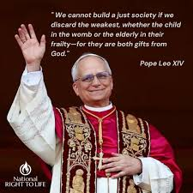

Please pray for the protection of ALL human life
from the moment of conception
to natural death!!

Immaculate Conception Parish
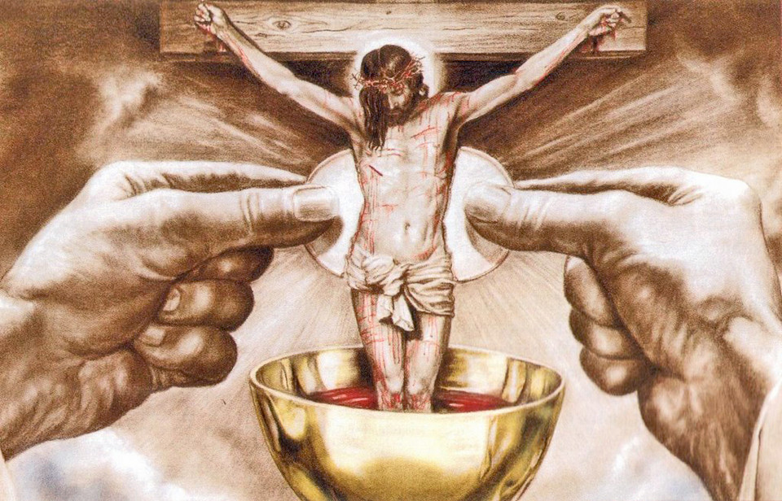
Pastor
Father George Panthananickal, CMI e-mail: gmariadoss@yahoo.com
(931) 433-6525
1900 Huntsville Hwy.
Fayetteville, TN 37334 Deacon Mike Hume: (931) 638-9700

Genesis 14:18-20; Psalm 110; I Corinthians 11:23-26; Luke 9:11-17
At the dawn of salvation history, God revealed our future in figures. That’s what’s going on in today’s First Reading: a priest-king comes from Jerusalem (see Psalm 76:3), offering bread and wine to celebrate the victory of God’s beloved servant, Abram, over his foes. By his offering, Melchizedek bestows God’s blessings on Abram. He is showing us, too, how one day we will receive God’s blessings and in turn “bless God”—how we will give thanks to Him for delivering us from our enemies, sin and death. As Paul recalls in today’s Epistle, Jesus transformed the sign of bread and wine, making it a sign of His body and blood, through which God bestows upon us the blessings of His “new covenant.” Jesus is “the priest forever according to the order of Melchizedek,” that God, in today’s Psalm, swears will rule from Zion, the new Jerusalem (see Hebrews 6:20–7:3). By the miracle of loaves and fishes, Jesus in today’s Gospel, again prefigures the blessings of the Eucharist. Notice that He takes the bread, blesses it, breaks it, and gives it to the Twelve. You find the precise order and words in the Last Supper (see Luke 22:19) and in His celebration of the Eucharist on the first Easter night (see Luke 24:30). The Eucharist fulfills the offering of Melchizedek. It is the daily miracle of the heavenly high priesthood of Jesus. It is a priesthood He conferred upon the Apostles in ordering them to feed the crowd, in filling exactly twelve baskets with leftover bread—in commanding them on the night He was handed over: “Do this in remembrance of Me.” Through His priests He still feeds us in “the deserted place” of our earthly exile. And by this sign He pledges to us a glory yet to come. For as often as we share in His body and blood. we proclaim His victory over death, until He comes again to make His victory our own.
--Dr. Scott Hahn, PhD

